
i
CLF-PRO-07-EN-GEBKIM-
Manual Assembly Techniques
WP6 COLLABORATIVE LEARNING FACTORY






Funded by the European Union. Views and opinions expressed are however those of the author(s) only and do not necessarily reflect those of the European Union or the European Education and Culture Executive Agency (EACEA). Neither the European Union nor EACEA can be held responsible for them.
This work is licensed by the LCAMP Partnership under a Creative Commons Attribution-NonCommercial 4.0 International License.
LCAMP partners:
TKNIKA – Basque VET Applied Research Centre, CIFP Miguel Altuna LHII, DHBW Heilbronn – Duale Hochschule, Baden-Württemberg, Curt Nicolin High School, AFM – Spanish Association of Machine Tool Industries, EARLALL – European Association of Regional & Local Authorities for Lifelong Learning, FORCAM, CMQE: Association campus des métiers et des qualifications industrie du future, MV: Mecanic Vallée, KIC: Knowledge Innovation Centre, MADE Competence Centre Industria 4.0; AFIL: Associazione Fabbrica Intelligente Lombardia, SIMUMATIK AB; Association HVC Association of Slovene Higher Vocational Colleges; TSCMB:Tehniški šolski center Maribor, KPDoNE: Kocaeli Directorate Of National Education; GEBKİM VET, GEBKİM OIZ and CAMOSUN college.

INDEX

1. INTRODUCTION 4
2. GETTING STARTED 5
3. DISASSEMBLY OF WHEEL PARTS 6
4. WHEEL INSTALLATION 7
5. Connecting the Wheel to the Stepper Motors 9
6. ASSEMBLY OF OTHER PARTS TO THE MAIN BODY 10
7. Index of images 11

INTRODUCTION
Participants in this micro course will learn the assembly stages, assembly techniques, and working with the 5S principle for the LCAMP robot (EXAM 4.0) by the end of the course.

The course content will include an example of Mecanum wheel assembly, along with brief and clear information about robot assembly.

Various equipment is used when assembling machines, robots, etc. in industry. Assembly techniques are constantly evolving with technology.

While assembly can be performed with robots, the assembly process steps can be simplified and user-friendly applications can be developed using MPS systems and devices similar to ARKITE, which is used within the scope of LCAMP.

In this course, we will focus on the steps of manual assembly.

GETTING STARTED
In order to perform the assembly process, the parts to be assembled, the equipment to be used during assembly, a table where the assembly will be performed, and personnel to perform the assembly are required.

Workplace health and safety measures must be in place, Personal Protective Equipment must be provided to personnel in a complete and functional state, and personnel must be trained in occupational health and safety.
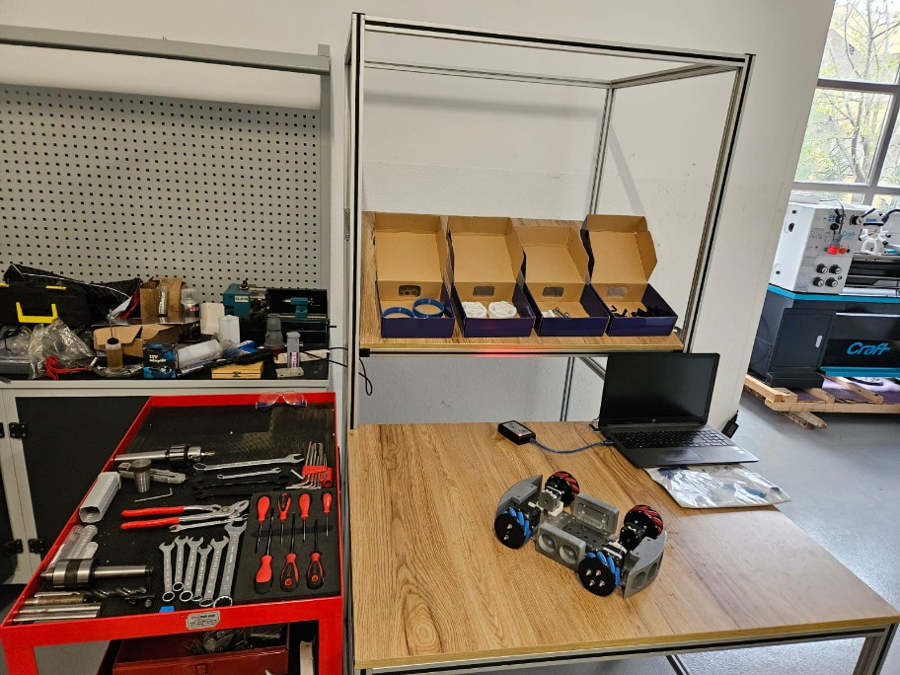

Figure 1: Preparing the Work Environment

DISASSEMBLY OF WHEEL PARTS

All assembly parts must be prepared in the work environment and sorted into appropriate boxes in an orderly manner. Equipment to be assembled is placed in suitable, easily accessible locations in the work environment. Personnel performing assembly wear/put on the required personal protective equipment.
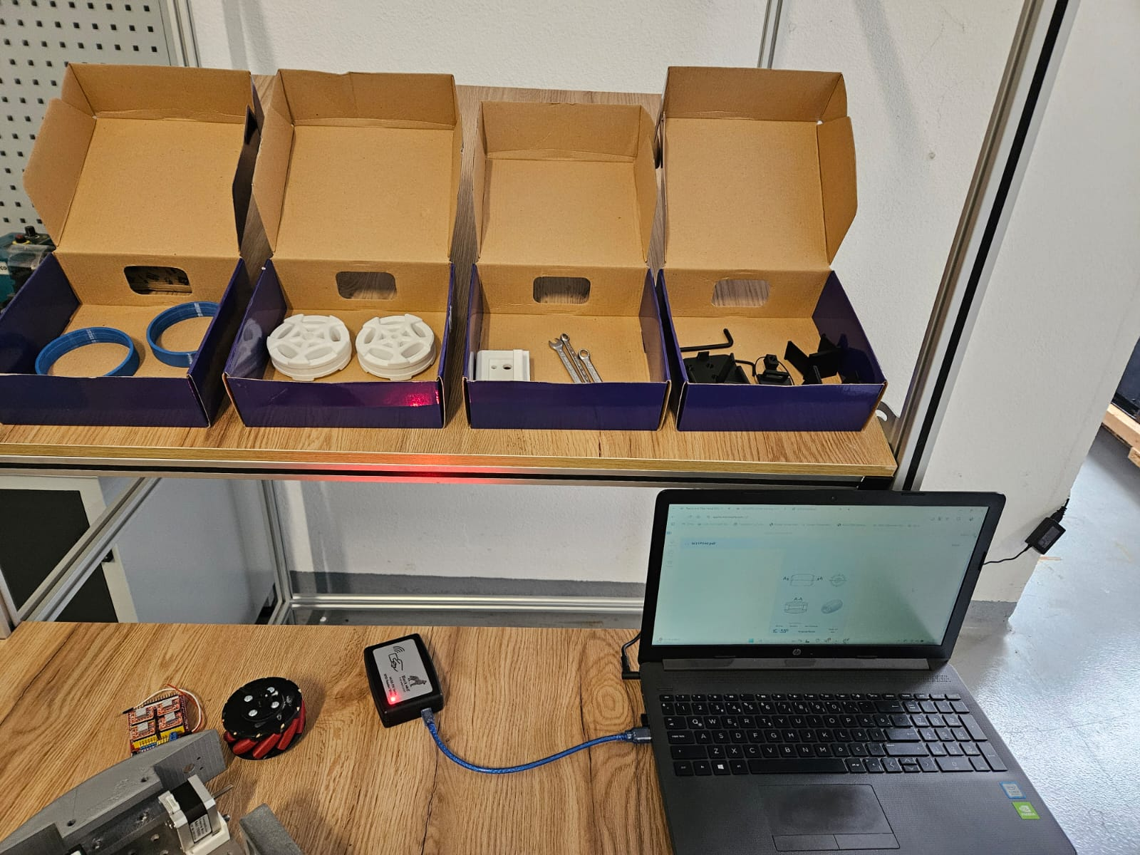

Figure 2: Preparation of Assembly Parts

WHEEL INSTALLATION

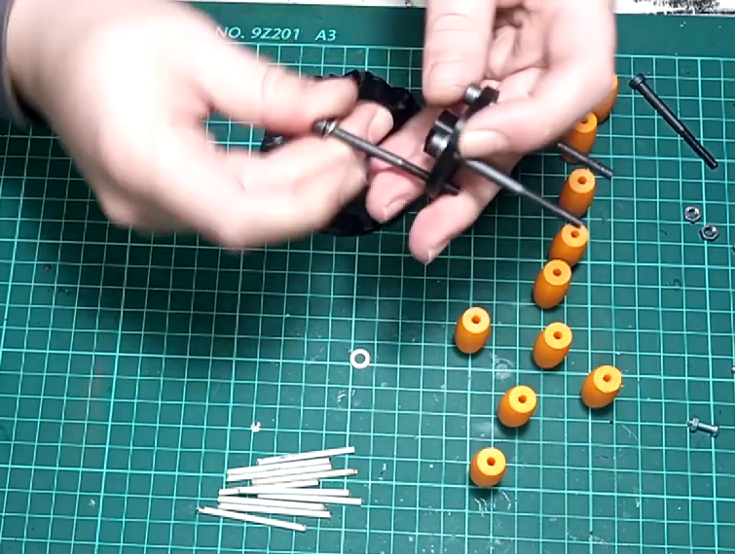
The wheel's stepper motor connection piece is taken. The bolts are placed one by one into the appropriate holes in the motor connection piece.

Figure 3: Stepper Motor Connection Part Assembly
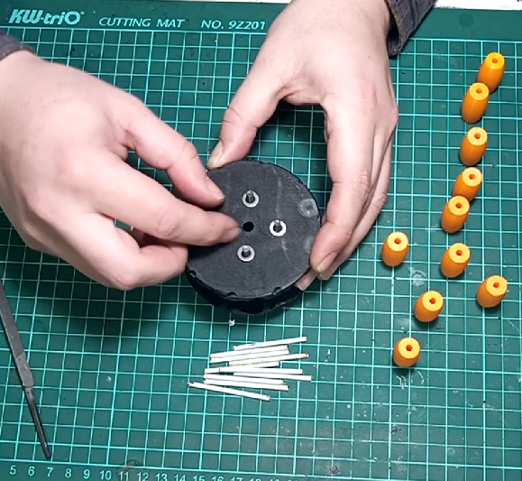
The stepper motor connection part is mounted to the lower and upper parts of the wheel using bolts and nuts.
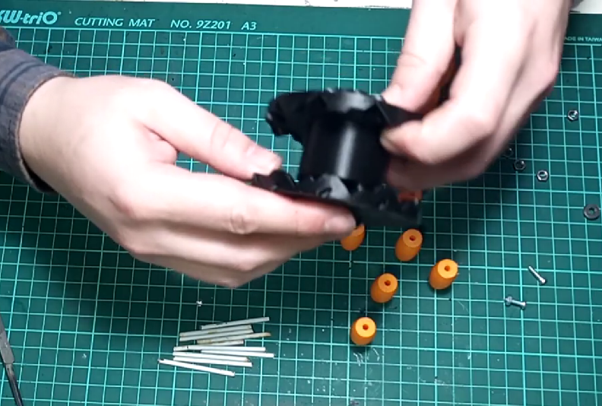

Figure 4: Wheel Upper and Lower Part Assembly

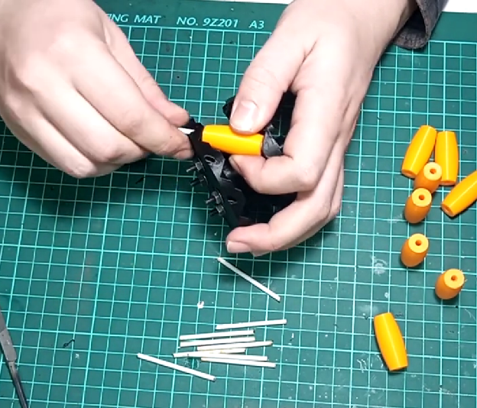
Metal wire, filament pieces, or wooden sticks are prepared in the size of the rollers. The rollers are attached to the body and edge parts of the wheel using the appropriately prepared piece (wire, filament, etc.) through the holes.
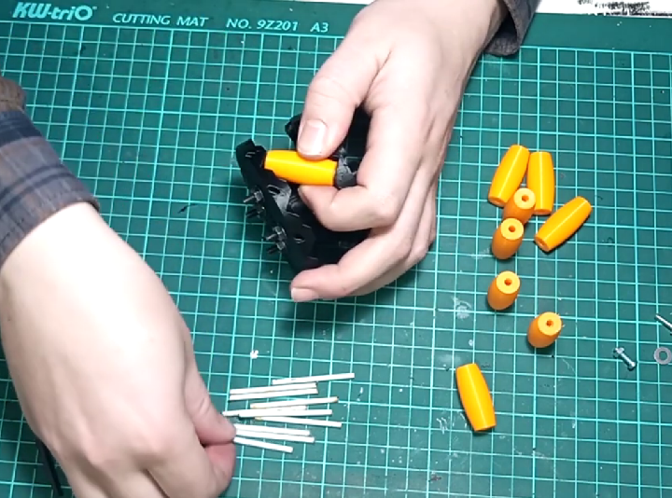

Figure 5: Mounting the Rollers to the Wheel Body

The rollers are secured at both ends with hot silicone or liquid adhesive to keep them in place. The process is repeated by mounting all rollers between the edge piece and the body.

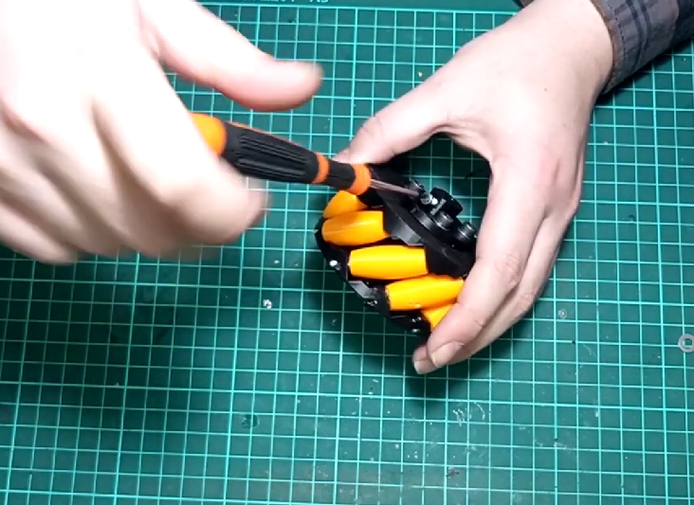
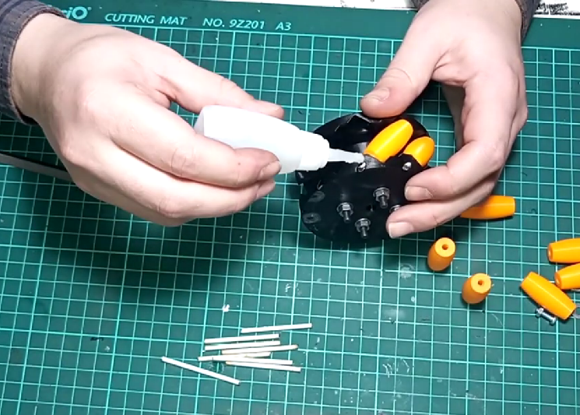
Figure 6: Roller Assembly and Adhesion

Connecting the Wheel to the Stepper Motors

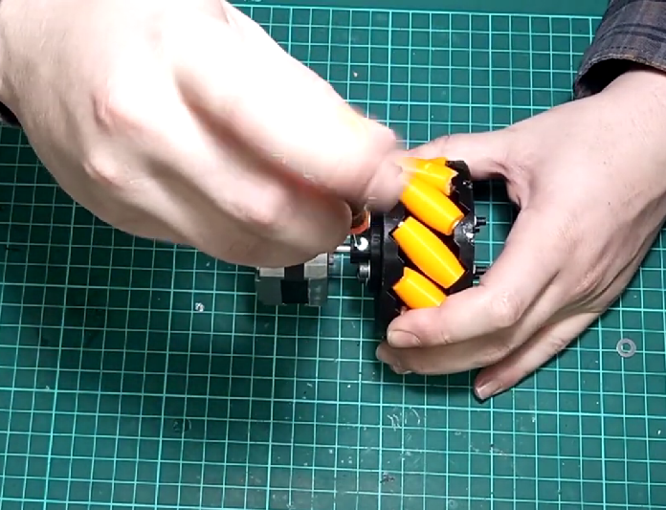
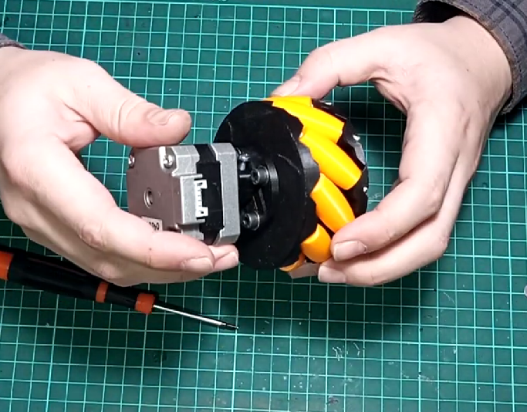
The assembled wheels are secured to the shafts of the stepper motors using set screws or bolts.

Figure 7: Mounting the Stepper Motor to the Wheel

Stepper motors are also secured with screws of the appropriate size for the stepper motor mounting brackets. Using the mounting holes on the stepper motor bracket, the stepper motor, wheel, and motor bracket are secured to the main body.
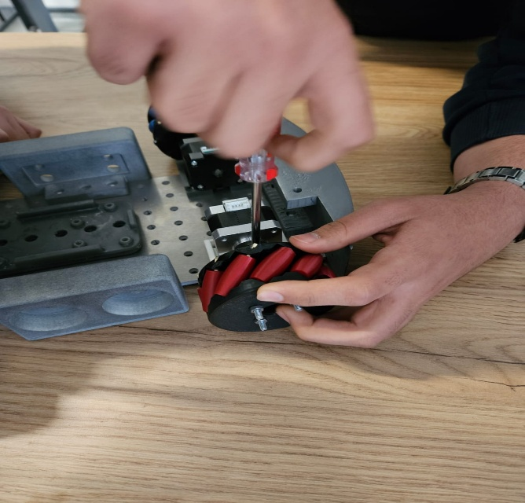

Figure 8: Mounting the Stepper Motor and Wheel to the Main Plate

ASSEMBLY OF OTHER PARTS TO THE MAIN BODY

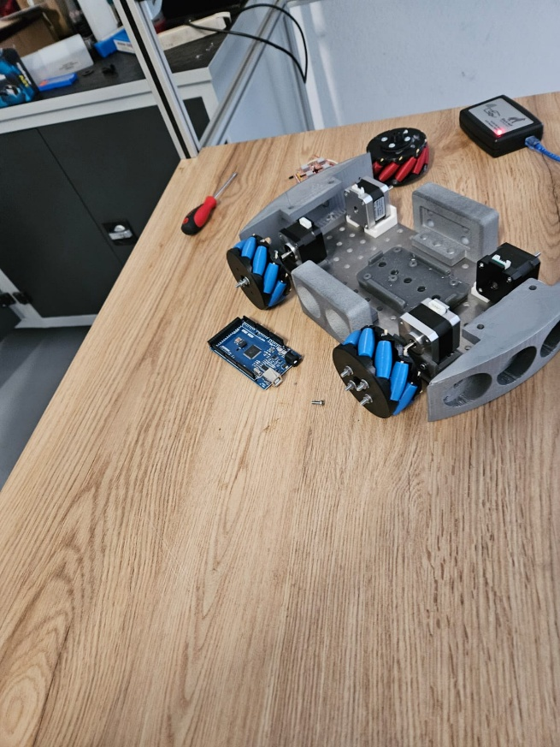
The sensor boxes are secured to the main body using the mounting holes on it. The Electronic Board (Arduino) holder is secured to the main body. The battery holder is secured to the main body. This completes the mechanical assembly.

Figure 9: Completion of Other Mechanical Component Assembly

Index of images

Figure 1: Preparing the Work Environment 5
Figure 2: Preparing the Assembly Parts 6
Figure 3: Mounting the Stepper Motor Connection Part 7
Figure 4: Mounting the Wheel Upper and Lower Parts 7
Figure 5: Mounting the Rollers to the Wheel Body 8
Figure 6: Roller Assembly and Gluing 8
Figure 7: Mounting the Stepper Motor to the Wheel 9
Figure 8: Mounting the Stepper Motor and Wheel to the Main Plate 9
Figure 9: Completion of Other Mechanical Part Assembly 10


