
CLF-PRO-06-EN-GEBKIM-
3D Printing of Robot Parts
WP6 COLLABORATIVE LEARNING FACTORY






Funded by the European Union. Views and opinions expressed are however those of the author(s) only and do not necessarily reflect those of the European Union or the European Education and Culture Executive Agency (EACEA). Neither the European Union nor EACEA can be held responsible for them.
This work is licensed by the LCAMP Partnership under a Creative Commons Attribution-NonCommercial 4.0 International License.
LCAMP partners:
TKNIKA – Basque VET Applied Research Centre, CIFP Miguel Altuna LHII, DHBW Heilbronn – Duale Hochschule, Baden-Württemberg, Curt Nicolin High School, AFM – Spanish Association of Machine Tool Industries, EARLALL – European Association of Regional & Local Authorities for Lifelong Learning, FORCAM, CMQE: Association campus des métiers et des qualifications industrie du future, MV: Mecanic Vallée, KIC: Knowledge Innovation Centre, MADE Competence Centre Industria 4.0; AFIL: Associazione Fabbrica Intelligente Lombardia, SIMUMATIK AB; Association HVC Association of Slovene Higher Vocational Colleges; TSCMB:Tehniški šolski center Maribor, KPDoNE: Kocaeli Directorate Of National Education; GEBKİM VET, GEBKİM OIZ and CAMOSUN college.

TABLE OF CONTENTS

1. INTRODUCTION 3
2. BEGINNING 4
3. ADDING PARTS TO 3D EDITION 5
4. ARRANGING THE PRINTING TABLE 6
5. LAYER SETTINGS 7
6. DURABILITY SETTINGS 8
7. SUPPORT SETTINGS 10
8. SKIRT AND EDGE SETTINGS 10
9. SLICING AND PRINTING THE PIECE 11
10. REMOVING THE PRINT 12

INTRODUCTION
Participants in this micro course will gain knowledge about 3D printing types, materials used, and slicing techniques by the end of the course, and will be able to slice and print any desired model.
3D printing technologies are currently a very popular method for creating 3D prints using FDM, SLA, DLP, and SLM type printers. There are some differences between printer types in terms of printing method. For example:
FDM printers are the most popular and affordable 3D printing technology on the market. They create 3D prints by applying materials layer by layer, using a highly precise hot glue gun mechanism.
SLA printers expose a layer of light-sensitive liquid resin to ultraviolet light, causing the resin to harden and solidify. The object is printed layer by layer, with each layer built on top of the previous one.
DLP printers use a printing method similar to SLA printers, but the difference is that DLP printers use a digital light projector, while SLA printers use a UV laser.
SLM printers use a high-powered laser to completely melt metal powders and transform them into three-dimensional solid objects.

Since our school has FDM-type 3D printers, the types of filaments used in FDM-type printers are:
PLA (Polylactic acid): A biodegradable organic material. It is one of the most commonly used materials in 3D printing.
PETG (Polyethylene terephthalate): A very popular filament due to its strength and durability.
TPU (Polyester Polyurethane): Resistant to abrasion, impacts and many chemicals. Versatile, used in many industries, flexible.
ABS: It is used in outdoor environments because it is resistant to high temperature and sunlight.
ASA: It is a preferred filament because it is resistant to outdoor conditions.
NOTE: Since ABS and ASA filament are easily affected by temperature change (during printing), it is more suitable to be printed with closed case printers.

Almost every 3d printer manufacturer has software for slicing, as well as different software such as Cura Slicer, Orca Slicer, Simplify3D. Slicing programs are used to convert the drawing file in STL or OBJ format into gcodes that the 3d printer will understand. After the slicing process is completed, the created gcode is transferred to the printer via sd card, usb memory or wifi.

BEGINNING
We use Orca Slicer as a slicing program. Now we will see how to make print adjustment via Orca slicer.
After downloading the Orca Slicer program from the internet and completing the installation, we run the program.
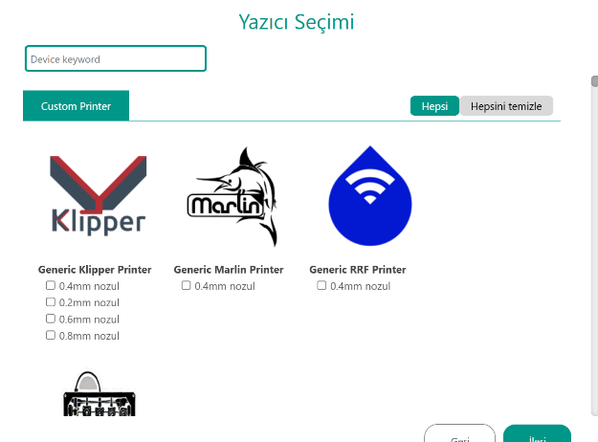

When we run Orca Slicer for the first time, it first asks us to select our printer. We select our printer and nozzle diameter.

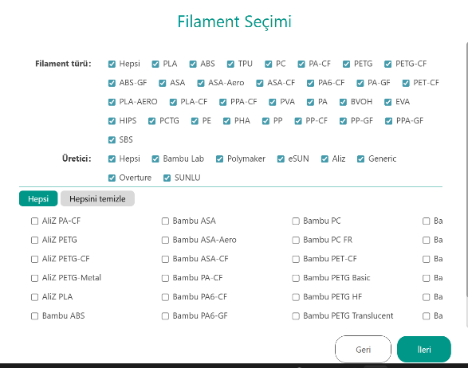
Figure 1 : Add Printer

Then we select the filaments that we will use with the printer. (It can also be changed later.) However, we need to select at least 1 filament to continue.

Figure 2 : Adding Filament

ADDING PARTS TO 3D EDITION

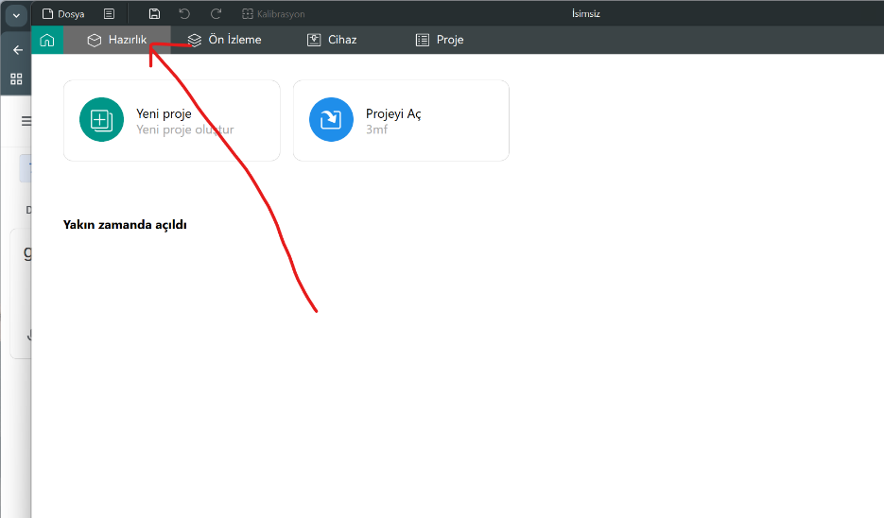
After completing the initial setup, we go to the Preparation section to add parts to the press.

While the preview menu shows a preview of the part slicing,
From the printer menu, if our printer can be controlled over Wi-Fi, instant monitoring and control of the printing on the printer is realized.

Figure 3 : Preparation menu

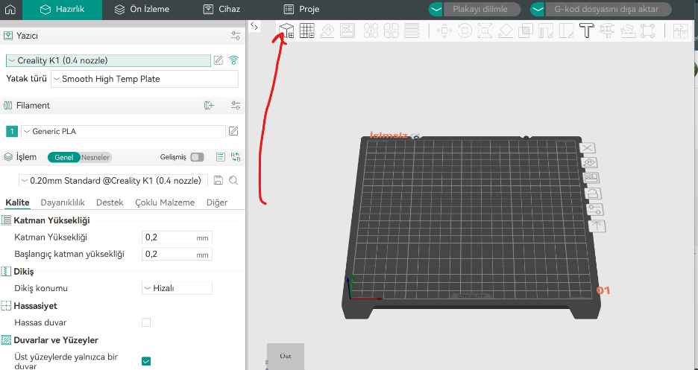
When we click on the cube shape indicated by the arrow, the menu for adding parts opens.

We add the drawing in STL or OBJ format to the program.

Figure 4 : Adding Parts to Print

ARRANGING THE PRINTING TABLE

The position of the part to be printed on the table, scaling of the part, determination of the support points, determination of the seam point, determination of the surface to sit on the table floor are made from this menu.

Select the surface of the part that will fit on the table surface.

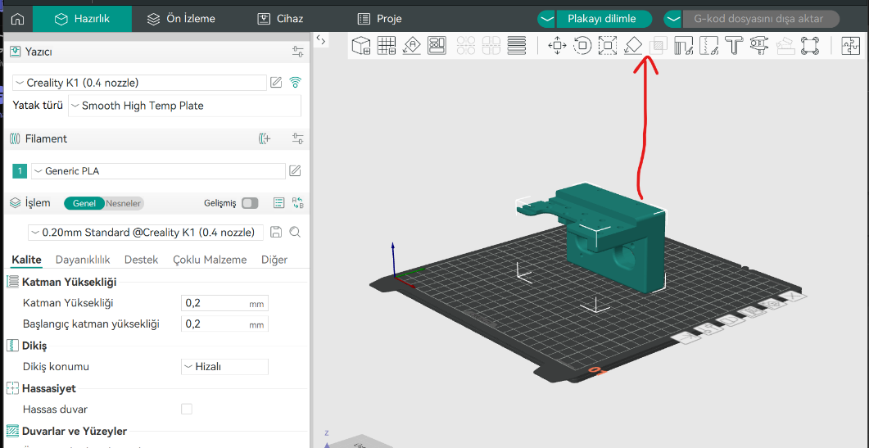
Figure 5 : Positioning the print on the table

LAYER SETTINGS
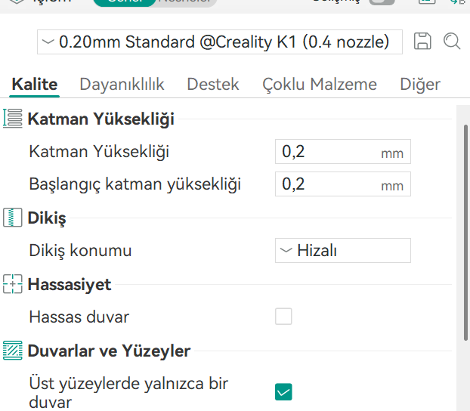

In the Quality menu, the first layer height, layer height and seam position of the part can be adjusted.

Seam position can be selected aligned as standard. However, if the seam is selected aligned in nested parts, the seam should also be taken into account when making tolerance adjustments to the part to be nested. Or the seam position should be selected randomly.

Figure 6 : Layer settings

DURABILITY SETTINGS

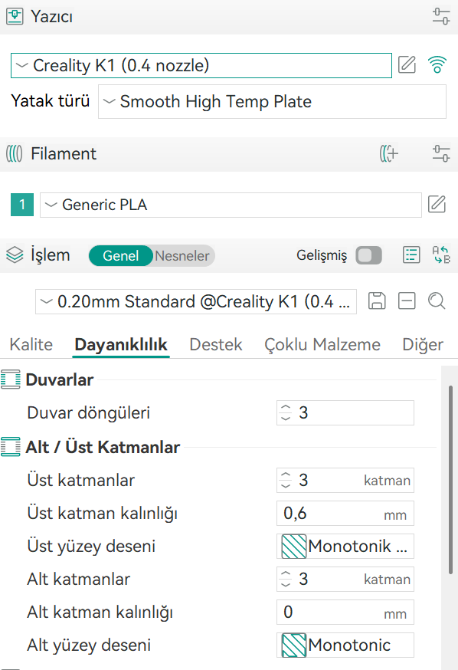
In the Durability menu, the durability settings of the print are made. If a piece with filling is selected, a top layer filling of 4 or 5 ensures that the top of the piece is properly covered. It also prevents the appearance of filling on the top surface.

Using the vase mode when printing hollow parts such as vases and chandeliers will reduce both the amount of filament to be used and the printing time.

Figure 7 : Endurance settings

SUPPORT SETTINGS
In 3D printing, some parts may have empty parts that do not touch the floor. In order to prevent sagging and distortion of the print, a support profile should be used while adjusting the slicing setting.

If your printer allows multi-filament printing, the support profiles can be printed from water-soluble hips filaments to ensure easy separation of the support from the part.

However, if printing with a single filament, it is essential to adjust the support profile in order to easily separate the supports from the print. It is important to adjust the backing so that it does not break easily during printing but is easily separated when printing is completed.
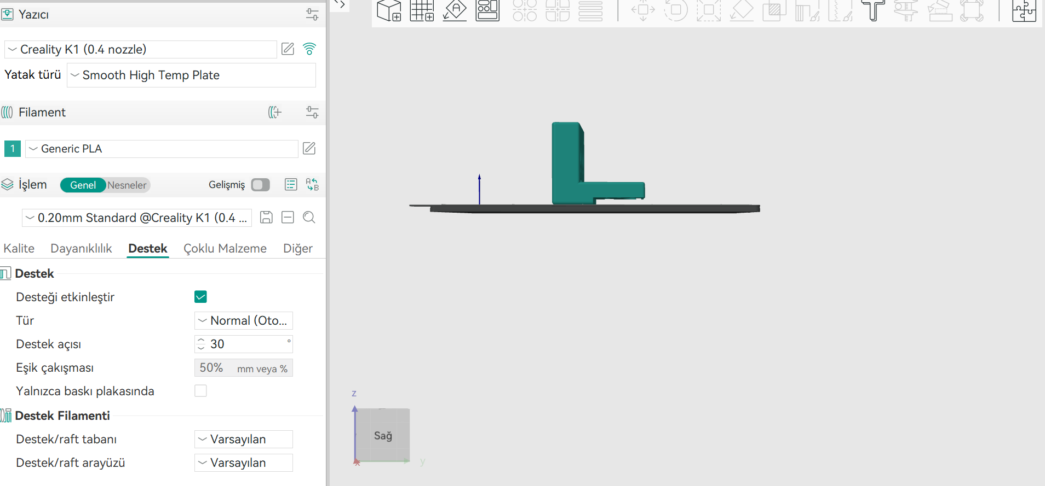

Figure 8 : Support Settings

SKIRT AND EDGE SETTINGS

Adhesives suitable for the tray can be used to ensure that the part is firmly attached to the tray and does not separate from the tray during printing. However, if printing at high speeds, glue may not be the solution.

At this point, skirts and edges can be used to hold the print to the table from more surfaces
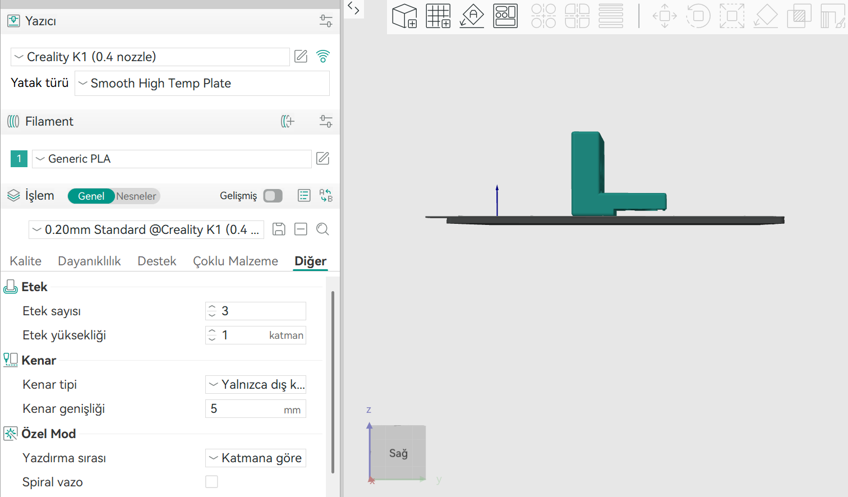

Figure 9 : Skirt and Edge Settings

SLICING AND PRINTING THE PIECE

After all print settings have been completed, the part is sliced.
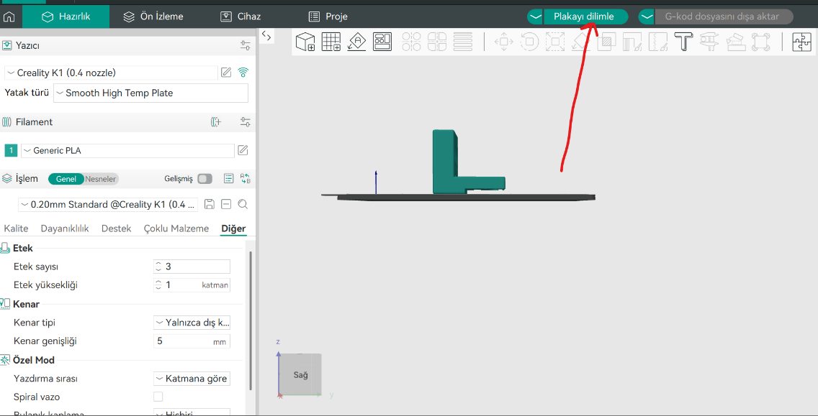

Figure 10 : Slicing the piece
The preview of the sliced part is checked. If there is no problem in slicing, the gcode file is created. It can be sent directly to the printer in printers that support wi-fi, or it can be transferred to the printer via USB memory or SD card in other printers..

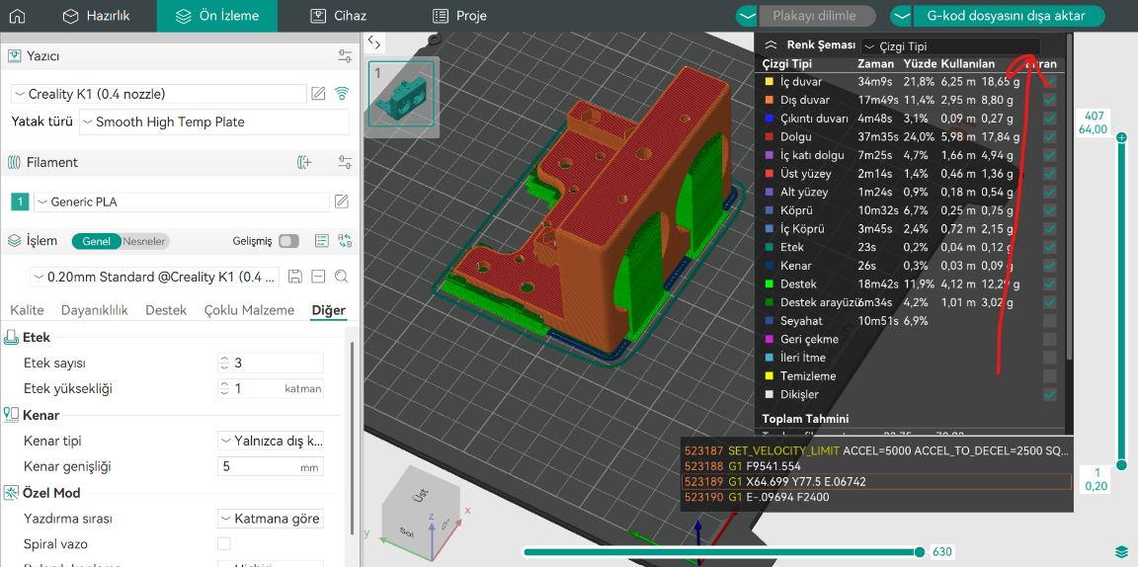

Figure 11 : Adding gcode to Printer

REMOVING THE PRINT

We start the printing process with the gcode file we send. We check the course of the print in the first few layers, if there is no problem, we take the part from the tray after the look is completed.

Figure 12 : Print removal

Index of images

Figure 1 : Adding a Printer 5
Image 2 : Adding Filament 5
Figure 3 : Preparation menu 6
Figure 4 : Adding Parts to a Print 6
Figure 5 : Positioning the print on the table 7
Figure 6 : Layer settings 8
Figure 7 : Endurance settings 9
Figure 8 : Support Settings 10
Figure 9 : Skirt and Edge Settings 11
Figure 10 : Slicing the piece 12
Figure 11 : Adding gcode to Printer 12
Figure 12 : Taking the print 13


