
WP6 COLLABORATIVE LEARNING FACTORY

DRAWING UP A MANUFACTURING RANGE





Funded by the European Union. Views and opinions expressed are however those of the author(s) only and do not necessarily reflect those of the European Union or the European Education and Culture Executive Agency (EACEA). Neither the European Union nor EACEA can be held responsible for them.
This work is licensed by the LCAMP Partnership under a Creative Commons Attribution-NonCommercial 4.0 International License.
LCAMP partners:
TKNIKA – Basque VET Applied Research Centre, CIFP Miguel Altuna LHII, DHBW Heilbronn – Duale Hochschule, Baden-Württemberg, Curt Nicolin High School, AFM – Spanish Association of Machine Tool Industries, EARLALL – European Association of Regional & Local Authorities for Lifelong Learning, FORCAM, CMQE: Association campus des métiers et des qualifications industrie du future, MV: Mecanic Vallée, KIC: Knowledge Innovation Centre, MADE Competence Centre Industria 4.0; AFIL: Associazione Fabbrica Intelligente Lombardia, SIMUMATIK AB; Association HVC Association of Slovene Higher Vocational Colleges; TSCMB:Tehniški šolski center Maribor, KPDoNE: Kocaeli Directorate Of National Education; GEBKİM OIZ and CAMOSUN college.

Document summary
Document type: | Public Course
Title | Drawing up a Manufacturing Range
Author/s | Christophe Belmon
Reviewer | Camille Léonard
Date | Jully 2025
Document status | 1.0
Document level | Confidential until its publication
Document description
Cite this deliverable as: | Belmon C., 2025, Drawing up a Manufacturing Range
Document level | Public

CONTENT TABLE

Executive Summary 7
1. course OBJECTIve 8
2. The process 8
3. Course 9
3.1. Definitions 9
3.2. Morphological Study of the Machined Part 10
3.2.1. The first machined surface must provide maximum stability for the subsequent machining operations. 10
3.2.2. The part resting on the first machined surface, must be able to be effectively clamped. 10
3.3. Analysis of Critical Specifications 10
3.3.1. Intrinsic dimensions for which: IT < 0,05 mm 10
3.3.2. Dimensions between surfaces for which: IT < 0,1 mm 10
3.3.3. Geometric tolerances for which: IT ~ 0,1 %. 10
3.3.4. Surface roughness: Ra ≤ 1,6. 10
3.4. Decisions for Making Intrinsic Surfaces 10
3.4.1. Role of the Operations 11
3.4.2. The dimensional and geometric quality of the surface depends on the consistency of the finishing chip thickness, as well as the rigidity of the tools, machines, and parts 11
3.4.3. Frontier between cutting tool and abrasive tool 12
3.4.4. Generating processes should be preferred over form processes for surfaces with tight intrinsic specifications. 12
3.4.5. To achieve the desired surface roughness, the feed rate must be selected according to the tool nose radius. 12
3.5. Decisions on the Grouping of Surface Machining 12
3.5.1. For two surfaces A and B linked by tight specifications, the following should be applied: 12
3.5.2. All accessible surfaces must be machined in the same phase 12
3.5.3. Finishing tools, which are fragile or expensive, must begin cutting, or even exit, On pre-machined (prepared) surfaces 13
3.6. Order of Operations 13
3.6.1. Finishing tools, being fragile or expensive, should operate for the shortest possible time, therefore over a minimal cutting path. 13
3.6.2. Tool entry and exit should be facilitated. To do this, plan for: 13
3.6.3. Machining operations that weaken the part should be postponed as late as possible. 14
3.6.4. The cutting edges of deformable tools (such as grooving tools or drills) must be loaded symmetrically. 14
3.6.5. In the case of intersection of surfaces the burr must be rejected: 14
3.6.6. Unless another rule contradicts it, the operation order should aim to allow the use of the most rigid tools possible. 14
3.7. Order of Phases 15
3.7.1. In phase 10, the surface or group of surfaces must be machined to ensure the most stable position possible and good clamping in subsequent phases. 15
3.7.2. If reworking is possible and equivalent in terms of stability on a plane or on a long cylinder, the support on the plane should be chosen. 15
3.7.3. The first three phases must enable the necessary and sufficient rework surfaces to be machined for subsequent positioning. 15
3.7.4. Beyond phase 20 or 30, a recovery on raw should only be exceptional 15
3.7.5. In the case where two surfaces A and B are positioned relative to each other (geometry, position, clamped side) and can be machined in relation to one another, the surface that offers the best rework stability and the possibility of correct clamping must be machined first. 15
3.7.6. Machining of fragile and precise surfaces—threads, ground surfaces, etc. should be delayed until later in the manufacturing process. 15
3.7.7. A precise finish must be removed from a blank which has given off too much heat. 15
3.8. Selection of Starting Surfaces 16
3.8.1. During the initial phases, the choice of positioning must allow for optimal distribution of material around the machined areas. 16
3.8.2. The positioning must be chosen to provide the best stability of the part during cutting. 16
3.8.3. Positioning dispersions should be kept to a minimum by positioning on good quality rough surfaces 16
3.8.4. The supports must oppose the cutting forces 16
3.9. positioning 16
3.9.1. La Positioning must be isostatic. 16
3.9.2. The support points defining a surface or a basic line must be as far apart as possible. 16
3.9.3. Rule 1.8.4 remains strictly applicable 16
3.9.4. The relative position of the elementary surfaces involved in positioning must allow the use of standard tooling. 16
3.9.5. Positioning and clamping elements must never interfere with the tool path. 16
3.10. Clamping 16
3.10.1. The position of the clamping points and the intensity of clamping must be such that the workpiece remains stable under the cut 17
3.10.2. Under no circumstances should the actions of the clamping on the part cause deformations that would result in the rejection of the part 17
3.11. Additional rules concerning machining on MOCN 17
3.11.1. When a tool is in place on its workstation, it must perform as many operations as possible 17
3.11.2. Operations must be organised in such a way as to reduce tool cycle times. 17
3.11.3. Drilling and reaming operations are carried out using machining cycles. 17
3.11.4. Contouring, it is possible to achieve a quality grade of 6–7 (finishing pass). 17
3.11.5. The part will be produced in a minimum number of phases. 17
3.11.6. On a machining center, the objective will be to access as many part faces as possible in the same phase: 17
3.11.7. If reworking is performed on a CNC machine, positioning deviations will be eliminated by: 18
3.11.8. Tool cycles should be as short as possible 18
4. Guided workS 18
4.1. Analysis of the Part 20
4.1.1. Analyse the morphology of the part 20
4.1.2. To analyse drawing spécifications 20
4.2. Define surface groupings 21
4.2.1. Identify machining directions 21
4.2.2. Complete the surface groupings table below 21
4.2.3. Make decisions on the production of intrinsic surfaces 21
4.3. Define Operation Groupings 22
4.4. Order the Machining Phases 22
4.4.1. Propose an Preliminary Manufacturing Study 22
4.4.2. PROPOSE ANOTHER Preliminary Manufacturing Study 23
5. References 24
6. Index of Images 25
7. Index of tables 25
8. Annexes 26
8.1. Annex 1 26
8.2. Annex 2: CORRECTION 30
8.2.1. Analysis of the part 30
8.2.2. Defining Surfaces Groupings 31
8.2.3. Define Operation Groupings 32
8.2.4. Order the Machining Phases 33
Draw up the machining range (Fill in a range sheet for each Preliminary Manufacturing Design) 33

Executive Summary
(ABSTRACT) Lorem ipsum dolor sit amet, consectetuer adipiscing elit, sed diam nonummy nibh euismod tincidunt ut laoreet dolore magna aliquam erat volutpat. Ut wisi enim ad minim veniam, quis nostrud exerci tation ullamLorem ipsum dolor sit amet, consectetuer adipiscing elit, sed diam nonummy nibh euismod tincidunt ut laoreet dolore magna aliquam erat volutpat. Ut wisi enim ad minim veniam, quis nostrud exerci tation ullam.
.

course OBJECTIve
The general rules outlined below will guide you as reliably as possible from the product definition drawing to the drafting of preliminary manufacturing study projects.
Despite similarities and analogies, each part must be considered a unique case.
Every manufacturing study is therefore dependent on:
- the part itself
- the production rate
- the available equipment
- the available personnel
- the deadlines
- the economic climate
These rules will apply to:
- parts that do not undergo heat treatment; after treatment, parts may only be machined using abrasive tools, electrical discharge machining (EDM), or high-speed machining (HSM)
- parts whose deformation due to cutting forces is negligible
- parts machined on conventional machine tools
- parts machined on CNC (computer numerical control) machines (see rules in the annexes)

The process
The manufacturing analysis involves 9 steps, which, thanks to the application of established rules and a number of decisions and compromises, should lead to the general scheduling of the manufacturing process.
Table 1. Nine steps of the manufacturing analysis
STEP | OBJECTIVE
1) Morphological study of the machined part | Make a likely initial choice of the first phase
2) Analysis of critical specifications | Identify the risks of rejects
3) Decision on the production of intrinsic surfaces | Ensure surface quality
4) Decision on grouping of surface machining | Limiting rework gaps and handling
5) Order of operations | Ensure part quality and minimize cost
6) Order of phases | Ensure part quality and minimize cost
7) Choice of starting surfaces | Ensure the best possible "balancing" of the raw part
The following two steps should enable proper drafting of the preliminary phase plans:
8) Positioning | Reducing recovery gaps
9) Clamping | Ensure the stability of the part during cutting

Course

Definitions
Workstation: Machine equipped to carry out a set of operations.
Operation: Execution of one or more basic surfaces, performed without dismounting the part.
Phase: A set of operations (possibly grouped into sub-phases) carried out at the same workstation. They are usually referred to by the name of the machine on which the operations are performed. Example: Example: Phase 10 TURNING.
Sub-phase: A set of operations performed without dismounting the part.
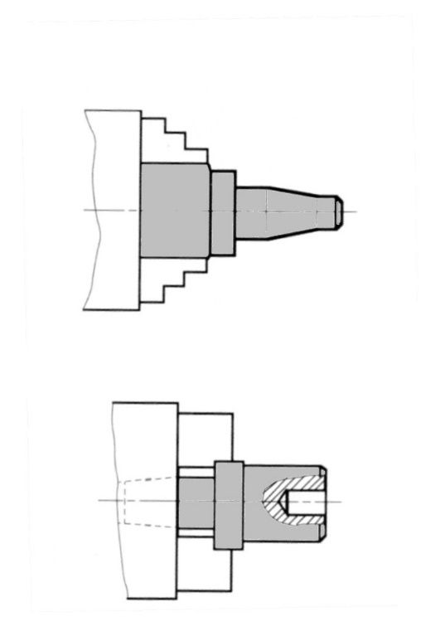
Sub-phase A: chuck: 3 hard jaws Sub-phase B: chuck: 3 soft jaws
Figure 1. Sub-phase A: Chuck: hard jaws.
Figure 2. Sub-phase B: chuck: 3 soft jaws

Morphological Study of the Machined Part
OBJECTIVE: To make a priori a probable choice of the first phase.

The first machined surface must provide maximum stability for the subsequent machining operations.
Note: A cylinder can be considered dominant over a plane when:
Projected surface area of the cylinder ≥ 1,5 surface area of the plane.
A cylinder can be considered usable for reworking when:
Length of the cylinder ≥ à 1,25 Ø cylinder.

The part resting on the first machined surface, must be able to be effectively clamped.

Analysis of Critical Specifications
OBJECTIVE: To identify the risks of scrap.
Only the following specifications will be considered as critical to achieve, and therefore analysed accordingly:

Intrinsic dimensions for which: IT < 0,05 mm

Dimensions between surfaces for which: IT < 0,1 mm

Geometric tolerances for which: IT ~ 0,1 %.

Surface roughness: Ra ≤ 1,6.

Decisions for Making Intrinsic Surfaces
OBJECTIVE: to ensure the quality of surfaces.
Focus is placed on the surfaces mentioned in sections 3.3.1 and 3.3.4.
The choice of the number of operations and the number of tools will be deduced from this analysis.

Role of the Operations
- Roughing: Removes excess material and prepares the part for subsequent operations.
- Semi-finishing: Shapes the surface and defines its position.
- Finishing: gives the surface its dimensions and roughness.
EACH OPERATION REQUIRES A DIFFERENT TOOL

The dimensional and geometric quality of the surface depends on the consistency of the finishing chip thickness, as well as the rigidity of the tools, machines, and parts
- The pass preceding the finishing operation must establish the geometry of the surface
- Therefore, in general and depending on the condition of the raw part, the decision will be:
  - 3 operations for quality < 8
- 2 operations for quality < 9–10
- 1 operation for quality > 10

Table 2. Table to Assist in Choosing the Number of Machining Operations
CRITERIA | 1  OPERATION | 2 OPERATIONS | 3 OPERATIONS | 4 OPERATIONS
IT > 0,4
0,15 < IT < 0,4
0,05 < IT < 0,15
IT < 0,05
Quality > 12
Quality 9-11
Quality 7-8
Quality < 7
Ra < 0,8 | Correction to be expected

QUALITIES LESS THAN OR EQUAL TO 6 REQUIRE CORRECTION OR EVEN SUPERFINISHING.

Frontier between cutting tool and abrasive tool
Grinding is intended for heat-treated parts.
Depending on the risk of deformation and the required surface roughness, grinding can be carried out up to grade 10.
For untreated parts, grinding is essential:
- For external surfaces with quality grades < 7
- For internal surfaces with quality grades < 6 (grade 7 can be achieved with a reamer, if possible)

Generating processes should be preferred over form processes for surfaces with tight intrinsic specifications.

To achieve the desired surface roughness, the feed rate must be selected according to the tool nose radius.

Decisions on the Grouping of Surface Machining
OBJECTIVE: Minimize handling and reworking deviations.
Rule imposed by an analysis of the geometry and relative dimensions of the surfaces.

For two surfaces A and B linked by tight specifications, the following should be applied:
- Machine A and B in the same phase
If that is not possible:

- Machine B by positioning on A
If that is still not possible:

- Machine both surfaces A and B by positioning on the same reference surface.
Rules imposed by combinations related to machine tools and cutting tools.
OBJECTIVE: To reduce the number of phases and idle times.

All accessible surfaces must be machined in the same phase
Association principle:

Technological criteria
When multiple surfaces are generated simultaneously:
Table 3. Plane cylinder and plan-plan connections
PLANE CYLINDER CONNECTION | PLAN-PLAN CONNECTION
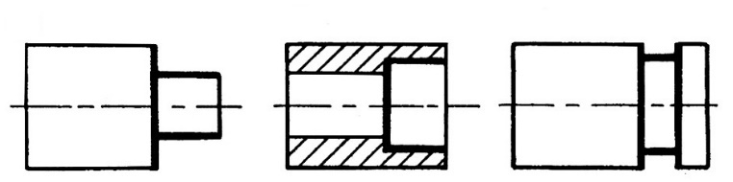 | 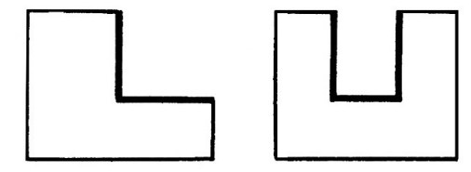

Economic Criteria
The grouping of certain surfaces reduces machining costs:

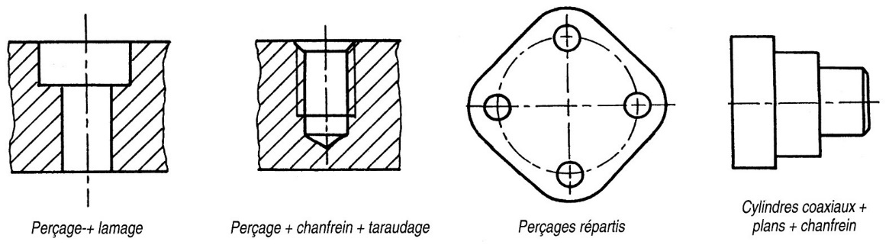
Figure 3. Grouping of surfaces associated with machining costs

Finishing tools, which are fragile or expensive, must begin cutting, or even exit, On pre-machined (prepared) surfaces

Order of Operations
Objective: Ensure part quality at minimum cost.

Finishing tools, being fragile or expensive, should operate for the shortest possible time, therefore over a minimal cutting path.

Tool entry and exit should be facilitated. To do this, plan for:
- Entry chamfers for finishing tools, taps, and reamers.
- Clearance volumes for boring tools, taps, reamers, and grinding wheels

Machining operations that weaken the part should be postponed as late as possible.

The cutting edges of deformable tools (such as grooving tools or drills) must be loaded symmetrically.

In the case of intersection of surfaces the burr must be rejected:
- Either on the surface on which it can be tolerated (which imposes the order of finishes).
- Or on the surface accessible for deburring.

Unless another rule contradicts it, the operation order should aim to allow the use of the most rigid tools possible.

Order of Phases
objective : To ensure part quality at minimum cost.
The rules relating to operations remain applicable to the phases.

In phase 10, the surface or group of surfaces must be machined to ensure the most stable position possible and good clamping in subsequent phases.

If reworking is possible and equivalent in terms of stability on a plane or on a long cylinder, the support on the plane should be chosen.

The first three phases must enable the necessary and sufficient rework surfaces to be machined for subsequent positioning.

Beyond phase 20 or 30, a recovery on raw should only be exceptional

In the case where two surfaces A and B are positioned relative to each other (geometry, position, clamped side) and can be machined in relation to one another, the surface that offers the best rework stability and the possibility of correct clamping must be machined first.

Machining of fragile and precise surfaces—threads, ground surfaces, etc. should be delayed until later in the manufacturing process.

A precise finish must be removed from a blank which has given off too much heat.
A general outline will be produced before the semi-finishing and finishing phases.

Selection of Starting Surfaces
objective : Ensure optimal balance.

During the initial phases, the choice of positioning must allow for optimal distribution of material around the machined areas.

The positioning must be chosen to provide the best stability of the part during cutting.

Positioning dispersions should be kept to a minimum by positioning on good quality rough surfaces

The supports must oppose the cutting forces

positioning
objectif: Reduce as much as possible the reworking deviations of parts in the workpiece holders.

La Positioning must be isostatic.

The support points defining a surface or a basic line must be as far apart as possible.

Rule 1.8.4 remains strictly applicable

The relative position of the elementary surfaces involved in positioning must allow the use of standard tooling.

Positioning and clamping elements must never interfere with the tool path.

Clamping
objective : To ensure that the complete connection is maintained under the action of the cutting forces.

The position of the clamping points and the intensity of clamping must be such that the workpiece remains stable under the cut
The fixing point should be placed near the location where cutting forces occur

Under no circumstances should the actions of the clamping on the part cause deformations that would result in the rejection of the part
- En flexion, torsion , flambage.
- Au matting.

Additional rules concerning machining on MOCN
Care must be taken with:
- choice of tools (type, material)
- cutting conditions (tool life)
- swarf removal.

When a tool is in place on its workstation, it must perform as many operations as possible

Operations must be organised in such a way as to reduce tool cycle times.

Drilling and reaming operations are carried out using machining cycles.

Contouring, it is possible to achieve a quality grade of 6–7 (finishing pass).

The part will be produced in a minimum number of phases.

On a machining center, the objective will be to access as many part faces as possible in the same phase:
- Through clever part gripping.
- By using a rotary table.
- To improve workpiece pick-up, the following features are required:
- Jaw pick-up or centering on turning parts.
- A plane face and possibly two bores for milling parts.

If reworking is performed on a CNC machine, positioning deviations will be eliminated by:
- Probing an already machined surface with a Renishaw-type device integrated into the machine.
- A calculation that will allow a change of the program origin.

Tool cycles should be as short as possible

Guided workS
The goal of this set of sessions is to design the manufacturing process for the robot's WS4P010 part.
Figure 4. Chassis view

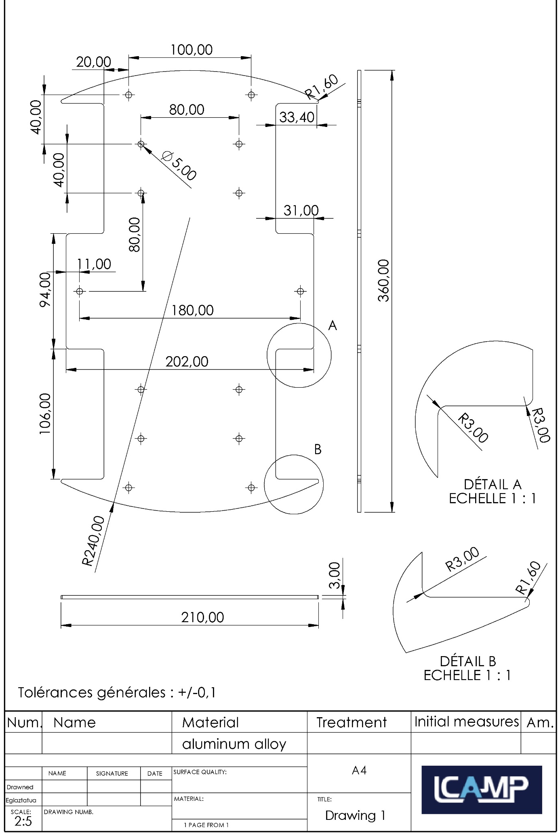
Figure 5. Image for designing the manufacturing process for the robot's WS4P010 part

Analysis of the Part

Analyse the morphology of the part
Objective : make the most likely choice for the first phase
Locate the rough and machined surfaces using the marking system defined below
Start with reference surfaces.
Identify surfaces that remain rough and mark them on the Bi drawing.
Identify machined surfaces and mark them on the drawing: plane Pi, cylinder Ci, other Xi.

4
5

1
6
Directions d’usinage
3
2
Figure 6. Analysis of the Part

To analyse drawing spécifications
OBJECTIVE: identify scrap risks and related surfaces.

Complete the analysis table below.

To be completed at 4.2.1 ↓
Table 4. Analysis of drawing specifications
Reference  surface | Reference element | Number | Specification | Tolerance zone | Link with specified reference(s) or other element(s)or other element(s)s) | Machining direction (see 2.1.1)

Highlight tricky specifications. That is: IT ≤ 0.05 ; qualité ≤ 7 ; Ra ≤ 0.8 ; zone de tolérance ≤ 0.05
Highlight them in the table on the previous page.

Define surface groupings
Some surfaces cannot be produced separately; they are grouped by technological requirements (grooving, counterboring, etc.).

Identify machining directions
Complete the « Machining Directions » column in the table 4.1.2

Complete the surface groupings table below

Make decisions on the production of intrinsic surfaces
OBJECTIVE : Ensure surface quality.
Some surfaces may require semi-finishing and finishing operations, or the use of specific machining processes, such as grinding.
Complete the "Comments" column of the surface grouping table.

Table 5. Decisions on the production of intrinsic surfaces
Machining direction | Surface groupings | Comments
1
2
3
4
5
6

Define Operation Groupings
OBJECTIVE: limit rework deviations and handling.
Complete the machining operation grouping table.
Table 6. Machining operation grouping table
Operations grouping | Surfaces

Order the Machining Phases
Draw up the machining order (fill in one order sheet per Preliminary Manufacturing Study).

Propose an Preliminary Manufacturing Study

Table 7. Preliminary Manufacturing Study -1 Nomenclature of phases and sub-phases
Preliminary Manufacturing Study -1 Nomenclature of phases and sub-phases
N° phase | S/ Phase | Designation of phases & operations | Machine | Positioning | Sketch

PROPOSE ANOTHER Preliminary Manufacturing Study
Table 8. Preliminary Manufacturing Study -2 Nomenclature of phases and sub-phases phase
Preliminary Manufacturing Study -2 Nomenclature of phases and sub-phases phase
N° phase | S/ Phase | Designation of phases & operations | Machine | Positioning | Sketch

References
Abele, E., Metternich, J., Tisch, M., Chryssolouris, G., Sihn, W., ElMaraghy, H., . . . Ranz, F. (2015). Learning Factories for Research, Education, and Training. Procedia CIRP, Volume 32, 1-6.
Abele, E., Metternich, J., Tisch, M., Chryssolouris, G., Sihn, W., ElMaraghy, H., . . . Ranz, F. (2015). Learning factories for research, education, and training. Procedia CIRP 32:1–6. doi: https:// doi. org/ 10. 1016/j. procir. 2015. 02. 187
Aegilmez, S. (2021). Forcam Force Edge Manual. (F. gmbh, Producer) Retrieved from https://forcam.com/app/uploads/2021/11/Manual-FORCAM-FORCE-EDGE.pdf
Belinski, R., Peixe, A., Frederico, G., & Garza-Reyes, J. (2020). Organizational learning and industry 4.0: findings from a systematic literature review and research agenda.. Benchmarking 27(8), 2435–2457. doi:https:// doi. org/ 10. 1108/BIJ- 04- 2020- 0158

Index of Images
Figure 1. Sub-phase A: Chuck: hard jaws. 10
Figure 2. Sub-phase B: chuck: 3 soft jaws 10
Figure 3. Grouping of surfaces associated with machining costs 14
Figure 4. Chassis view 19
Figure 5. Image for designing the manufacturing process for the robot's WS4P010 part 21
Figure 6. Analysis of the Part 21
Figure 7. Annexe: Analyse the morpholofy of the part 31

Index of tables
Table 1. Nine steps of the manufacturing analysis 9
Table 2. Table to Assist in Choosing the Number of Machining Operations 12
Table 3. Plane cylinder and plan-plan connections 14
Table 4. Analysis of drawing specifications 22
Table 5. Decisions on the production of intrinsic surfaces 23
Table 6. Machining operation grouping table 23
Table 7. Preliminary Manufacturing Study -1 Nomenclature of phases and sub-phases 24
Table 8. Preliminary Manufacturing Study -2 Nomenclature of phases and sub-phases phase 24
Table 9. 1st Machining phase 27
Table 10. Combining surfaces 28
Table 11. Order of operations 29
Table 12. Moving into position (MiP) and holding in position (MaP) 30
Table 13. Annexe: Analyse the design drawing specifications 32
Table 14. Annexe: Making decisions on the creation of intrinsic surfaces 33
Table 15. Annexe: Define operation groupings 33
Table 16. Annexe: Preliminary Manufacturing Study -1 Nomenclature of phases and sub-phases 34
Table 17. Annexe: Preliminary Manufacturing Study -2 Nomenclature of phases and sub-phases 35

Annexes

Annex 1
Resource document: application rules
Table 9. 1st Machining phase
Rule | Illustration
Positioning the part in the 1st machining phase must :  allow good material distribution (balancing),  be carried out on quality raw surfaces (avoid parting lines),  facilitate effective clamping. | 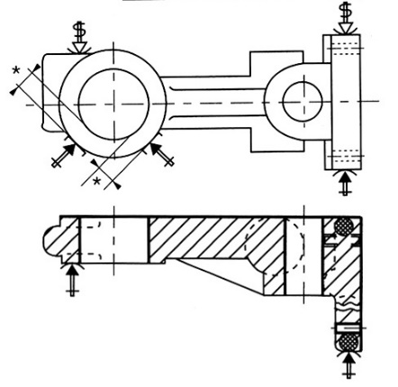  * Distribution of materials  1st phase
The surfaces machined in the first phase must contribute to the positioning of the next phase and, if possible, allow for the complete definition of the reference system.
The part, resting on the first machined surface, must be easy to clamp securely. | 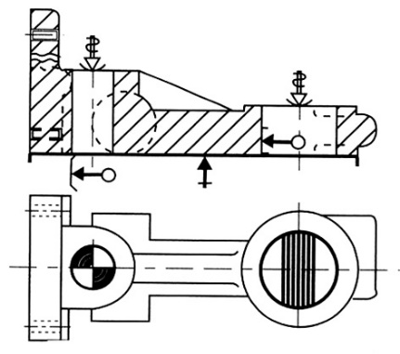  For the 2nd phase, the reference frame is made up of machined surfaces (plane support, centring, locating).

Table 10. Combining surfaces
Rule | Illustration
For surfaces with delicate specifications, give priority to:
- Machining these surfaces in the same phase, if they can be combined | 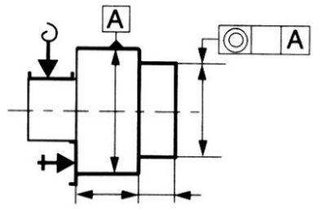
- Machining one surface by positioning it on the other. | 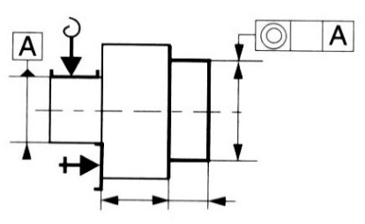
- The machining of these 2 surfaces concerning the same reference frame | 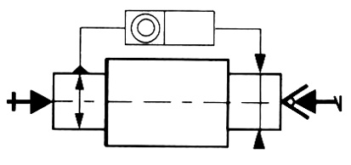
During the machining phase, the maximum number of accessible surfaces compatible with the machine and its equipment must be machined | 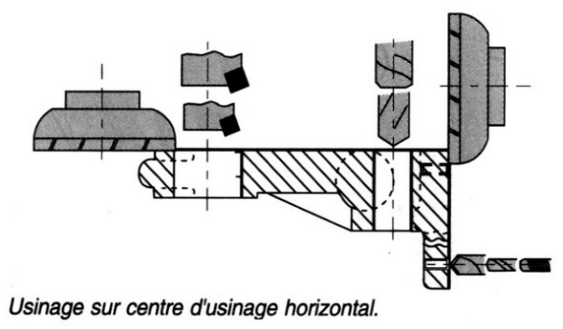  Machining on a horizontal machining centre
Fragile and expensive finishing tools should attack and, if possible, clear machined surfaces | 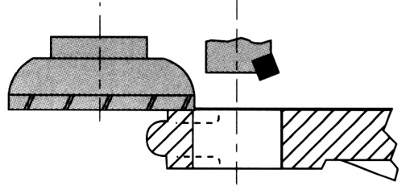  The drawing is machined before machining.
The finishing tool must work alone | 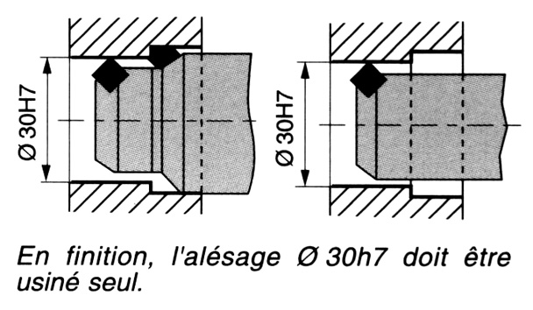  To finish, bore Ø 30h7 must be machined alone

Table 11. Order of operations
Rule | Illustration
The choice of the number of operations required to produce an elementary surface depends on the surface condition and the quality of the desired dimensions.

The roughing operation eliminates the surface layer of metal whose physical and geometrical defects are the result of the blank manufacturing process.
The semi-finishing operation ensures the regularity of the finishing chip and the geometric accuracy of position.
The finishing operation must meet the required quality (dimensions, tolerances, surface finish).
Make a general rough sketch before starting to finish fragile and precise surfaces (risk of deformation, heat generation).  (Drafts of A and D before finishing) | 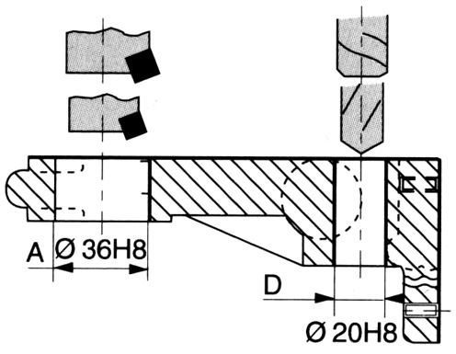
If burrs are formed, they must be rejected on a non-functional surface. | 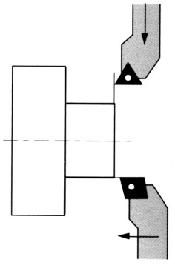  You have to put up a front before you can argue.
In the case of intersecting holes, the small diameter should be drilled first to avoid deflecting the tools. | 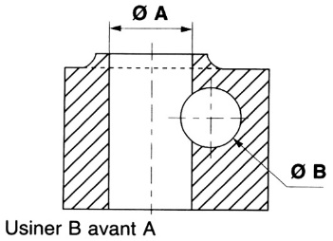  Machine B before A
Boring and tapping operations must be preceded by a chamfering operation. | 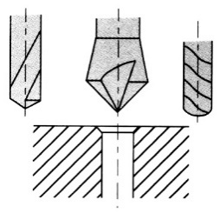

Table 12. Moving into position (MiP) and holding in position (MaP)
Rule | Illustration
Workpiece positioning must be isostatic. However, when machining deformable parts, additional adjustable supports can be added to prevent any deformation.
The aim should be to achieve maximum stability of the part by keeping the support points as far apart as possible. | 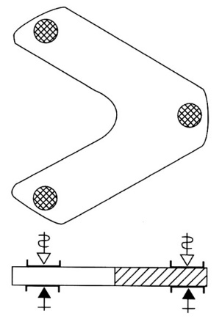
The clamping forces must not deform the workpiece. | 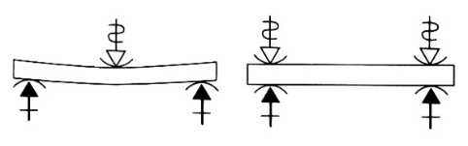
The supports must resist cutting forces, except in the case of ceiling mounting where the feed forces are low. | 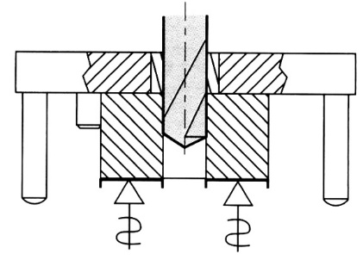  Ceiling mounting

Annex 2: CORRECTION

Analysis of the part

Analyse the morpholofy of the part
Objective: make the most likely choice for the first phase
Locate the raw and machined surfaces using the markings defined below.
Start with the reference surfaces.
Identify the surfaces that remain rough and mark them on the Bi drawing.
Identify the machined surfaces and mark them on the drawing: plane Pi, cylinder Ci, other Xi.

C1 (x14)
B1
4
5

1
6
Directions d’usinage
3
2
X1
B2
Figure 7. Annexe: Analyse the morpholofy of the part

Analyse the design drawing specifications
OBJECTIVE : To identify the risks of scrap and related surfaces.

Complete the analysis table below
To be completed at 4.2.1 ↓
Table 13. Annexe: Analyse the design drawing specifications
Surface mark | Reference element | Number | Specification | Tolerance zone | Link with specified reference(s) or other element(s) | Machining direction  (see 2.1.1)
B1 |  | 1 | 3 | ± 0,1 | B2
B2 |  | 1 | 3 | ± 0,1 | B1
C1 |  | 14 | ∅5  100  80  180  11  20 | ± 0,1  ± 0,1  ± 0,1  ± 0,1  ± 0,1  ± 0,1 | C1  C1  C1  X1  X1 | 1,4
X1  (Contour de la pièce) |  | 1 | R1,6  R3  R240  33,4  31 | ± 0,1  ± 0,1  ± 0,1  ± 0,1  ± 0,1 |  | 1, 4

Highlight the tricky specifications.
That is to say: IT ≤ 0.05; quality ≤ 7; Ra ≤ 0.8; tolerance zone ≤ 0.05
Highlight them in the table on the previous page.

Defining Surfaces Groupings
Some surfaces cannot be machined separately; they are grouped together by technological requirement (grooving, facing, etc.)

8.2.2.1 Identify the machining directions
Complete the “Machining directions” column in table 4.1.2.

8.2.2.2. Complete the surface grouping table below

2.2.2.3. Making decisions on the creation of intrinsic surfaces
OBJECTIVE : to ensure surface quality.
Some surfaces may require 1/2 finishing and finishing operations, or the use of special machining processes, such as grinding.
Complete the “Comments” column of the surface grouping table

Table 14. Annexe: Making decisions on the creation of intrinsic surfaces
Machining direction | Surface grouping | Comments
1 | C1, X1
2
3
4 | C1, X1
5
6

Define Operation Groupings
OBJECTIVE : limit rework and handling errors
Complete the table of machining operation groupings

Table 15. Annexe: Define operation groupings
Group of operations | Surfaces
Drilling, Contouring | C1, X1

Order the Machining Phases

Draw up the machining range (Fill in a range sheet for each Preliminary Manufacturing Design)

Propose a Preliminary Manufacturing Study

Table 16. Annexe: Preliminary Manufacturing Study -1 Nomenclature of phases and sub-phases
Preliminary Manufacturing Study -1 Nomenclature of phases and sub-phases
N° phase | S/ Phase | Description of phases and operations | Machine | Positioning | Sketch
10 |  | Raw capacity:  400x250 in plate thickness 3
20 |  | Pointing, C1 drilling (x14)  Additional screw clamping in 4 holes ∅5  Contouring X1 with cutter 2 sizes | 3-axles CUCN with vertical spindle | Installed on a martyr plate  Supported by flanges  Supported by flanges and screws

Propose another Preliminary Manufacturing Study

Table 17. Annexe: Preliminary Manufacturing Study -2 Nomenclature of phases and sub-phases
Preliminary Manufacturing Study -2 Nomenclature of phases and sub-phases
N° phase | S/ Phase | Description of phases & operations | Machine | Positioning | Sketch
10 |  | Raw capacity:  400x250 in plate thickness 3
20 |  | Pointing, C1 drilling to diameter 2 (x14) for wire passage | 3-axis CUCN with vertical spindle | Mounting on martyr plate  Support by flanges
30 |  | Drilling C1 to diameter 5 (x14)  Contouring X1 | Wire EDM machine | Support by flanges



