
WP6 COLLABORATIVE LEARNING FACTORY

3D PRINTERS




Funded by the European Union. Views and opinions expressed are however those of the author(s) only and do not necessarily reflect those of the European Union or the European Education and Culture Executive Agency (EACEA). Neither the European Union nor EACEA can be held responsible for them.
This work is licensed by the LCAMP Partnership under a Creative Commons Attribution-NonCommercial 4.0 International License.
LCAMP partners:
TKNIKA – Basque VET Applied Research Centre, CIFP Miguel Altuna LHII, DHBW Heilbronn – Duale Hochschule, Baden-Württemberg, Curt Nicolin High School, AFM – Spanish Association of Machine Tool Industries, EARLALL – European Association of Regional & Local Authorities for Lifelong Learning, FORCAM, CMQE: Association campus des métiers et des qualifications industrie du future, MV: Mecanic Vallée, KIC: Knowledge Innovation Centre, MADE Competence Centre Industria 4.0; AFIL: Associazione Fabbrica Intelligente Lombardia, SIMUMATIK AB; Association HVC Association of Slovene Higher Vocational Colleges; TSCMB:Tehniški šolski center Maribor, KPDoNE: Kocaeli Directorate Of National Education; GEBKİM OIZ and CAMOSUN college.

Document summary
Document type: | Public Course
Title | 3D Printers
Author/s | Daniel Guiraudie
Reviewer | Camille Léonard
Date | Jully 2025
Document status | 1.0
Document level | Confidential until its publication
Document description | This course aims to cover the basics and history of additive manufacturing, explore its applications, present some of its principles, and outline a process for printing a part using the fused filament fabrication (FFF) method.
Cite this deliverable as: | Guiraudie D., 2025, 3D Printers
Document level | Public

CONTENT TABLE

Executive Summary 5
1. Introduction 6
1.1. General Information 6
1.2. Examples of Parts 6
1.3. History 8
2. 3D Printing – Applications 9
2.1. Advantages 9
2.2. Disadvantages 9
3. General Approach 10
3.1. Main Steps 11
3.1.1. CAD Model Recuperation 11
3.1.2. Converting the CAD Model 11
3.1.3. Preparation for Printing 12
3.1.4. Application 14
4. Index of Images 17
5. Index of tables 17
6. Annexes 18
6.1. Typology of the Main Principles 18
6.1.1. Pastic and Composite Materials 18
6.1.2. Metalic Materials 19

Executive Summary

In this course (which is not intended to be exhaustive), we will cover the basics and history of additive manufacturing, explore its applications, present some of its principles, and outline a process for printing a part using the fused filament fabrication (FFF) method.

.

Introduction

General Information
3D printing offers :
- greater design freedom
- material savings
- localized production
- object customization
Indeed, in most cases, traditional manufacturing starts from a raw block from which material is removed to obtain the desired part, whereas additive manufacturing builds the object layer by layer.
The two manufacturing processes are complementary, but the way parts are designed is different. The fields of application are very diverse: aerospace, space industry, automotive, medical, civil engineering…

Examples of Parts
Civil Engineering | Automotive | Aerospace
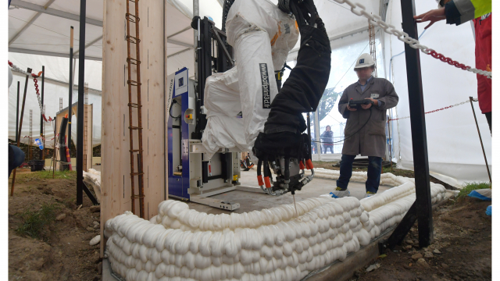 | 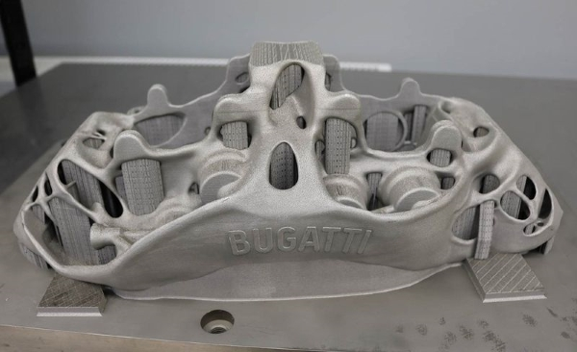  Brake caliper | 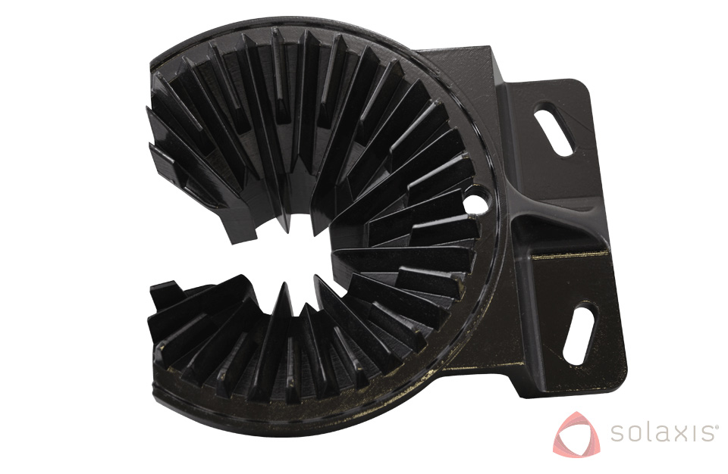
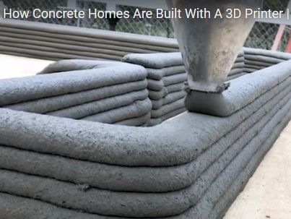 | 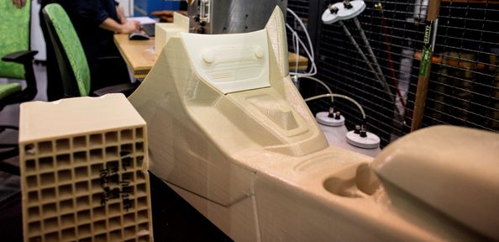  Interior cockpit prototype | 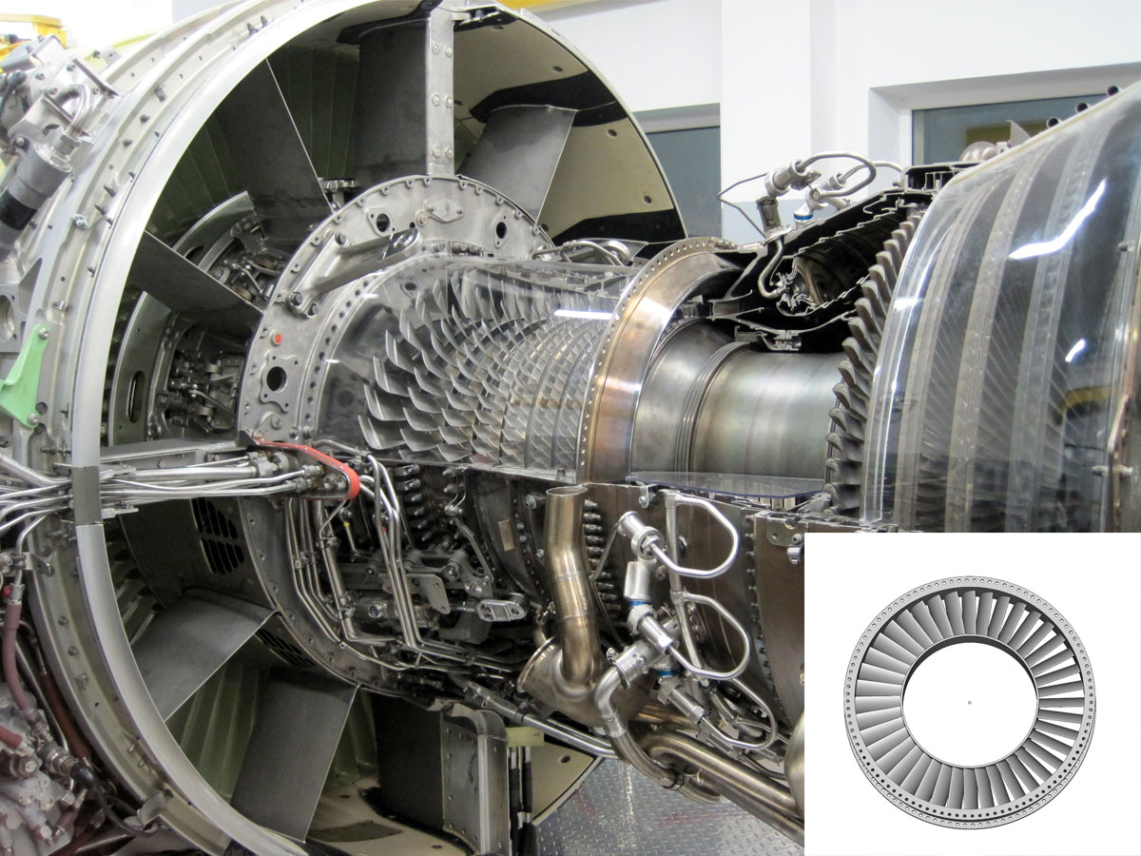  Turbine blade
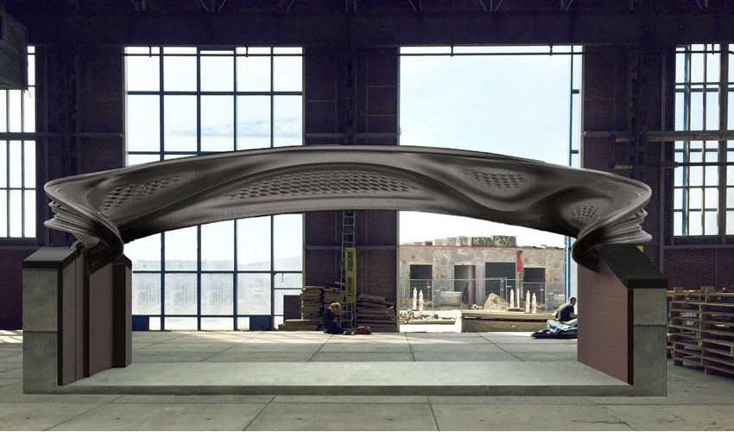
3D-printed steel bridge

It is possible to customize the product, meet short lead times, produce small series, and create complex shapes—all while reducing costs.

Evolution graphs

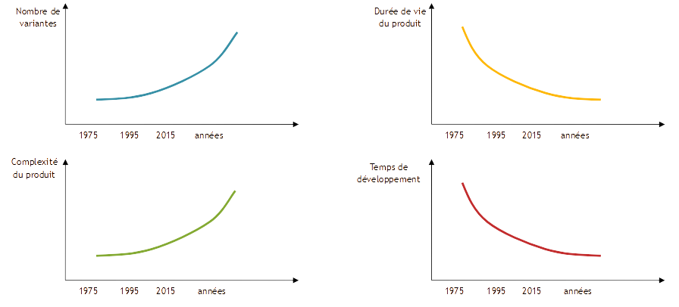
Figure 1. Evolution graphs.

Global market
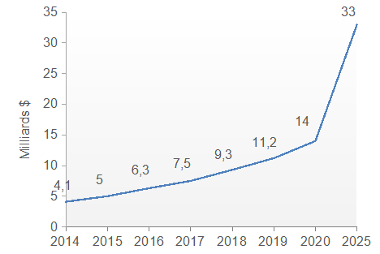
Figure 2. Global market

History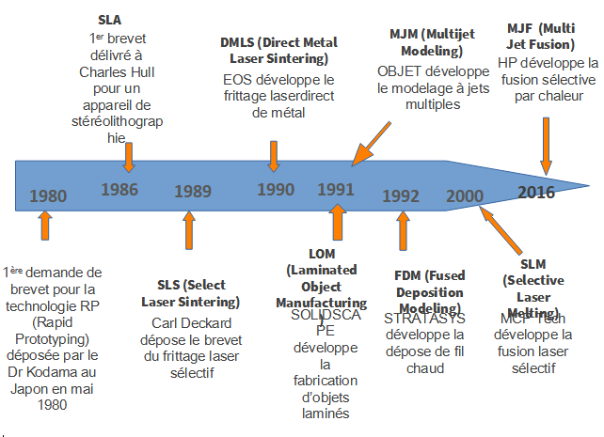

Figure 3. History
Legend translation:
1980: 1st patent application for RP (Rapid Prototyping) technology filed by Dr. Kodama in Japan in May 1980
1986: SLA 1st patent granted to Charles Hull for a stereolithography device
1989: SLS (Select Laser Sintering) Carl Deckard patents selective laser sintering
1990: DMLS (Direct Metal Laser Sintering) EOS develops direct metal laser sintering
1991: LOM (Laminated Object Manufacturing): SOLIDSCAPE develops laminated object manufacturing
MJM (Multijet Modeling): OBJET develops multi-jet modeling
1992: FSM (Fused Deposition Modeling) STRATASYS develops hot-wire deposition
2000: SLM (Selective Laser Melting): MCT Tech develops selective laser melting
2016: MJF (Multi Jet Fusion) HP develops selective heat fusion

3D Printing – Applications

Advantages
- Ability to produce complex shapes: Enables the manufacturing of 3D parts without shape being a limiting factor—such as cavities, lattices (lattice structures), thin walls, etc.
- Clear weight savings thanks to lattice structures or topological optimization (using material only where it is needed). This also allows for a reduction in the number of final parts by combining several components into a single printed piece, thus reducing subsequent assembly operations.
- Mechanical properties under static loads are often equivalent or even superior to those of traditional processes (casting, rolling).
- Customization without additional cost: Production of unique, personalized parts—different from one another—on the same build plate and within the same production cycle.
- This is particularly valuable in the medical field, for example in creating prosthetics tailored to each patient.
- Possibility to functionalize surfaces, optimize fluid management, or shorten production lead times.

Disadvantages
The cost of production remains the most limiting factor, mainly due to the high cost of machines and their low productivity. The lack of material standards specific to certain sectors also slows the adoption of these processes.
As a result, 3D printing is more suitable for small to medium production runs. Some processes do not allow for certain surface orientations without the addition of supports, which can lead to expensive post-processing.
Vérification
intérêt économique

General Approach
3D printing encompasses technologies that manufacture parts by successively adding layers of material based on a digital model.
Table 1. General approach
Basic principle | Detailed principle
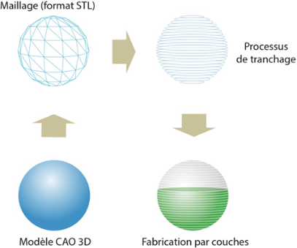  Legend translation:  Mesh (STL format)  Slicing process  3D CAD model  Layer fabrication | 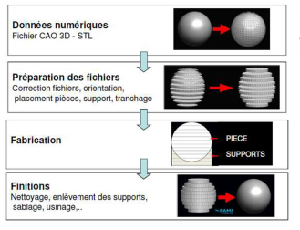  Legend translation :  Digital data: 3D CAD file - STL  File preparation: File correction, orientation, part placement, support, slicing  Manufacturing  Finishing: Cleaning, support removal, sandblasting, machining,...

Main Steps
Digital channel

3D modeling
Post-treatment
3D printing
Route preparation/generation
Conversion

3D printers
Integrated software
Converter
3D modeler
Accessories
Modele
Cleaning, sanding...
Surface treatment

3D CAD: compliance with process-related design rules
Scanning of physical objects
(3D scan)
-3D formats:
STL, OBJ, STEP

-Visualization, analysis and repair of defects
Model orientation
Support generation
Slicing
Path generation (filling and contours)
Machine management (direct, network...)
Material management according to machine autonomy
(Liquids, powders, solids)
-Substrate removal

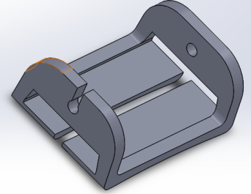
CAD Model Recuperation
Figure 3. CAD model recuparation
The care and attention taken in preparing the 3D CAD file has a direct impact on the quality of the 3D print.
Ensure that wall thicknesses are compatible with the printing technology.
Laying plane: minimum thickness 0.3 mm
Vertical plane: minimum thickness 0.5 mm

Converting the CAD Model
It is necessary to convert the model into a format compatible with 3D printers (in this case, only the STL format).
This format is based on facetting using triangular elements (MAILLAGE).
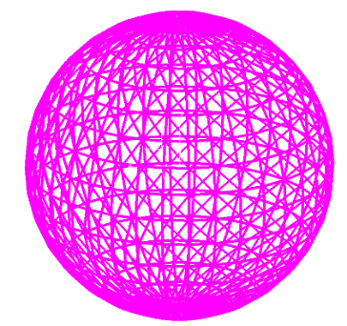
Convert file to stl with fine parameters

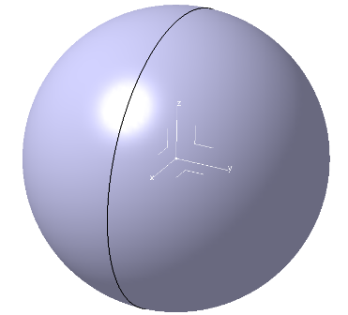

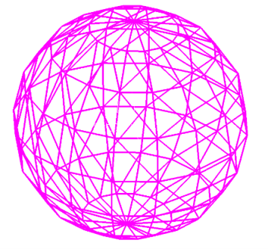
Conversion du fichier en stl avec des paramètres larges

Convert file to stl with wide parameters
CAD
Model

Figure 4. Converting the CAD model


You need to reduce the risk of having surfaces with facets that are too visible, while limiting the size of the STL file, which has an impact on how quickly it can be managed by the preparation software.
Correct the mesh if necessary (remove any surface intersections).

Preparation for Printing
Figure 5. Converting the CAD model, 2nd image
Importance of part orientation on the machine table
Table 2. Preparation for printing
Printing time is generally proportional to part height on the Z axis | Limiting the amount of media | Improve surface quality and mechanical properties
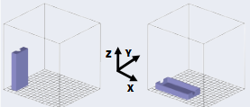  Slower Faster | 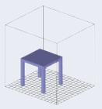  Need support  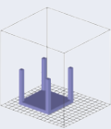  No support | 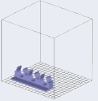  Fragility between layers  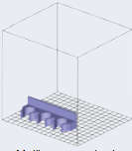  Better resistance

Slicing is the transformation of the model into layers of constant or variable thickness. It influences manufacturing time and part precision.
Fewer, thicker layers = faster, but more fragile
Fewer, thinner layers = slower, but more resistant
The support is often made of cellular or hollow structures, and is used to support the overhanging parts of a part being manufactured.

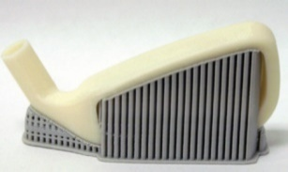
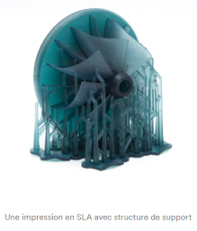
Figure 6. Preparation for printing 2nd image
Figure 7. Preparation for printing 1st image

Path generation takes into account layer geometry and determines process parameters (nozzle diameter, flux, laser power, speed, etc.).

Table 3. Peparation for printing 2nd table
The contours of the model influence the resistance | Inside the model: adjusting the filling intensity | Example
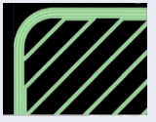  The outline is made with  3 layers | 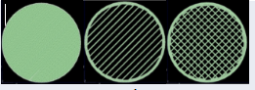  Full Spaced Spaced  One-way Two-way | 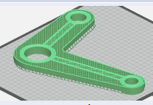

Application
Software used: CAD Solidworks 3D printer Ultimaker
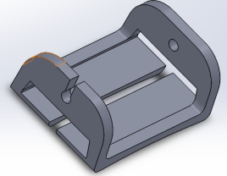
Part : Front part
Figure 8. Application, front part

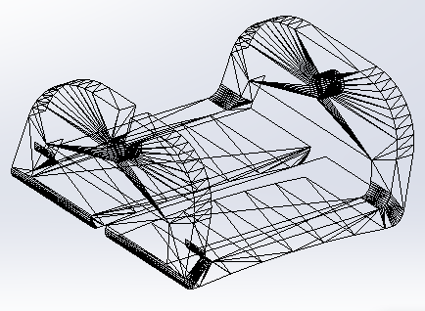
STL format conversion

Figure 9. STL format conversion

Orientation on 3D machine plate
Use symbols
Print time +++ ++ +
Support: +++ ++ +

Table 4. Orientation on 3D machine plate
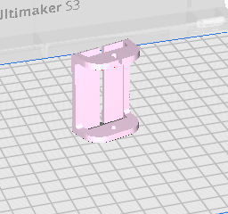 | 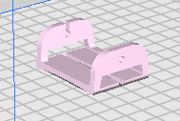 | 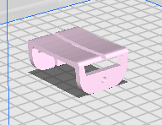
Print time:  support | Print time:  support | Print time:  support
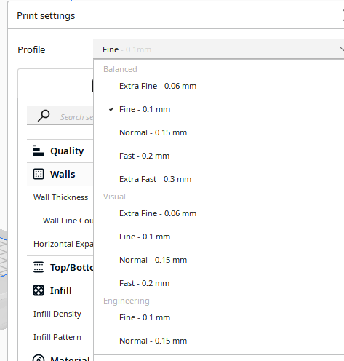

Generation path

Parameters related to the generation of paths:

- Layer thickness

- Wall thickness (wall, shell, etc.)

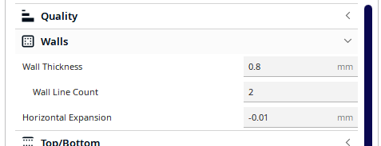
- To the filling

- Print speed

- Support type
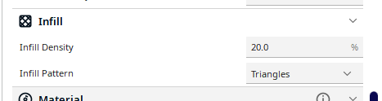
- Machine nozzle
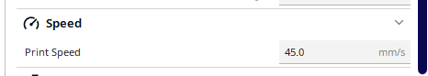
Here 0.4 mm

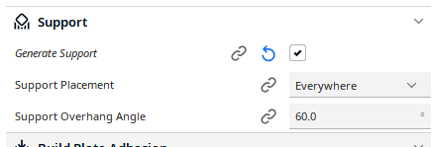

Figure 10. Generation path

After slicing the part, visualization of the layers and supports

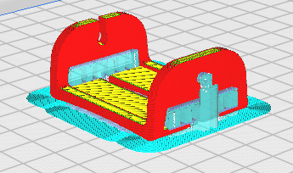
Figure 11. Generation path

Post-processing

Remove all supports
Check the appearance of the surfaces
Check the dimensions
Verify the geometry

Index of Images
Figure 1. Evolution graphs. 7
Figure 2. Global market 8
Figure 3. CAD model recuparation 11
Figure 4. Converting the CAD model 12
Figure 5. Converting the CAD model, 2nd image 12
Figure 6. Preparation for printing 2nd image 13
Figure 7. Preparation for printing 1st image 13
Figure 8. Application, front part 14
Figure 9. STL format conversion 14
Figure 10. Generation path 16
Figure 11. Generation path 16
Figure 12. Molten wire printing 18
Figure 13. Resin Polymerization Printing 19
Figure 14. Impression par 3dp binder jetting 19
Figure 15. Laser melting on a powder bed 20
Figure 16. Laser Fusion on Powder 2nd image 21
Figure 17. Laser Fusion on Powder 1st image 21

Index of tables
Table 1. General approach 10
Table 2. Preparation for printing 12
Table 3. Peparation for printing 2nd table 14
Table 4. Orientation on 3D machine plate 15

Annexes

Typology of the Main Principles

Pastic and Composite Materials
      - Molten wire printing
A thermoplastic-based filament is heated and extruded through a nozzle to form successive layers creating a part

filament
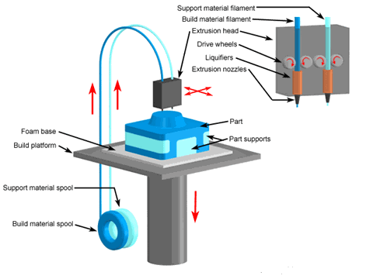
nozzle
Figure 12. Molten wire printing

Resin Polymerization Printing
A beam of UV rays is projected by a laser to polymerize a photosensitive resin contained in the 3D printer's tray, forming a solid layer.
With each layer, the tray is lowered and printing continues.

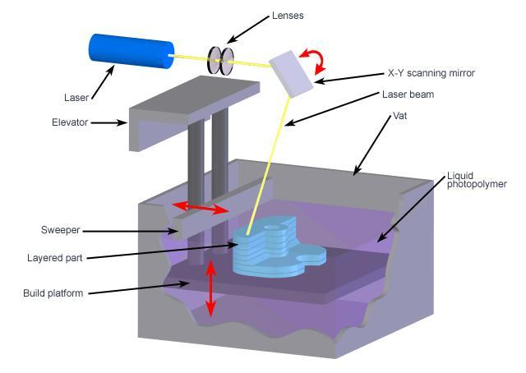
Figure 13. Resin Polymerization Printing

Impression par 3dp binder jetting
A print head deposits a binder on a layer of powder in a selective process that is repeated until a complete part is formed. The unbound powder can be used as a support.
With each layer, the platen is lowered and printing continues.
Once the part is complete, the unbonded powder is removed to reveal the finished object.
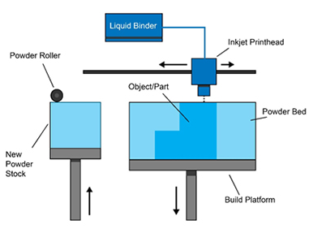
Figure 14. Impression par 3dp binder jetting

Metalic Materials

Laser melting on a powder bed
The powder (5 to 45µm) is spread by a roller or scraper, in layers of 20 to 100µm, on a preheated plate (200°C).
The laser beam (from 50 to 1000W, 400W standard) scans (1m/s) the section of the part to be manufactured.
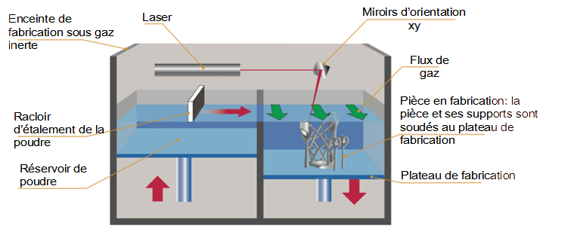
Figure 15. Laser melting on a powder bed

Legend translation:
Enceinte de fabrication sous gaz: Gas manufacturing enclosure
Laser: Laser
Miroirs d’orientation xy : Xy orientation mirrors
Flux de gaz: Gas flow
Pièce en fabrication = la pièce et ses supports sont soudés au plateau de fabrication : Part being manufactured = the part and its supports are welded to the manufacturing platform
Racloir d’étalement de la poudre : Powder spreading scraper
Réservoir de poudre : Powder tank
Plateau de fabrication: Manufacturing platform

4.1.2.2 Laser Fusion on Powder

The laser-melted powder is deposited on a plate to manufacture a complex part
On a part to add a function or repair
Deposition bead width from 1 to 5 mm height from 0.3 to 2mm

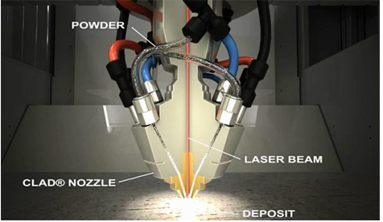
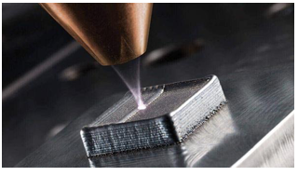
Figure 16. Laser Fusion on Powder 2nd image
Figure 17. Laser Fusion on Powder 1st image

.

