
CLF-DES-04-EN-GEBKIM-
3D Design with Solidworks
WP6 COLLABORATIVE LEARNING FACTORY






Funded by the European Union. Views and opinions expressed are however those of the author(s) only and do not necessarily reflect those of the European Union or the European Education and Culture Executive Agency (EACEA). Neither the European Union nor EACEA can be held responsible for them.
This work is licensed by the LCAMP Partnership under a Creative Commons Attribution-NonCommercial 4.0 International License.
LCAMP partners:
TKNIKA – Basque VET Applied Research Centre, CIFP Miguel Altuna LHII, DHBW Heilbronn – Duale Hochschule, Baden-Württemberg, Curt Nicolin High School, AFM – Spanish Association of Machine Tool Industries, EARLALL – European Association of Regional & Local Authorities for Lifelong Learning, FORCAM, CMQE: Association campus des métiers et des qualifications industrie du future, MV: Mecanic Vallée, KIC: Knowledge Innovation Centre, MADE Competence Centre Industria 4.0; AFIL: Associazione Fabbrica Intelligente Lombardia, SIMUMATIK AB; Association HVC Association of Slovene Higher Vocational Colleges; TSCMB:Tehniški šolski center Maribor, KPDoNE: Kocaeli Directorate Of National Education; GEBKİM VET, GEBKİM OIZ and CAMOSUN college.

INDEX

1. INTRODUCTION 4
2. Gettıng started 5
3. WHEEL LOWER PART DRAWING 7
4. Drawing the rollers 10
5. Shaft drawıng 11
6. Assembly of the Wheel in the SOLIDWORKS Program 12
7. Index of images 14

INTRODUCTION
Participants in this micro course will gain knowledge about the 3D design of the LCAMP robot by the end of the course and will be able to design the robot's parts independently.
Various programs are used for 3D design. AutoCAD, Fusion360, Blender, Catia, and SolidWorks are some of these programs. In this course, we will learn the design stages specifically for the wheel design of the LCAMP robot using the SolidWorks program.






Figure 1: 3D design software

Gettıng started

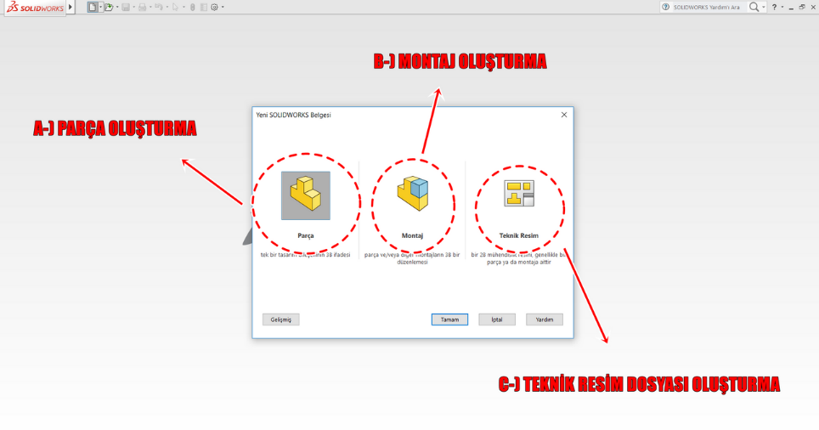
When we open the SolidWorks program, this screen appears. In this screen, solid models can be designed in the Part section, while the Assembly section is used to assemble the drawn parts. In the Drawing section, the technical drawing details for production are created for the drawn parts or assemblies.

Figure 2: SolidWorks Start Screen

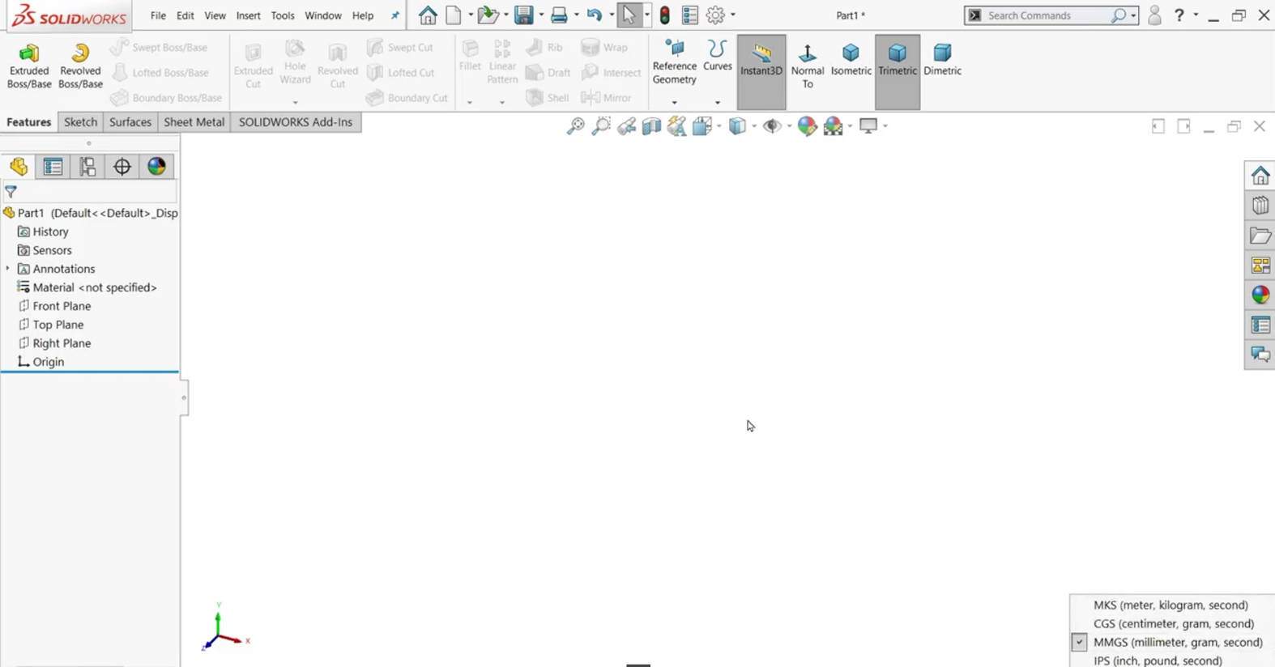
When creating solid model settings (extrude, revolve, loft, fillet, chamfer, etc.) from the Features menu, 2D drawing settings (line, rectangle, arc, circle, pattern, mirror, chamfer, fillet, etc.) are made from the Sketch menu. Surface modeling operations are performed from the Surfaces menu, and metal settings are made from the Sheet Metal section. This menu can be customized by adding or removing desired settings.

Figure 3: SolidWorks Menus

WHEEL LOWER PART DRAWING

Before starting the drawing, we choose which plane to draw on based on the part design and shape.

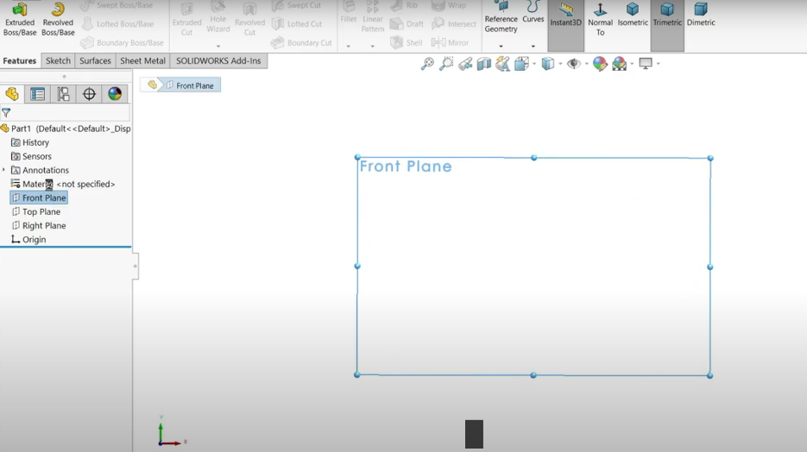

Figure 4: Plane Selection
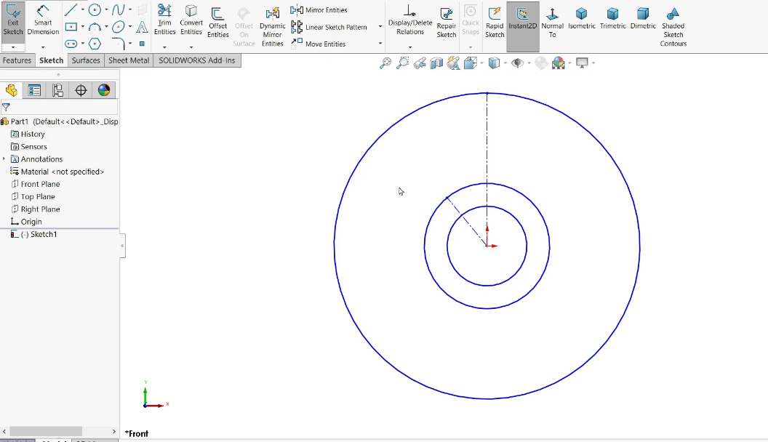
When drawing the wheel lower body, we first draw the circles at the center and the reference circles.

Figure 5: Drawing the center and reference circles

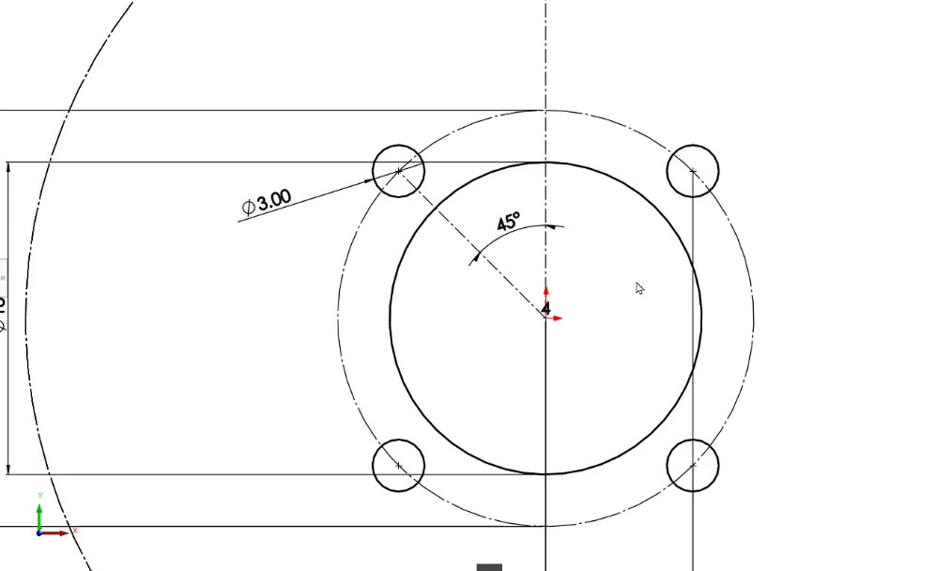
We continue by drawing the mounting screw holes for the stepper motor.

Figure 6: Drawing of the stepper motor mounting holes
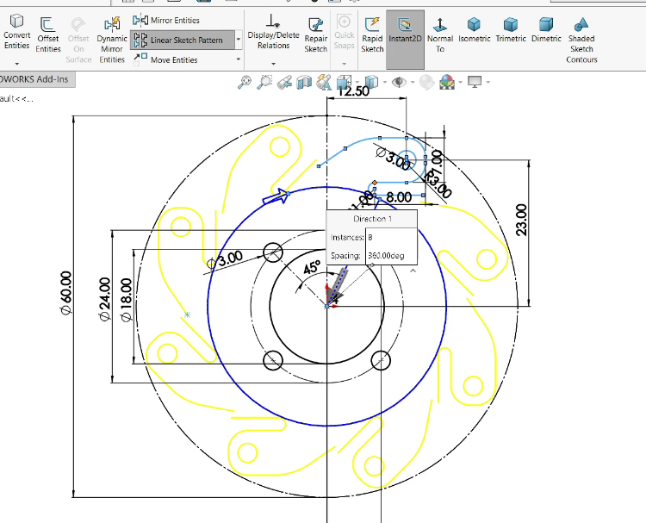
We draw the edge parts to be mounted on the rollers of the lower part using the line and arc commands and perform circular replication according to the reference circle.
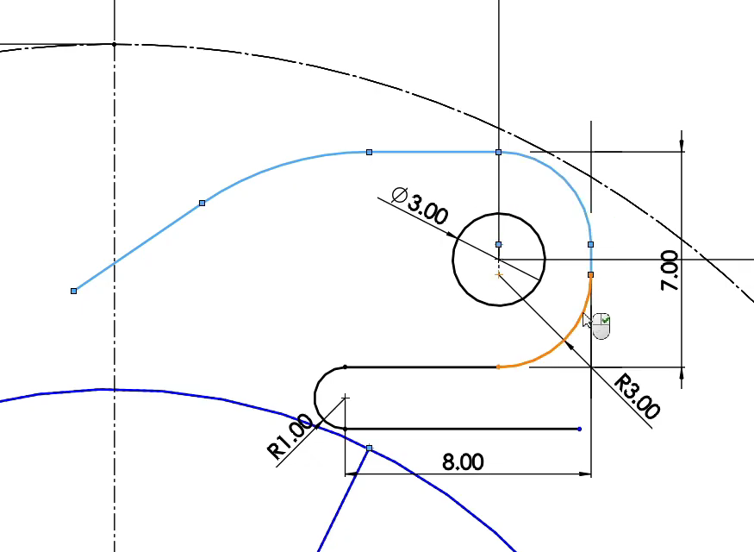

Figure 7: Lower part edge drawing and circular replication

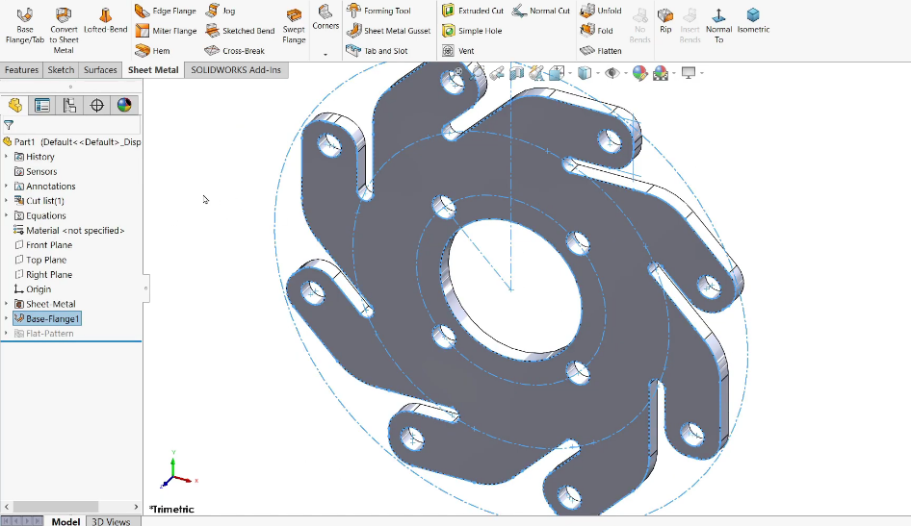
We are converting the drawing into a solid. Here, we can create a solid model from the sheet metal settings if we want, or we can create a solid model using extrusion It can be created.

Figure 8: Conversion to solid model

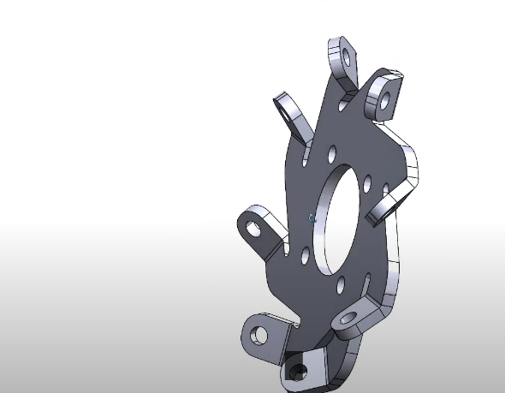
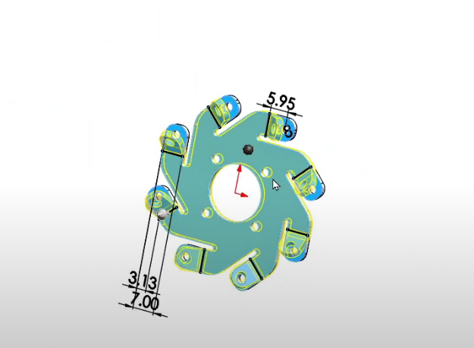
The process of sloping the edges to allow for the installation of rollers is done from the sheet metal settings. Once we have completed the drawing of the part, we save the drawing using File->Save.

Figure 9: Making the edges sloped

Drawing the rollers
We are opening a new page for drawing the rollers. Since the rollers are oval pieces, it will be easier to create a solid model by drawing half of it and rotating it 360 degrees around the reference axis.
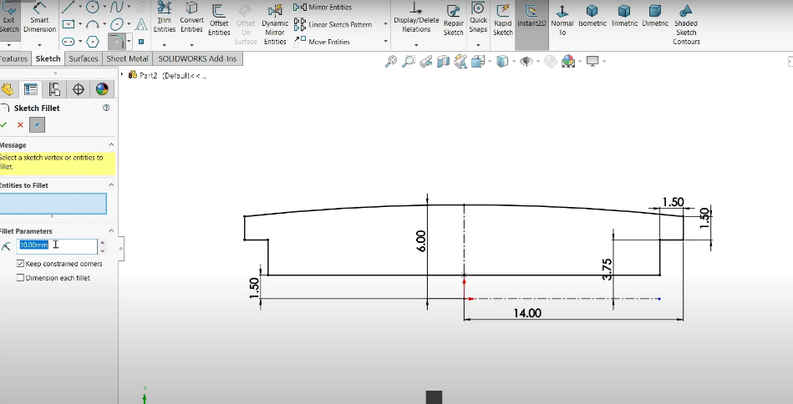

Figure 10: Roller Sketch drawing
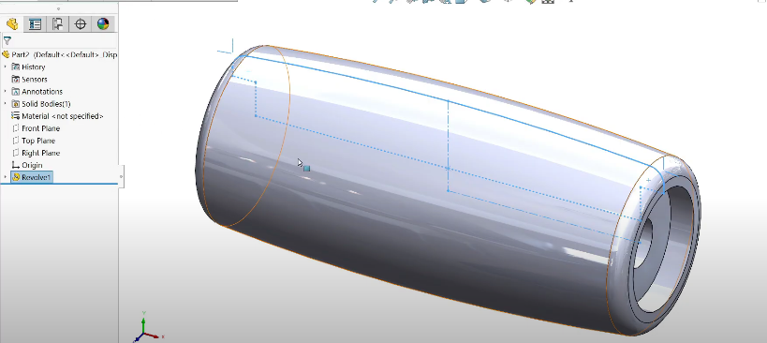
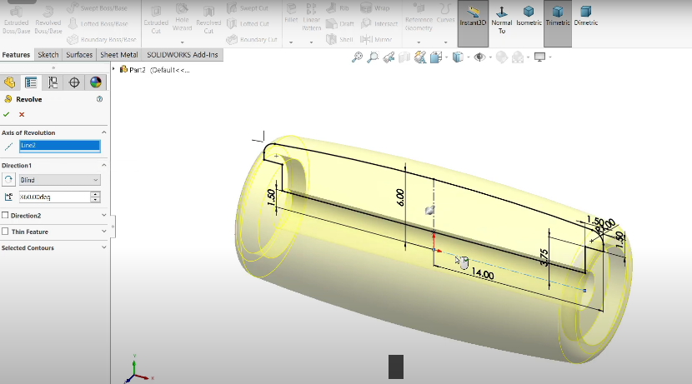
We use the Revole command from the Features menu to create by rotating the rollers. Once we have completed the drawing of the part, we save the drawing using File->Save.

Figure 11: Rotation using Revolve

Shaft drawıng

Frame We need to design a shaft to connect the bottom and top parts. We open a new design page for the shaft drawing. We complete the sketch drawing and create a solid model. Then we drill the mounting holes so that we can assemble the bottom and top parts. When we complete the drawing of the part, we save the drawing by selecting File->Save.

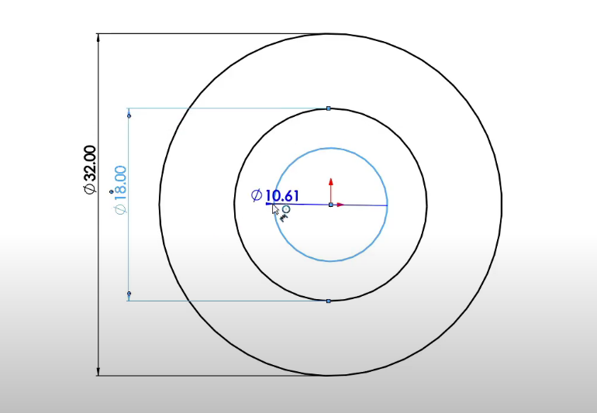
The bolt drawing can be created as needed, or a ready-made bolt of the appropriate size from the SolidWorks library can be used.
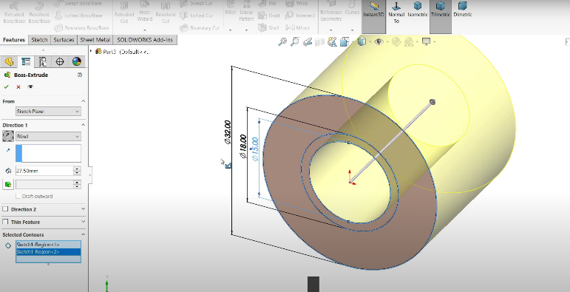

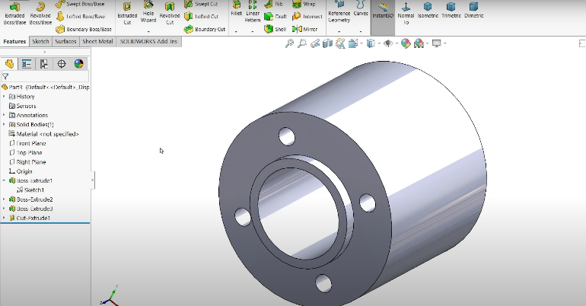

Figure 12: Shaft drawing

Assembly of the Wheel in the SOLIDWORKS Program
To assemble the wheel, select assembly from the menu in Figure 2 (Page 5). Once the assembly is open, add the parts we drew to the assembly from the Insert Components section. Add 2 pieces from the Frame part, one for the bottom and one for the top. Add 8 pieces each from the Roller and Bolt parts. Add 1 piece from the Shaft part.
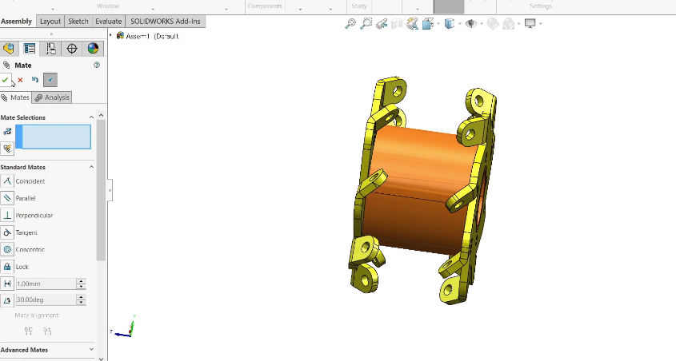
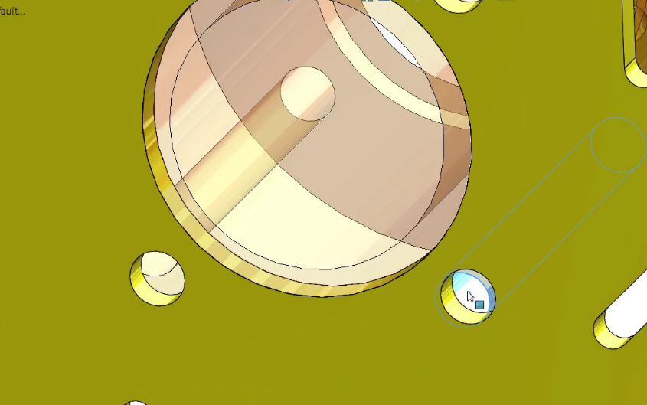
We provide a mounting relationship where the holes in the shaft and upper and lower parts are concentric. We add a mounting relationship where the topmost point of the shaft part coincides with the inner surface of the frame parts.

Figure 13: Assembly relationships-1

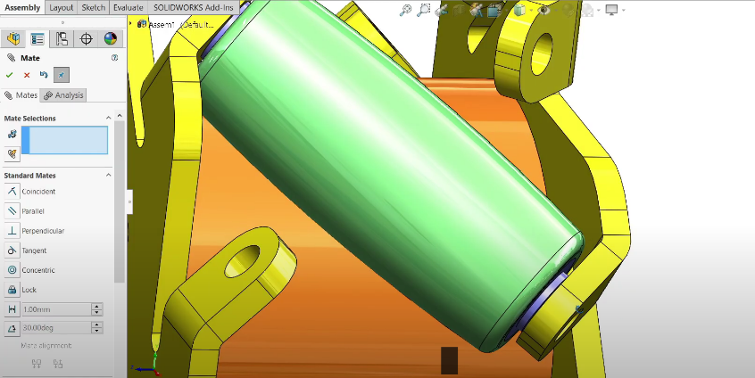
The hole in the roller and the holes in the inclined surfaces of the lower and upper parts are provided with a mounting relationship such that they are concentric. The roller is provided with a mounting relationship such that its top point coincides with the inner point where it will contact the lower part.
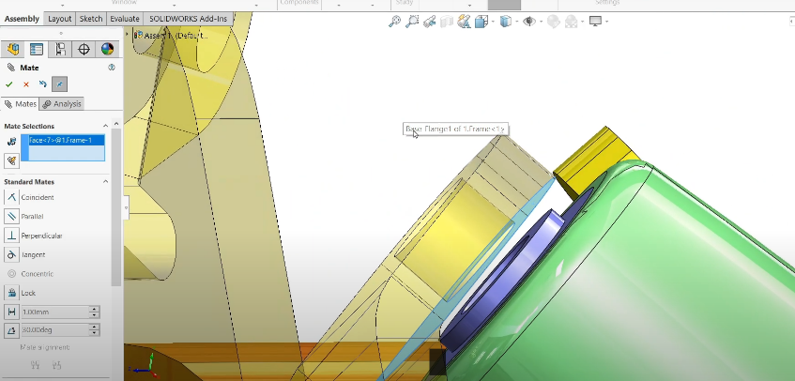

Figure 14: Assembly relationships-2
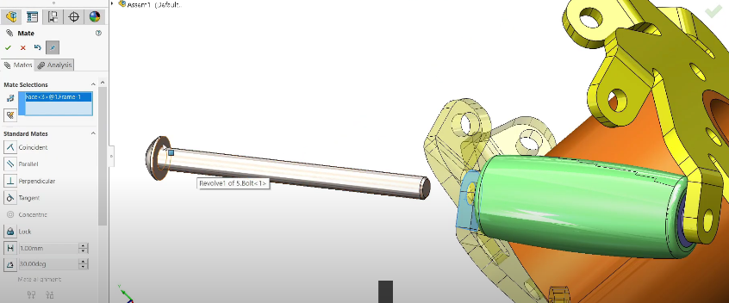
The bolt is adjusted so that the hole in the rollers is concentric. The flat area under the bolt is aligned so that it coincides with the top point of the rollers. The same alignment is performed for the nut. The process is repeated for all rollers to complete the assembly.
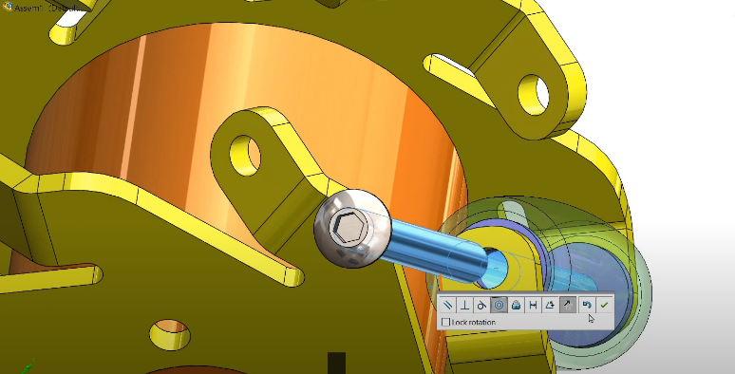
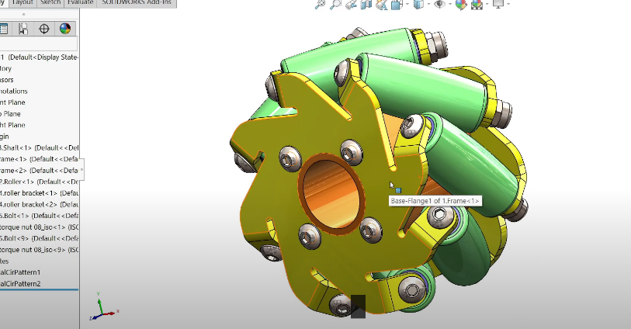
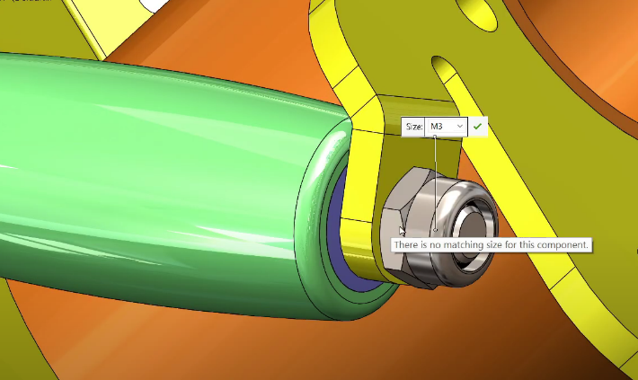

Figure 15: Assembly relationships-3

Index of images

Figure 1: 3D design programs 4
Figure 2: SolidWorks Start Screen 5
Figure 3: SolidWorks Menus 6
Figure 4: Plane Selection 7
Figure 5: Drawing the center and reference circles 7
Figure 6: Drawing the stepper motor mounting holes 8
Figure 7: Drawing the lower part edges and circular replication 8
Figure 8: Converting to a solid model 9
Figure 9: Making the edges inclined 9
Figure 10: Roller Sketch 10
Figure 11: Rotation with Revolve 10
Figure 12: Shaft drawing 11
Figure 13: Assembly relationships-1 12
Figure 14: Assembly relationships-2 13
Figure 15: Assembly relationships-3 13



