
ANALYSIS OF AN EXISTING DESIGN AND REDESIGN RELATED TO CERTAIN MANUFACTURING CONSTRAINTS
WP6 COLLABORATIVE LEARNING FACTORY






Funded by the European Union. Views and opinions expressed are however those of the author(s) only and do not necessarily reflect those of the European Union or the European Education and Culture Executive Agency (EACEA). Neither the European Union nor EACEA can be held responsible for them.
This work is licensed by the LCAMP Partnership under a Creative Commons Attribution-NonCommercial 4.0 International License.
LCAMP partners:
TKNIKA – Basque VET Applied Research Centre, CIFP Miguel Altuna LHII, DHBW Heilbronn – Duale Hochschule, Baden-Württemberg, Curt Nicolin High School, AFM – Spanish Association of Machine Tool Industries, EARLALL – European Association of Regional & Local Authorities for Lifelong Learning, FORCAM, CMQE: Association campus des métiers et des qualifications industrie du future, MV: Mecanic Vallée, KIC: Knowledge Innovation Centre, MADE Competence Centre Industria 4.0; AFIL: Associazione Fabbrica Intelligente Lombardia, SIMUMATIK AB; Association HVC Association of Slovene Higher Vocational Colleges; TSCMB:Tehniški šolski center Maribor, KPDoNE: Kocaeli Directorate Of National Education; GEBKİM OIZ and CAMOSUN college.

Document summary
Document type: | Public Course
Title | Analysis of an Existing Design and Redesign Related to Certain Manufacturing Constraints
Author/s | Gilbert Gleye
Reviewer | Camille Léonard
Date | Jully 2025
Document status | 1.0
Document level | Confidential until its publication
Document description | This document outlines a course dedicated to the analysis of a sub-system of the Lcamp robot (omniwheel) with the objective of identifying functional surfaces, kinematic connections, and assembly clearances.
Cite this deliverable as: | Gleye G., 2025, Analysis of an Existing Design and Redesign Related to Certain Manufacturing Constraints
Document level | Public

CONTENT TABLE

Executive Summary 5
1. Introduction 6
2. Analysis of a design and redesign 6
2.1. Analysis of Functional Surfaces of a Part 6
2.1.1. Functional surfaces to assemble « star 1-1 » over « star 1-2 » 7
2.1.2. Functional surfaces for assembling the axle on « star 1-1 » and « star 1-2 » 8
2.2. Analysis of Kinematic Links in an Assembly 9
2.2.1. Study of the assembly of the two half-wheels: « star 1-1 » and « star 1-2 » 9
2.2.2. Study of the assembly of the two half-wheels: « star 1-1 » and « star 1-2 » and of the axle 10
2.2.3. Study of the assembly between the « half-wheel + axle » block and the roller 10
2.3. Analysis of Clearance in an Assembly 11
2.3.1. Study of the plane contact areas between the two half-wheels 11
2.3.2. Study of the cylindrical contact zones between the two half-wheels 12
2.3.3. Study the clearance between the axle and the two half-wheels 12
2.3.4. Study of the clearance between the axle and the roller 13
2.3.5. Study of the clearance between the half-wheels and the roller 13
2.4. Use of Standard Elements in an Assembly 13
2.4.1. Wheel part that can be produced from a commercial bar 13
2.4.2. Exploitation of a manufacturer's document - choice of part number 14
2.4.3. Redesign associated with a standard element 14
2.5. The « Product-Process-Materials » Relatioship 14
2.5.1. Complete the table following the instructions below: 14
2.6. Using Standard Elements in an Assembly 15
2.6.1. Improving « mountability » performance 15
2.6.2. Improving « roller rotation » performance 16
3. Conclusion and outlooks 18
4. References 19
5. Index of Images 20
6. Index of tables 21
7. Annexes 22
7.1. Typology of Clearances 22
7.2. Standard Elements 23
7.3. Answers to Activities 24
7.3.1. Analysis of functional surfaces of a part 24
7.3.2. Analysis of kinematic link in an assembly 26
7.3.3. Analysis of clearances in an assembly 27
7.3.4. Use of standard elements in an assembly 29
7.3.5. The “product-process-materials" relationship 30
7.3.6. Analysis of the specifications document and redesign of an existing system 31

Executive Summary
Initially, this course consists of an analysis of the design of a sub-system making up the Lcamp robot (omniwhhel wheel) in order to identify the functional surfaces, kinematic links and assembly clearances. The course then goes on to analyse the materials associated with the manufacturing processes. The final part consists of redesigning certain parts in order to improve the assembly phase.

Introduction
This document is not a course but a succession of activities, sometimes associated with elements of the course, and requiring pre-requisites. The aim of these activities is to assimilate a method of rigorous analysis of the parts making up an assembly in order to optimise the future production of these parts and, if necessary, redesign certain parts.

Lcamp robot background:

The various parts composing a wheel model of the Lcamp robot (omniwheel) are produced using 3D plastic printing.
When assembling these parts, various problems can be found:

- difficulty or even impossibility of nesting two parts (dimensions too close to each other, burrs at corners)
- non-optimal contact between certain surfaces (burrs, misalignment of geometry)
production of the axis not very precise in 3D printing (approximate cylindricity, perfectible surface condition)
- limited resistance of the axle in 3D plastic printing.

These various problems require a revision of the geometry of certain surfaces of the parts (shape, extent, dimensions) and a production of the axle in metal that does not require long or complex machining (use of standard profiles).

In the following activity, we will identify the surfaces that could be geometrically modified, suggest modifications and propose an alternative for manufacturing the axles.

Analysis of a design and redesign

Analysis of Functional Surfaces of a Part
Objective: identify a functional surface on a part and characterise the geometry (shape and dimensions) of this surface.

Support: parts making up the omniwheel wheels of the Lcamp robot

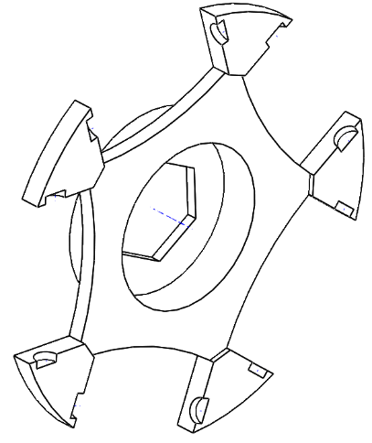
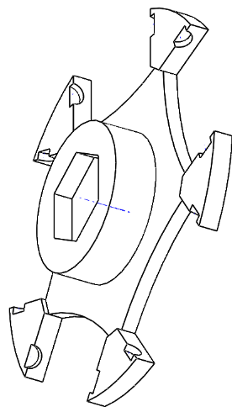
Functional surfaces to assemble « star 1-1 » over « star 1-2 »
Figure 1. Fitting of the 2 half-wheels together

Fitting of the 2 half-wheels together

- In the 2 figures opposite, colour the surfaces in contact when the 2 half-wheels are assembled as follows:
  - in blue: surfaces in plane contact
  - in red: surfaces in contact cylinder/cylinder

- Place one (or more) red cross(es) on the plane surfaces that should not be in contact.

Orientations to be respected between the 2 half-wheels

- In the 2 figures below, colour the coincident surfaces when assembling the 2 half-wheels:
  - in blue: the visible plane surfaces that must coincide to allow the subsequent assembly of an axle
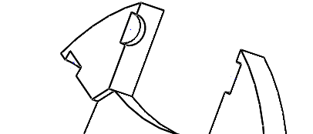
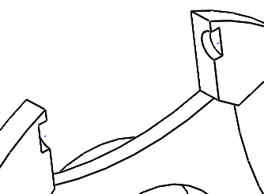
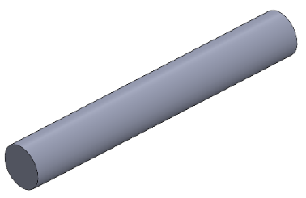
  - in red: the visible cylindrical surfaces that must coincide to allow the subsequent assembly of an axle
Figure 2. 1st step from Orientations to be respected between the 2 half-wheels

- Colour in the 2 figures below the coincident surfaces when assembling the 2 half-wheels:

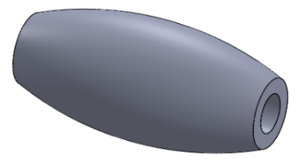
  - in blue: the visible plane surfaces that must coincide to allow a correct rotation of a roller

Figure 3. 2nd step from Orientations to be respected between the 2 half-wheels

- In the 2 figures below, colour in the coincident surfaces when assembling the 2 half-wheels:
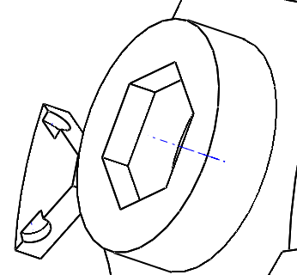
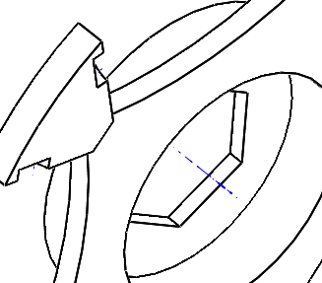
  - in blue: the visible plane surfaces that must coincide to allow subsequent assembly of the hexagonal hub
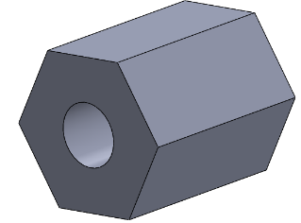

Figure 4. 3rd step from Orientations to be respected between the 2 half-wheels

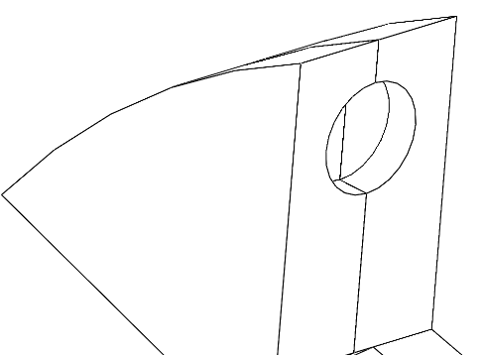
Functional surfaces for assembling the axle on « star 1-1 » and « star 1-2 »
Figure 5. Fitting of the axle into the 2 half-wheels.

Fitting of the axle into the 2 half-wheels.
- In the figure opposite, colour the surfaces in contact when assembling the axle to the 2 half-wheels:
  - in blue: plane surfaces that must coincide
  - in red: cylindrical surfaces that must coincide

Analysis of Kinematic Links in an Assembly
Objective: Identify the elementary motions possible between the different parts making up an assembly. Determine the kinematic link associated with an assembly, and particularly the fixed (or rigid) joint.
Support: parts making up the omniwheel wheels of the Lcamp robot.

Study of the assembly of the two half-wheels: « star 1-1 » and « star 1-2 »

Motions associated with the « half-wheel » assembly

Notation: To designate the possible elementary motions, we will use the notation T for translation, R for rotation, with, as a subscript, the letter of the axis of the reference frame associated with the motion. (Example: Tx designates translation along x, and Ry designates rotation about y).
Figure 6. Study of the assembly of the two half-wheels: "star 1-1" and "star 1-2"
x
x
y
y
z
z
- Give the elementary motion(s) that are possible between these two half-wheels when they are assembled (see figure opposite).
Possible motions: ………………………………………….

Link associated with the « half-wheel »

- Determine then the kinematic link associated with this assembly
Associated link:
………………………………………….

Study of the assembly of the two half-wheels: « star 1-1 » and « star 1-2 » and of the axle

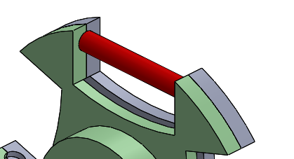
Motions associated with the « half-wheel + axle » assembly
Figure 7. Study of the assembly of the two half-wheels: "star 1-1” and “star 1-2” and of the axle
x
y
z
- Give the possible elementary motion(s) between the two half-wheels when assembled with the axle (see figure opposite).
Possible motions: ………………………………………….

Link associated with the « half-wheel + axle » assembly
- Determine the kinematic link associated with this assembly
Associated link: ………………………………………….
From now on, the « half-wheel + axle » assembly made up of the 3 parts (star 1-1, star 1-2 et axle), will be considered as a non-deformable block (this is what we call a “kinematic equivalence class”).

Study of the assembly between the « half-wheel + axle » block and the roller

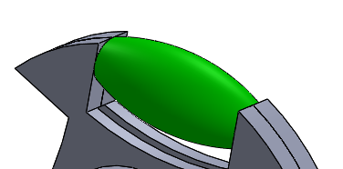
Motions associated with the assembly « half-wheels + axle » + roller
x
y
z
Figure 8. 1st step from Study of the assembly between the "half-wheel + axle” block and the roller
- Give the elementary motion(s) possible between the « half-wheel + axle » assembly and the roller (see figure opposite)
Possible motions: ………………………………………….

Link associated with the « half-wheel + axle » assembly
- Determine the kinematic link associated with this assembly
Associated link: ………………………………………….

Dimensional constraints associated with a link
- To ensure that the motions associated with this link are correct in reality, what are the dimensions of the roller compared with the dimensions of the « half-wheel + axle » assembly?

Table 1. Dimensional constraints associated with a link
(Answer below by circling the correct answers.)
Relationship between lengths L | L1 > L2 | L1 = L2 | L1 < L2
Relationship between diameters D | D1 > D2 | D1 = D2 | D1 < D2
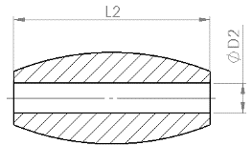
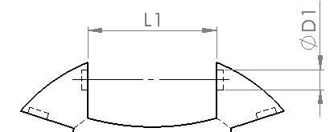
Figure 9. 2nd step from Study of the assembly between the "half-wheel + axle” block and the roller

Analysis of Clearance in an Assembly
Objective: Identify the type of functional clearance (positive, uncertain or negative) in the contacts between the parts of an assembly.
Support: parts making up the omniwheel wheels of the Lcamp robot
Typology of clearance: See course in annexe 1

Study of the plane contact areas between the two half-wheels

The figure below shows the two half-wheel assembled and in cross-sectional view
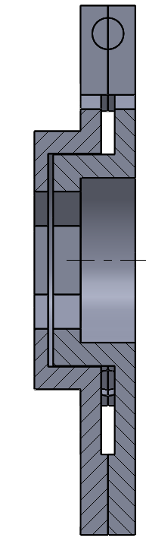
- What contact must absolutely be made between 2 plane surfaces of these 2 parts? (see also § 2.1.1.1)
Figure 10. Study of the plane contact areas between the two half-wheels
Contact (1)
Contact (2)
Circle the correct answer below:
contact (1) contact (2)

- What contact between 2 plane surfaces of these 2 parts must therefore not occur?
Circle the correct answer: contact (1) contact (2)
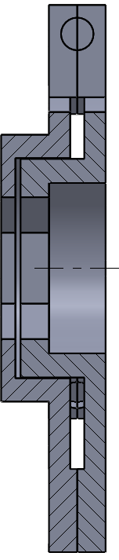
- Deduce the type of clearance to be respected between the two plane surfaces associated with the absence of contact by circling the correct answer below:
Figure 11. Study of the cylindrical contact zones between the two half-wheels
□positive clearance □uncertain clearance □ negative clearance

Study of the cylindrical contact zones between the two half-wheels
The figure below shows the two half-wheels assembled and in cross-section
- What contact must absolutely be made between 2 cylindrical surfaces of these 2 parts? see also § 2.1.1.1)
Circle the associated area on the Figure 11:
- Deduce the type of clearance to be respected between the two associated cylindrical surfaces by circling the answer:
□positive clearance □uncertain clearance □ negative clearance

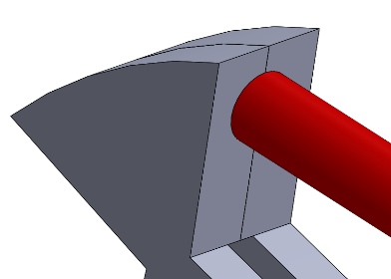
Study the clearance between the axle and the two half-wheels
Figure 12. 1st step from Study the clearance between the axle and the two half-wheels
The figures opposite show the extremity of the axle mounted in the two half-wheels.
- Considering what was seen in question 2.3.1 concerning the contact to be respected, suggest the type of clearance to be respected between the cylindrical surfaces of the axle and the half-wheels by circling the correct answer below:

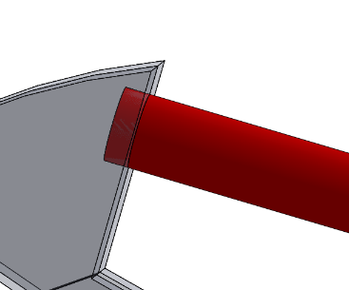
□positive clearance □uncertain clearance □ negative clearance
Figure 13. 2nd step from from Study the clearance between the axle and the two half-wheels

- Suggest the type of clearance to be maintained between the plane surfaces of the end of the axle and the half-wheels by circling the correct answer below:
□positive clearance □uncertain clearance □ negative clearance

Study of the clearance between the axle and the roller
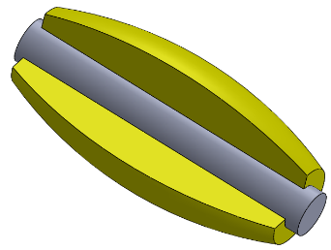
The figure opposite shows the roller mounted on the axle.
Figure 14. Study of the clearance between the axle and the roller
- Considering what was seen in questions 2.2.3.2 and 2.2.3.3, propose the type of clearance to be respected between the cylindrical surfaces of the axle and the roller by circling the correct answer below:
□positive clearance □uncertain clearance □ negative clearance

Study of the clearance between the half-wheels and the roller
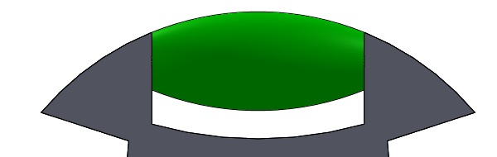
The figure opposite shows the roller mounted on the half-wheels.
Figure 15. Study of the clearance between the half-wheels
- Considering what was seen in questions 2.2.3.2 and 2.2.3.3, suggest the type of clearance (in axial motion) to be respected between the plane surfaces of the half-wheels and the roller by circling the correct answer:

□positive clearance □uncertain clearance □ negative clearance

Use of Standard Elements in an Assembly
Objective: to suggest the use of commercial components in order to facilitate the production of certain parts making up an assembly.
Support: parts making up the omniwheel wheels of the Lcamp robot
Standard elements: See presentation in Annexe 2

Wheel part that can be produced from a commercial bar
Among the parts that make up the complete wheel, suggest the one that can be produced by cutting from a commercial bar, by circling it in the following list:
- half-wheel « star 1-1 »
- half-wheel « star 1-2 »
- axle
- roller

Exploitation of a manufacturer's document - choice of part number
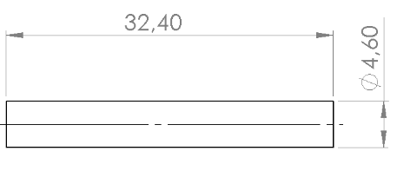
The document in annexe 2 is taken from the website of a metal profiles retailer:
The axle initially designed for the robot wheel is defined by the drawing opposite:
Suggest a reference (diameter) for the cylindrical bar that could be used to make the 10 axles that make up a wheel. Justify your proposal.
Figure 16. Exploitation of manufacturer’s document – choice of part number
Suggested diameter: …….

Redesign associated with a standard element
In the table below, indicate the parts of the 3 other parts making up the wheel that need to be redesigned locally to account for the choice of axle reference defined above. Specify the old and new dimensions.
Table 2. Redesign associated with a standard element
PART | REDESIGN
PART | Part(s) to be redesigned | Original dimension(s) | Dimension(s) after redesign
Star 1-1
Star 1-2
Roller

The « Product-Process-Materials » Relatioship
Objective: analyse the relationships between the function of a part, its manufacture, and the material it is made from.
Support: parts making up the omniwheel wheels of the Lcamp robot

Complete the table following the instructions below:
- Put from --- to +++ for each of the resistance criteria linked to the function (--- meaning « non-existent », -- meaning « very low », - meaning « low », + meaning « light », ++ meaning « moderate » and +++ meaning « very high »).
- For the manufacturing processes, choose one of the following (purchasing, milling, turning, moulding, welding, stamping, folding, cutting, 3d printing), keeping in mind that the aim is to produce a small series.
- For materials, choose from the following (plastic, composite, metal, wood, glass, rock, ceramic)

Table 3. Product-process-materials relationship.
PART | CONTRAINTS LINKED TO THE FUNCTION OF THE PART |  |  | Manufacturing (small series) MANUFACTURING  (SMALL SERIES) | MATERIALS
PART | Mechanical resistance | Chemical  resistance | Thermal  resistance | Manufacturing (small series) MANUFACTURING  (SMALL SERIES) | MATERIALS
Star 1-1
Star 1-2
Axle
Rollers

Using Standard Elements in an Assembly
Objective: analyse the requirements of a new specifications document created to improve the performance of an existing system and propose design solutions and redesign certain elements of the existing system to satisfy the new requirements.
Support: parts making up the omniwheel wheels of the Lcamp robot

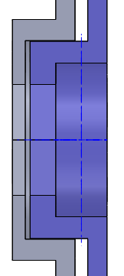
Improving « mountability » performance
New requirement: « The 2 half-wheels must be easier to assemble ».
The drawing opposite shows a view of the central part of the assembly of the 2 half-wheels in cross-section.
Propose a simple geometric modification to one of the 2 half-wheels to satisfy the new requirement. Present your solution in the form of a freehand drawing, in the box below, showing the geometric modification and providing a brief descriptive text.
Figure 17. Improving "mountability" performance

Table 4.Improving “mountability” performance
Drawing of the solution + explanatory text:

Improving « roller rotation » performance
New requirement: “The 10 rollers must rotate more easily on their axles”.
The drawings below show the assembly of a roller on the wheel, in longitudinal section.
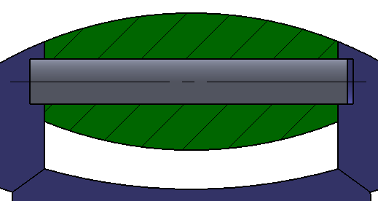
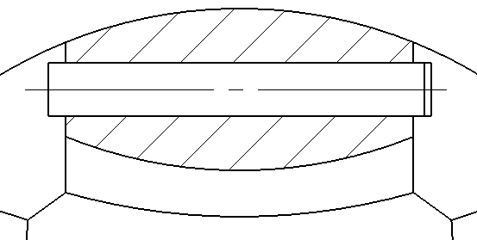
Figure 18. 1st step from Improving "roller rotation" performance

On the drawing on the right, above, draw in red the lines representing the surfaces that rub when the roller rotates.

Suggest a simple modification to the geometry of the roller to reduce the size of these surfaces by drawing the roller in longitudinal cross-section in the box below. You can add an explanatory text.

Table 5. Improving "roller rotation" performance
Drawing of the solution + explanatory text:

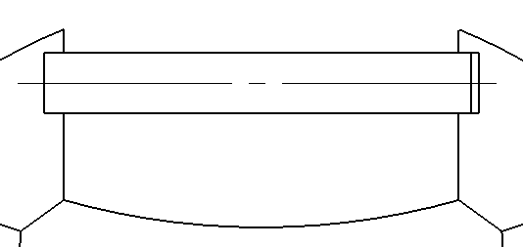
Figure 19. 2nd step from Improving "roller rotation"
performance

Conclusion and outlooks
This course is not aimed at providing methods for designing parts. It simply aims to show that the design of a part is linked to the function it must accomplish, considering the other parts with which it is in contact, standard commercial components, manufacturing choices (process and material), and assembly constraints.

Good design means optimising all these factors to obtain a functional, reliable system at the lowest possible cost (manufacturing, assembly).

References

Index of Images
Figure 1. Fitting of the 2 half-wheels together 7
Figure 2. 1st step from Orientations to be respected between the 2 half-wheels 7
Figure 3. 2nd step from Orientations to be respected between the 2 half-wheels 8
Figure 4. 3rd step from Orientations to be respected between the 2 half-wheels 8
Figure 5. Fitting of the axle into the 2 half-wheels. 8
Figure 6. Study of the assembly of the two half-wheels: "star 1-1" and "star 1-2" 9
Figure 7. Study of the assembly of the two half-wheels: "star 1-1” and “star 1-2” and of the axle 10
Figure 8. 1st step from Study of the assembly between the "half-wheel + axle” block and the roller 10
Figure 9. 2nd step from Study of the assembly between the "half-wheel + axle” block and the roller 11
Figure 10. Study of the plane contact areas between the two half-wheels 11
Figure 11. Study of the cylindrical contact zones between the two half-wheels 12
Figure 12. 1st step from Study the clearance between the axle and the two half-wheels 12
Figure 13. 2nd step from from Study the clearance between the axle and the two half-wheels 12
Figure 14. Study of the clearance between the axle and the roller 13
Figure 15. Study of the clearance between the half-wheels 13
Figure 16. Exploitation of manufacturer’s document – choice of part number 14
Figure 17. Improving "mountability" performance 15
Figure 18. 1st step from Improving "roller rotation" performance 16
Figure 19. 2nd step from Improving "roller rotation" 17
Figure 20. Typology of clearances. 22
Figure 21. Steel bars 23
Figure 22. Answer from Fitting of the 2 half-wheels together 24
Figure 23. Answer from 1st step from Orientations to be respected between the 2 half-wheels 24
Figure 24. Answer from 2nd step from Orientations to be respected between the 2 half-wheels 25
Figure 25. Answer from 3rd step from Orientations to be respected between the 2 half-wheels 25
Figure 26. Answer from Fitting of the axle into the 2 half-wheels 25
Figure 27. Study of the assembly of the two half-wheels: "star 1-1" and "star 1-2" 26
Figure 28. Study of the assembly of the two half-wheels: "star 1-1” and “star 1-2” and of the axle 26
Figure 29. 1st step from Study of the assembly between the "half-wheel + axle” block and the roller 27
Figure 30. 2nd step from Study of the assembly between the "half-wheel + axle” block and the roller 27
Figure 31. Study of the plane contact areas between the two half-wheels 28
Figure 32. Study of the cylindrical contact zones between the two half-wheels 28
Figure 33. 1st step from Study the clearance between the axle and the two half-wheels 28
Figure 34. 2nd step from Study the clearance between the axle and the two half-wheels 29
Figure 35. Study of the clearance between the axle and the roller 29
Figure 36. Study of the clearance between the half-wheels 29
Figure 37. Exploitation of manufacturer’s document – choice of part number 30
Figure 38. Improving « mountability » performance 31
Figure 39. Answer from Improving "mountability" performance 31
Figure 40. Answer from Improving "roller rotation" performance 32
Figure 41. Answer from Improving "roller rotation" performance 32

Index of tables
Table 1. Dimensional constraints associated with a link 11
Table 2. Redesign associated with a standard element 14
Table 3. Product-process-materials relationship. 15
Table 4.Improving “mountability” performance 16
Table 5. Improving "roller rotation" performance 17
Table 6. Typology of Clearances 22
Table 7. Answer from Redesign associated with a standard element 30
Table 8. Answer from Product-process-materials relationship 31
Table 9. Improving « mountability » performance 31
Table 10. Improving ‘roller rotation’ performance 32

Annexes

Typology of Clearances
Reminder: The clearance between two parts refers to the possible motion between these two parts. Attention: this clearance can be positive (in the case of a containing part which is larger than the part contained), negative (in the case of a containing part which is smaller than the part contained; this is referred to as clamping) or uncertain (in the case of a containing part which can sometimes be smaller, sometimes larger than the part contained, depending on the manufacturing precision).

Remember that the dimensions of a manufactured part are toleranced, in other words the theoretical value of each dimension of the part has a tolerance which allows manufacturing inaccuracies to be incorporated.
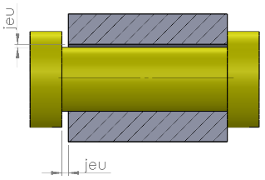
Example: A length of 20 mm will not be noted L = 20 in a manufacturing process, but rather L = ${20}^{\begin{matrix}+0,1 \\ -0,05\end{matrix}}$ so that all parts with a length L between 19.95 mm and 20.1 mm are considered good. It is an illusion to believe that you can manufacture a part with a length of exactly 20 mm; you have to allow for a margin of error.
(1)
Figure 20. Typology of clearances.
Note (1) the containing part (in grey) and (2) the contained part (in yellow) - see figure opposite.
(2)
Relationship between the dimensions of (1), (2) and the possible types of clearance.

Table 6. Typology of Clearances
 | POSITIVE CLEARANCE  (MOTION) | UNCERTAIN MOTION | NEGATIVE CLEARANCE (TIGHTENING)
Relationship between lengths L | L1 > L2 (always) (*) | L1 > L2 (sometimes) or L1 < L2 (sometimes) (**) | L1 < L2 (always)
Relationship between diametres D | D1 > D2 (always) | D1 > D2 (sometimes) or D1 < D2 (sometimes) | D1 < D2 (always)

(*) L1 > L2 (always) means that, whatever the tolerances on L1 and L2, we always have L1 > L2

(**) L1 > L2 (sometimes) means that, because of the tolerances on L1 and L2, we can have L1 > L2 but also L1 < L2, depending on the manufactured parts we associate.
□positive clearance □uncertain clearance □ negative clearance

Standard Elements

When you use screws and nuts to fasten two parts together, you wouldn't think of having to manufacture them because it would be too long and therefore too expensive. Similarly, if you have to make a pivot link using ball bearings, you wouldn't think of having to manufacture them. These two examples show that it is sometimes appropriate to use commercially available components.
Tubes, profiles
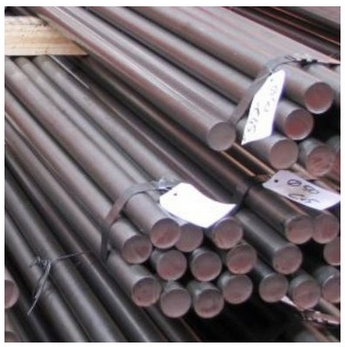
Among the standard elements, we can distinguish parts with a widely used shape (‘round’ tubes, ‘square’ tubes, cylinders, angles, etc.) which are sold in bars of a certain length, which are then cut to the required size.
Figure 21. Steel bars
Exploiting a manufacturer's document - choice of a reference
The document below is taken from the website of a metal profiles retailer:

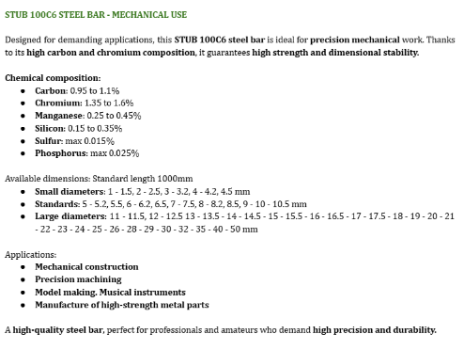

Answers to Activities

Analysis of functional surfaces of a part

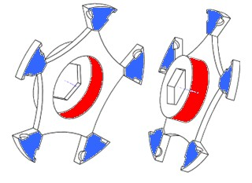
Functional surfaces to assemble « star 1-1 » over « star 1-2 »
Figure 22. Answer from Fitting of the 2 half-wheels together

Fitting of the 2 half-wheels together
- In the 2 figures opposite, colour the surfaces in contact when the 2 half-wheels are assembled as follows:
  - in blue: surfaces in plane contact
  - in red: surfaces in contact cylinder/cylinder

- Place one (or more) red cross(es) on the plane surfaces that should not be in contact.

Orientation to be respected between the 2 half-wheels
- Colour the 2 figures below to show which surfaces coincide when the 2 half-wheels are assembled:
  - in blue: the visible plane surfaces that must coincide to enable an axle to be fitted later.
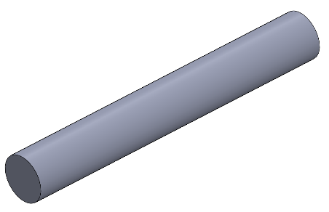
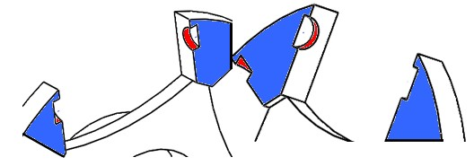
  - in red: the visible cylindrical surfaces that must coincide to allow the subsequent assembly of an axle.
Figure 23. Answer from 1st step from Orientations to be respected between the 2 half-wheels

- Colour in the 2 figures below the coincident surfaces when assembling the 2 half-wheels:
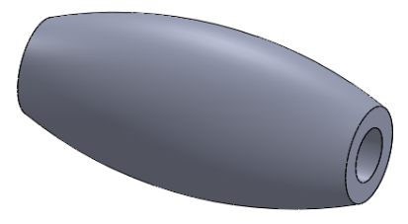
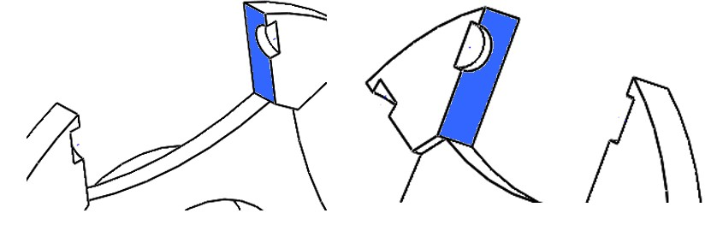
  - in blue: the visible plane surfaces that must coincide to allow a correct rotation of a roller
Figure 24. Answer from 2nd step from Orientations to be respected between the 2 half-wheels

- In the 2 figures below, colour in the coincident surfaces when assembling the 2 half-wheels
  - in blue: the visible plane surfaces that must coincide to allow subsequent fitting of the hexagonal hub
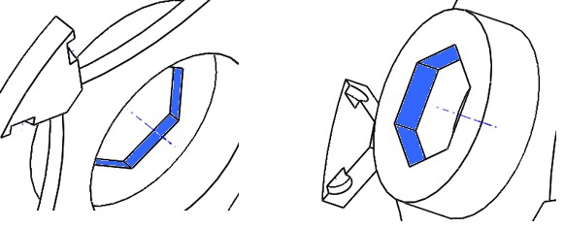
Figure 25. Answer from 3rd step from Orientations to be respected between the 2 half-wheels

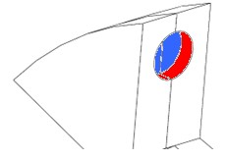
Functional surfaces for assembling the axle on « star 1-1 » and « star 1-2 »
Figure 26. Answer from Fitting of the axle into the 2 half-wheels

Fitting of the axle into the 2 half-wheels.
- In the figure opposite, colour the surfaces in contact when assembling the axle to the 2 half-wheels:
  - in blue: plane surfaces that must coincide
  - in red: cylindrical surfaces that must coincide

Analysis of kinematic link in an assembly
Objective: Identify the elementary motions possible between the different parts making up an assembly. Determine the kinematic link associated with an assembly, and particularly the fixed (or rigid) joint.
Support: parts making up the omniwheel wheels of the Lcamp robot

Study of the assembly of the two half-wheels: « star 1-1 » and « star 1-2 »

Motions associated with the « half-wheel » assembly
Notation: To designate the possible elementary motions, we will use the notation T for translation, R for rotation, with, as a subscript, the letter of the axle of the reference frame associated with the motion. (example: Tx designates translation along x, and Ry designates rotation about y).
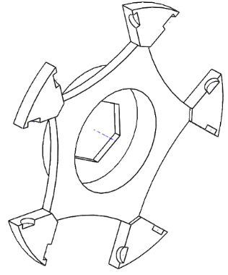
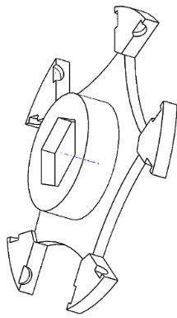
- Give the elementary motion(s) that are possible between these two half-wheels when they are assembled (see figure below).
Figure 27. Study of the assembly of the two half-wheels: "star 1-1" and "star 1-2"
x
x
y
y
z
z
Possible motions: R_{x}

Link associated with the « half-wheel »
- Déterminer alors la liaison cinématique associée à cet assemblage
Associated link: PIVOT link (x axis)

Study of the assembly of the two half-wheels: « star 1-1 » and « star 1-2 » and of the axle

Motions associated with the « half-wheel + axle » assembly
x
y
z
- Give the possible elementary motion(s) between the two half-wheels when assembled with the axle (see figure opposite).
Possible motions: None

Link associated with the « half-wheel + axle » assembly
- Determine the kinematic link associated with this assembly
Associated link: ENCASTREMENT link
Figure 28. Study of the assembly of the two half-wheels: "star 1-1” and “star 1-2” and of the axle

From now on, the « half-wheel + axle » assembly made up of the 3 parts (star 1-1, star 1-2 et axle), will be considered as a non-deformable block (this is what we call a “kinematic equivalence class”).

Study of the assembly between the « half-wheel + axle » block and the roller

Motions associated with the assembly « half-wheels + axle » + roller
- Give the elementary motion(s) possible between the « half-wheel + axle » assembly and the roller (see figure opposite).
x
y
z
Possible motions: R_{z}

Link associated with the « half-wheel + axle » assembly

- Determine the kinematic link associated with this assembly
Figure 29. 1st step from Study of the assembly between the "half-wheel + axle” block and the roller

Associated link: PIVOT link (z axis)

Dimensional constraints associated with a link
- To ensure that the motions associated with this link are correct in reality, what are the dimensions of the roller compared with the dimensions of the « half-wheel + axle » assembly?

(Answer below by circling the correct answers.)
Relationship between lengths L | L1 > L2 | L1 = L2 | L1 < L2
Relationship between diameters D | D1 > D2 | D1 = D2 | D1 < D2
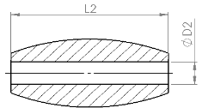
Figure 30. 2nd step from Study of the assembly between the "half-wheel + axle” block and the roller

Analysis of clearances in an assembly

Study of the plane contact areas between the two half-wheels
The figure below shows the two half-wheels assembled and in cross-sectional view
- What contact must absolutely be made between 2 plane surfaces of these 2 parts? (see also § 2.1.1.1)

Circle the correct answer below:
Contact (2)
contact (1) contact (2)
Contact (1)

Figure 31. Study of the plane contact areas between the two half-wheels

- What contact between 2 plane surfaces of these 2 parts must therefore not occur?
Circle the correct answer opposite: contact (1) contact (2)
- Deduce the type of clearance to be respected between the two plane surfaces associated with the absence of contact by circling the correct answer below:

□positive clearance □uncertain clearance □negative clearance

Study of the cylindrical contact zones between the two half-wheels

The figure below shows the two half-wheels assembled and in cross-section.

- What contact must absolutely be made between 2 cylindrical surfaces of these 2 parts? see also § 2.1.1.1)
Circle the associated area on the drawing opposite:
- Deduce the type of clearance to be respected between the two associated cylindrical surfaces by circling the answer:
Figure 32. Study of the cylindrical contact zones between the two half-wheels

□positive clearance □uncertain clearance □negative clearance acceptable solution

Study the clearance between the axle and the two half-wheels
The figures opposite show the extremity of the axle mounted in the two half-wheels.
- Considering what was seen in question 2.3.3 concerning the contact to be respected, suggest the type of clearance to be respected between the cylindrical surfaces of the axle and the half-wheels by circling the correct answer:
□positive clearance □uncertain clearance □negative clearance
Figure 33. 1st step from Study the clearance between the axle and the two half-wheels
We cannot accept any other answer, otherwise the contact between the half-wheels on the plane surfaces would be unpredictable.
- Suggest the type of clearance to be maintained between the plane surfaces of the end of the axle and the half-wheels by circling the correct answer:

□positive clearance □uncertain clearance □negative clearance
We cannot accept any other answer, otherwise it would be difficult, if not impossible, to assemble the axles.
Figure 34. 2nd step from Study the clearance between the axle and the two half-wheels

Study of the clearance between the axle and the roller
Figure 35. Study of the clearance between the axle and the roller
The figure opposite shows the roller mounted on the axle.
4Considering what was seen in questions 2.2.3.2 and 2.2.3-3, propose the type of clearance to be respected between the cylindrical surfaces of the axle and the roller by circling the correct answer:

□positive clearance □uncertain clearance □negative clearance
This is the only way to ensure that the roller rotates freely on the axle.

Study of the clearance between the half-wheels and the roller
The figure opposite shows the roller mounted on the half-wheels.
4Considering what was seen in questions 2.2.3.2 and 2.2.3-3, suggest the type of clearance (axial) to be respected between the plane surfaces of the half-wheels and the roller by circling the correct answer:
Figure 36. Study of the clearance between the half-wheels
□positive clearance □uncertain clearance □negative clearance
This is the only way to ensure that the roller rotates freely on the axle.

Use of standard elements in an assembly

Wheel part that can be produced from a commercial bar

Among the parts that make up the complete wheel, suggest the one that can be produced by cutting from a commercial bar, by circling it in the following list:
- half-wheel « star 1-1 »
- half-wheel « star 1-2 »
- axle
- roller

Exploitation of a manufacturer's document - choice of part number

The document in annexe 2 is taken from the website of a metal profiles retailer:
Figure 37. Exploitation of manufacturer’s document – choice of part number
Suggest a reference (diameter) for the cylindrical bar that could be used to make the 10 axles that make up a wheel. Justify your proposal.
Suggested diameter: 4,5 mm (we can accept 4 mm, 4.2 mm or 5 mm)
Justification: This is the diameter closest to the original diameter.

Redesign associated with a standard element

In the table below, indicate the parts of the 3 other parts making up the wheel that need to be redesigned locally to account for the choice of axle reference defined above. Specify the old and new dimensions.
Table 7. Answer from Redesign associated with a standard element
PART | REDESIGN
PART | Part(s) to be redesigned | Original dimension(s) | Dimension(s) after redesign
Star 1-1 | Half cylinder receiving the end of the axle | φ 4,6 | φ 4,5 (*)
Star 1-2 | Half cylinder receiving the end of the axle | φ 4,6 | φ 4,5 (*)
Roller | Through bore | φ 4,6 | φ 4,5 (*)

(*) we can accept 4 mm, 4.2 mm et 5 mm following the answer given to the 7.3.4.2

The “product-process-materials" relationship
Complete the table on the next page following the instructions below:
- Put from --- to +++ for each of the resistance criteria linked to the function (--- meaning « non-existent », -- meaning « very low », - meaning « low », + meaning « light », ++ meaning « moderate » and +++ meaning « very high »).
- For the manufacturing processes, choose one of the following (purchasing, milling, turning, moulding, welding, stamping, folding, cutting, 3d printing), keeping in mind that the aim is to produce a small series.
- For materials, choose from the following (plastic, composite, metal, wood, glass, rock, ceramic)

Table 8. Answer from Product-process-materials relationship
PART | CONTRAINTS LINKED TO THE FUNCTION OF THE PART |  |  | Manufacturing (small series) MANUFACTURING  (SMALL SERIES) | MATERIALS
PART | Mechanical resistance | Chemical  resistance | Thermal  resistance | Manufacturing (small series) MANUFACTURING  (SMALL SERIES) | MATERIALS
Star 1-1 | -- | --- | -- | 3d printing | Plastic
Star 1-2 | -- | --- | -- | 3d printing | Plastic
Axle | + | --- | -- | Cutting | Metal bar
Rollers | -- | --- | -- | 3d printing | Plastic

Analysis of the specifications document and redesign of an existing system

Improving « mountability » performance

New requirement: « The 2 half-wheels must be easier to assemble ».

The drawing opposite shows a view of the central part of the assembly of the 2 half-wheels in cross-section.
Suggest a simple geometric modification to one of the 2 half-wheels to satisfy the new requirement. Present your solution in the form of a freehand drawing, in the box below, showing the geometric modification and providing a brief
descriptive text.
Table 9. Improving « mountability » performance

Drawing of the solution + explanatory text:

Create a 1 mm 45° chamfer on the cylindrical part of ‘star 1-1’ that fits into ‘star 1-2’.
Figure 38. Improving « mountability » performance
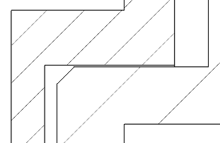
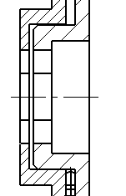

Figure 39. Answer from Improving "mountability" performance

Improving ‘roller rotation’ performance
New requirement: “The 10 rollers must rotate more easily on their axles”.
The drawings below show the assembly of a roller on the wheel, in longitudinal section.
Figure 40. Answer from Improving "roller rotation" performance
On the drawing on the right, above, draw in red the lines representing the surfaces that rub when the roller rotates.

Suggest a simple modification to the geometry of the roller to reduce the size of these surfaces
by drawing the roller in longitudinal cross-section in the box below. You can add an explanatory text.
Table 10. Improving ‘roller rotation’ performance
Drawing of solution + explanatory text:
Reduction of rubbing surfaces:
(1) Two annular contacts replacing
the cylindrical contact on the axle.
(2) Reduction of the lateral contact surface.
3d cross-section view of the modified roller:
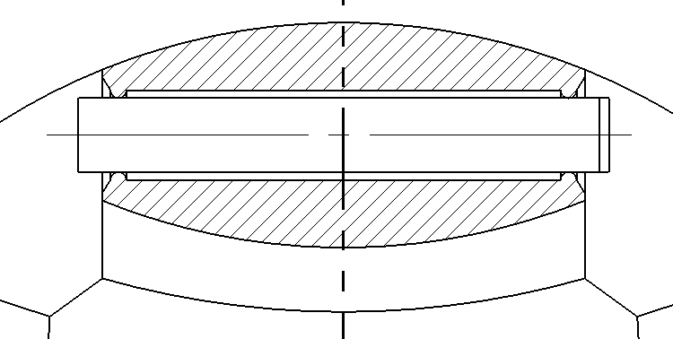

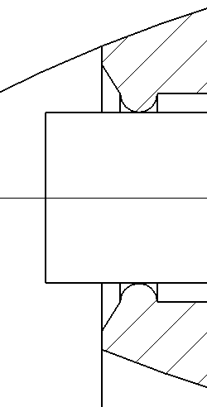
(1)
(2)
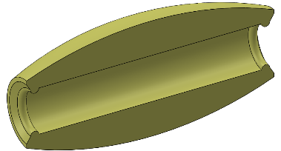
Figure 41. Answer from Improving "roller rotation" performance

We can accept any modifications made to the roller that show a reduction in the contact surfaces between the roller and the half-wheels or axle.



