
CLF-DES-01-EN-MA
PLM management –
3D experience
WP6 COLLABORATIVE LEARNING FACTORY






Funded by the European Union. Views and opinions expressed are however those of the author(s) only and do not necessarily reflect those of the European Union or the European Education and Culture Executive Agency (EACEA). Neither the European Union nor EACEA can be held responsible for them.
This work is licensed by the LCAMP Partnership under a Creative Commons Attribution-NonCommercial 4.0 International License.
LCAMP partners:
TKNIKA – Basque VET Applied Research Centre, CIFP Miguel Altuna LHII, DHBW Heilbronn – Duale Hochschule, Baden-Württemberg, Curt Nicolin High School, AFM – Spanish Association of Machine Tool Industries, EARLALL – European Association of Regional & Local Authorities for Lifelong Learning, FORCAM, CMQE: Association campus des métiers et des qualifications industrie du future, MV: Mecanic Vallée, KIC: Knowledge Innovation Centre, MADE Competence Centre Industria 4.0; AFIL: Associazione Fabbrica Intelligente Lombardia, SIMUMATIK AB; Association HVC Association of Slovene Higher Vocational Colleges; TSCMB:Tehniški šolski center Maribor, KPDoNE: Kocaeli Directorate Of National Education; GEBKİM OIZ and CAMOSUN college.

CONTENT TABLE

1. Introduction 4
2. Access to the dashboard from different screens. 10
3. How to add a new dashboard. 11
4. How to add a tab to a dashboard. 13
5. How to add apps to a dashboard or tab of a dashboard 14
6. Practical apps 15
6.1. 3D Drive 15
6.2. 3D Swym 16
6.3. 3D Play: 17
6.4. 3D Space 18
7. Solidworks and 3DExperience 19
8. 3D Experience PLM 23
9. How to find efficiently 25
10. Additional educational resources 27
11. Index of Images 28

Introduction

Create an account
The access to the platform is given by an administrator. An email with the invitation would be sent to the given email address.
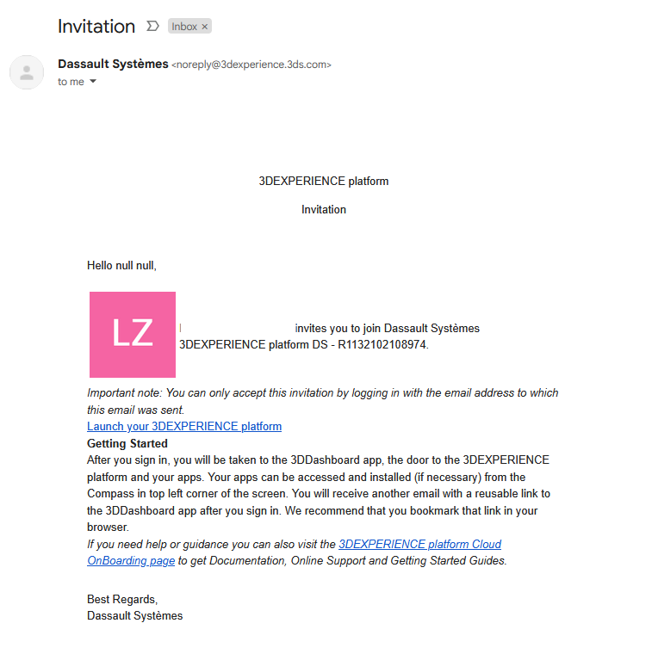
Figure 1Example of invitation email
Click on the link Launch your 3DExperience platform. And fill the form that would be opened in the browser.
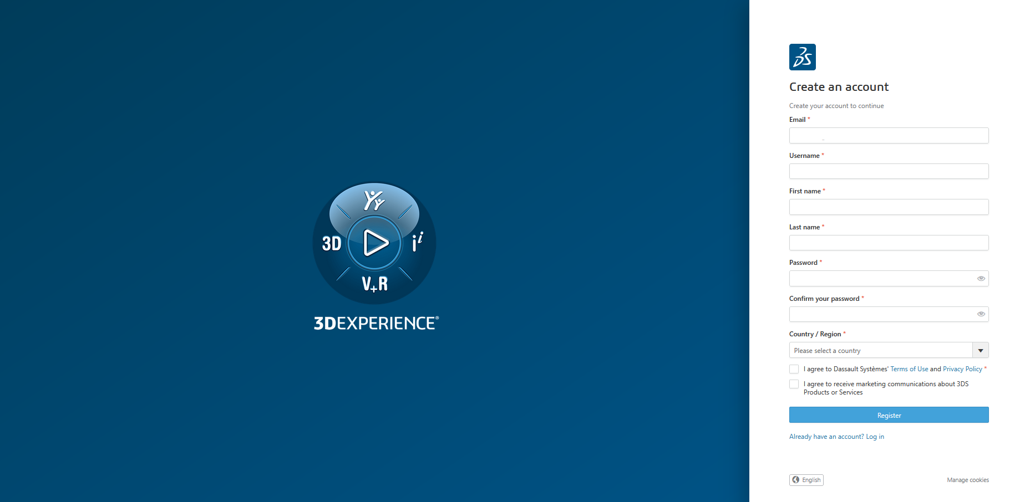
Figure 23DExperience registration webpage
Once the registration is finished you would have the chance to enter to the platform.
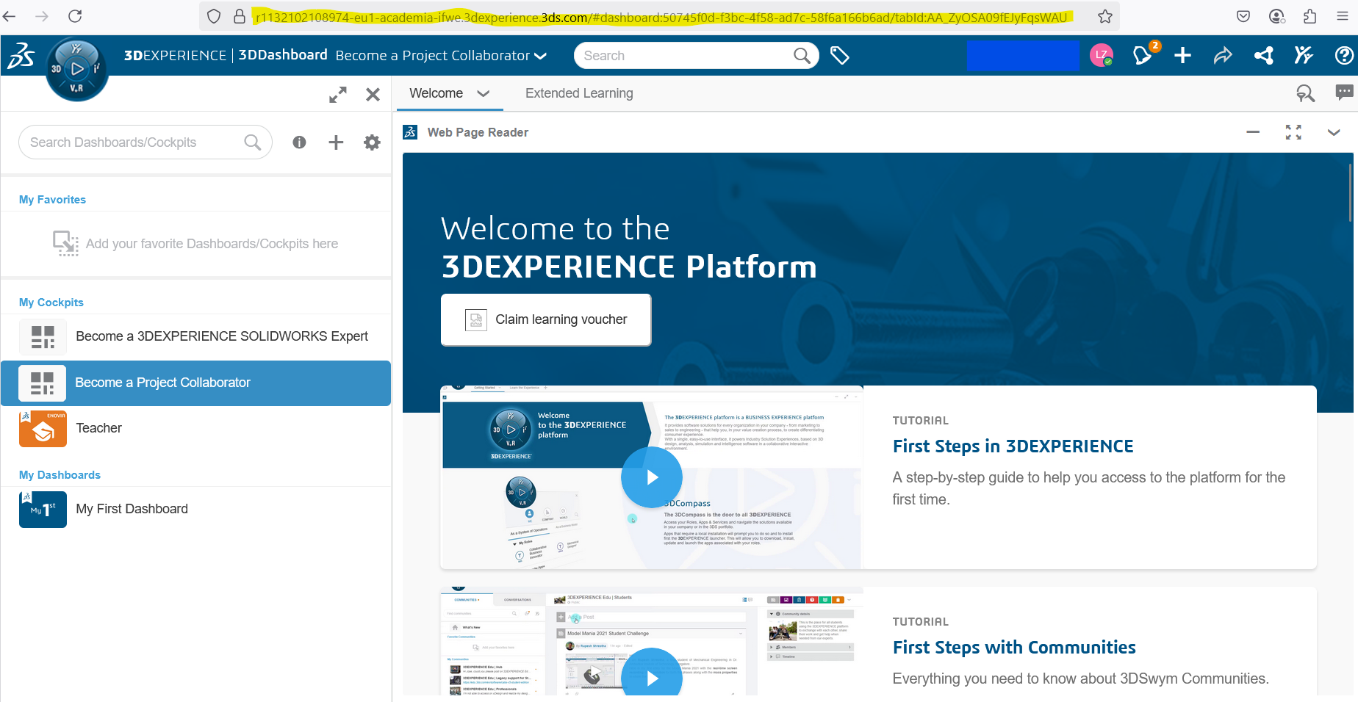
Figure 3 Initial view of the platform.

Recommendation: Save the bookmark of the platform or at least the invitation email to access easily the web address to access easier to the platform. More if you are using more than one platforms in 3D Experience.

Step up your profile.
Each user has its own user profile. This profile contains the information of the user that would be visible to all the users of the platform.
It is important to set the privacy settings at the beginning and update them necessarily: values like cookies, password or 2 step validation can be configured in this screen.
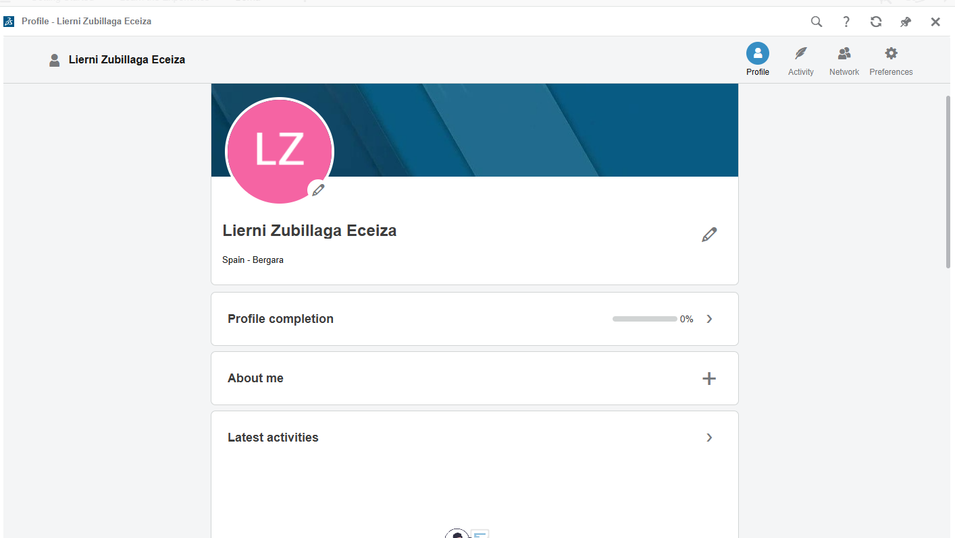
Figure 4Profile main page

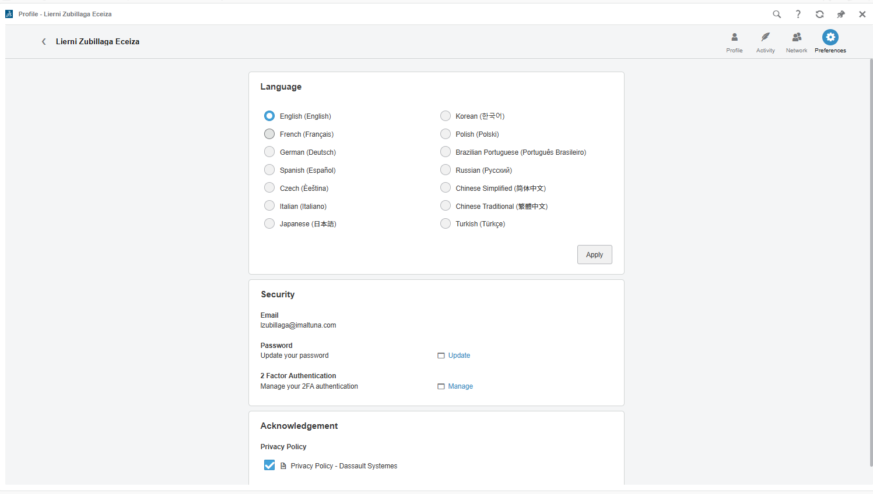
Figure 5Basic settings of the user

Additionally, preferences like language, mouse configuration… can be set here too.
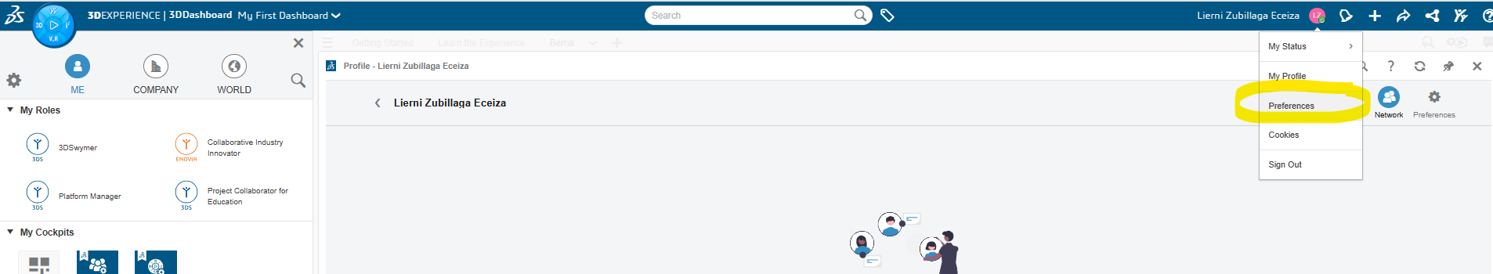
Figure 6Preferences menu selection botton

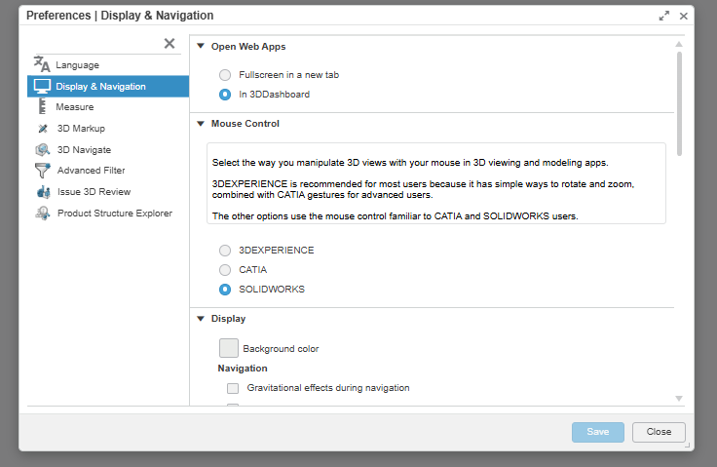
Figure 7Different preferences that can be set up.

Roles
User roles might depend on the licensing of the organization that is inviting you an Educational 3D Experience platform or managing the platform
The educational roles available are:
  - 3D Experience Solidworks for Education
  - 3DSwymer
  - Collaborative Industry Innovator
  - Project Collaborator for Education
  - Teacher
.
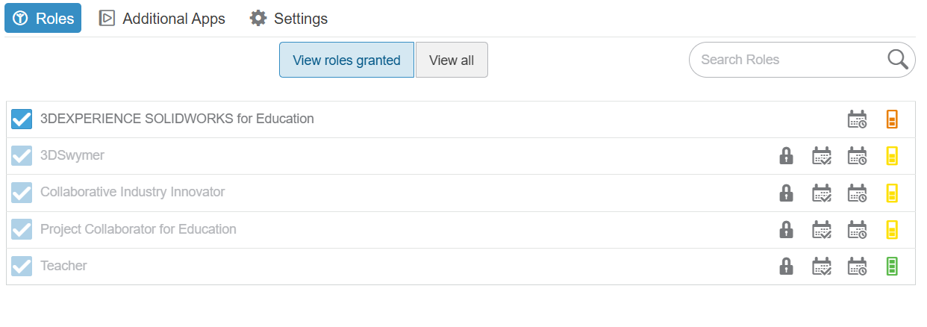

Dashboard
The dashboard is a way of displaying content and resources in the platform. It is recommended to shortcut the most used apps.
There is a default dashboard which is name My First Dashboard and it is proposed empty to every user. This dashboard can be renamed.
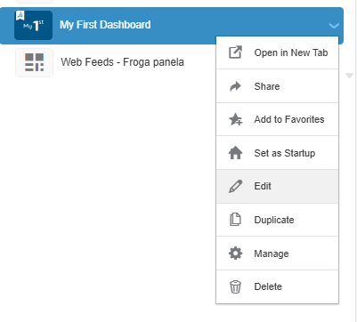
Figure 8How to edit the name of the dashboard

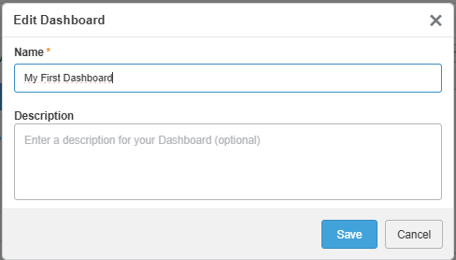
Figure 9Dashboard edition window view.
The own dashboard can personalize with the application that are most used by each user or based on their interests simplifying the user experience of the 3D Experience platform.
In general dashboard are personal but if desired they can be shared. Note that only personal dashboards can be edited. The ones that have been shared to the user and accepted by them are not editable.
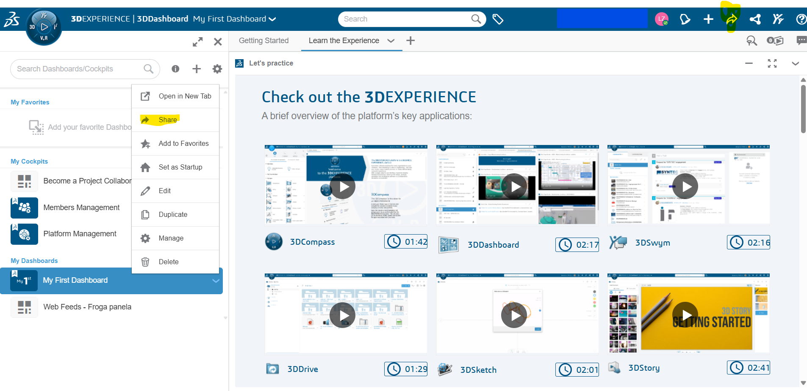
Figure 10 Image containing in yellow the option to share a dashboard.

Access to the dashboard from different screens.
Click on the compass and the hamburger menu on the right side.
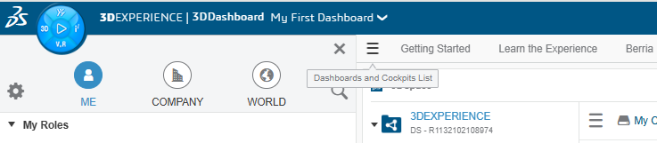
Figure 11 Access to the dashboards.
Then a menu on the left side would be displayed with the different dashboards the can be chosen by clicking on them.
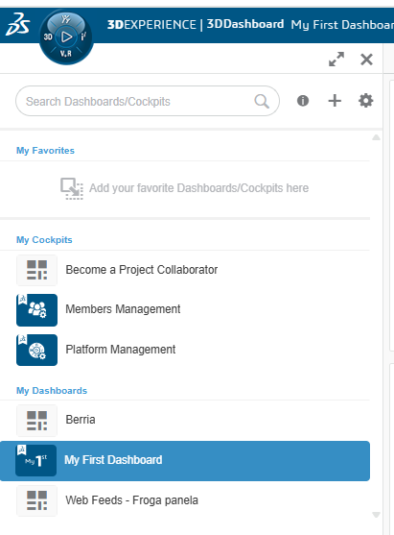
Figure 12 Dashboards menu

How to add a new dashboard.
They are two possible ways to add a new dashborad. One from the dashboard left side menu and two from the general menu.
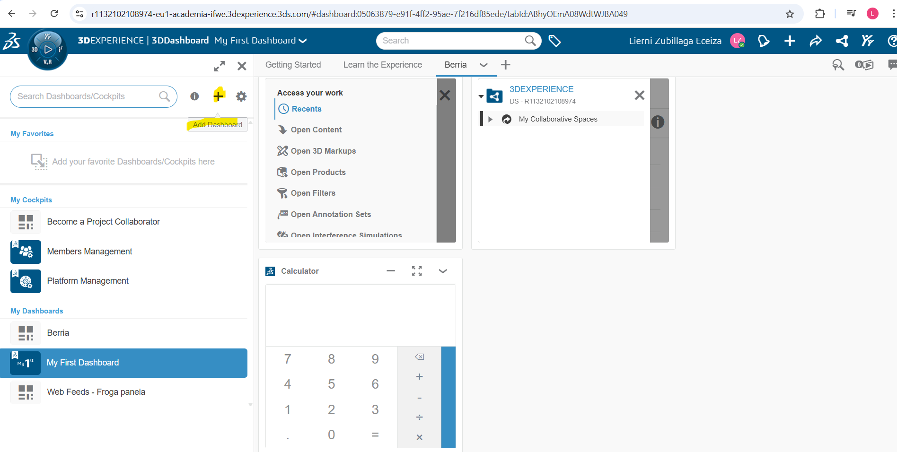
Figure 13 By clicking on the + sign a new dashboard can be added.
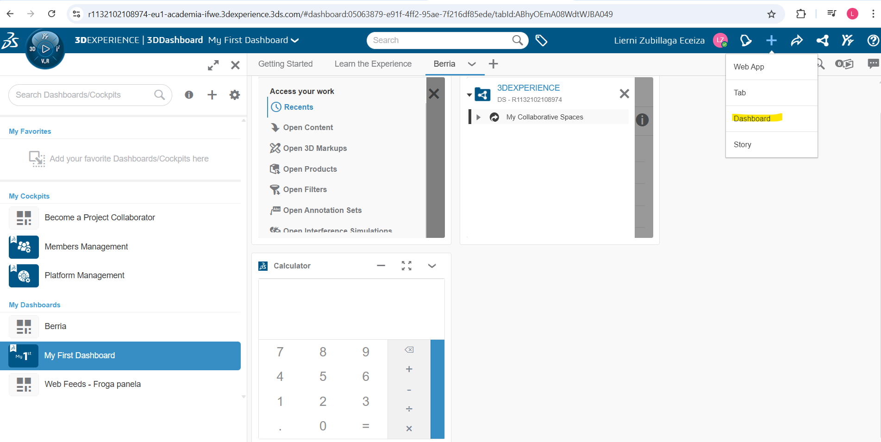
Figure 14 Adding a dashboard from the general menu on the top.
Then a menu would be displayed where it can be chosen from an empty dashboard or a dashboard from a template.
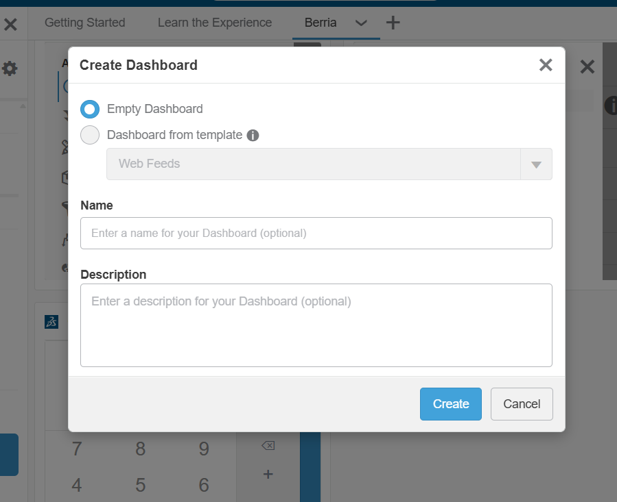
Figure 15 Dashboard creation menu.

How to add a tab to a dashboard.
Once you are in the desired dashboard it is possible to add the needed tabs.
They are two possible ways to add them. One from the tab menu on the top of the dashboard and from the general menu.
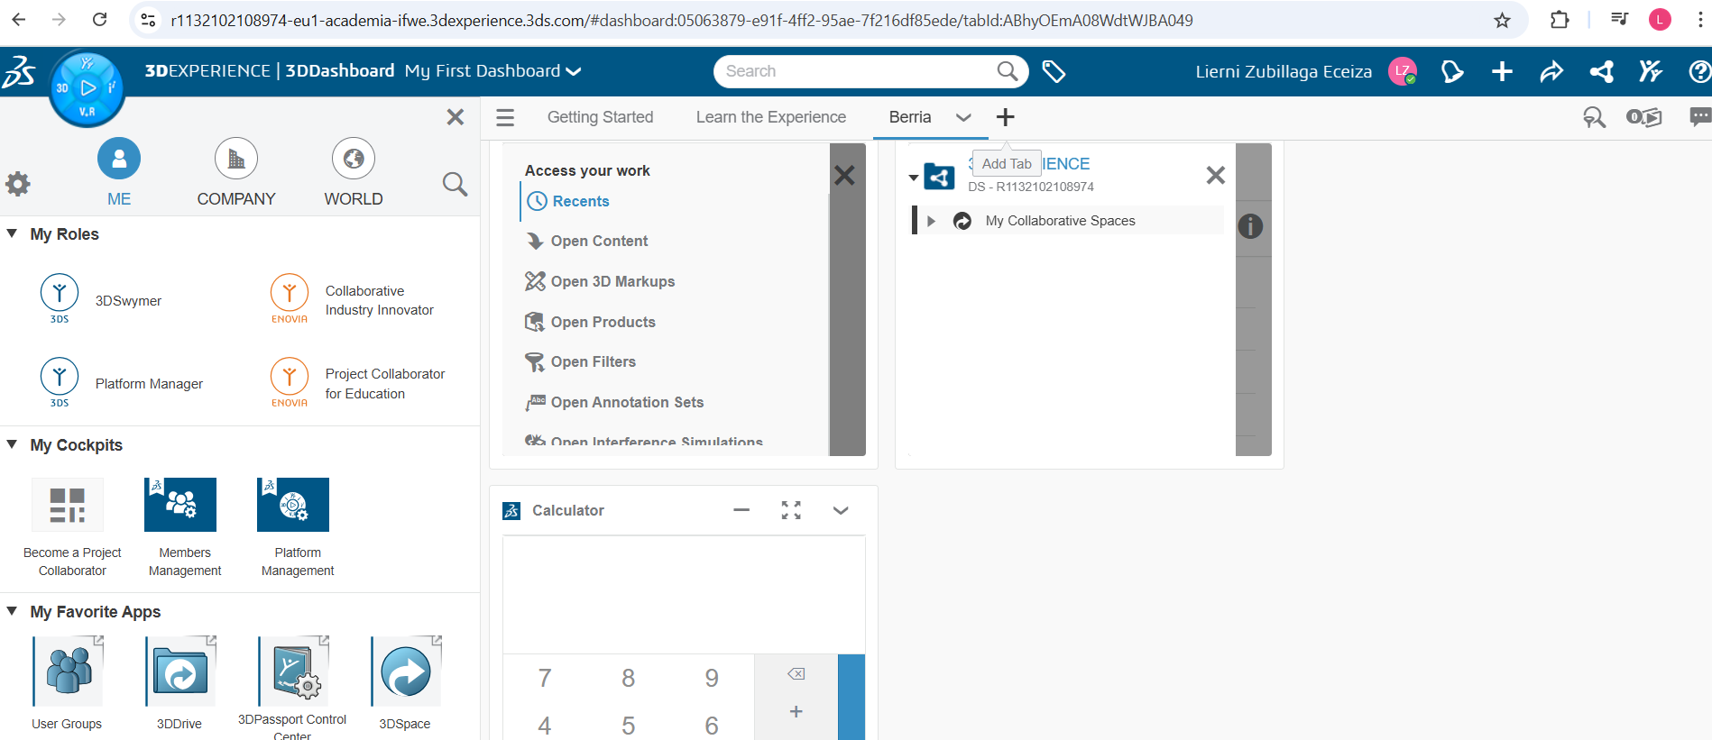
Figure 16 By clicking on the + sign a new tab can be added.
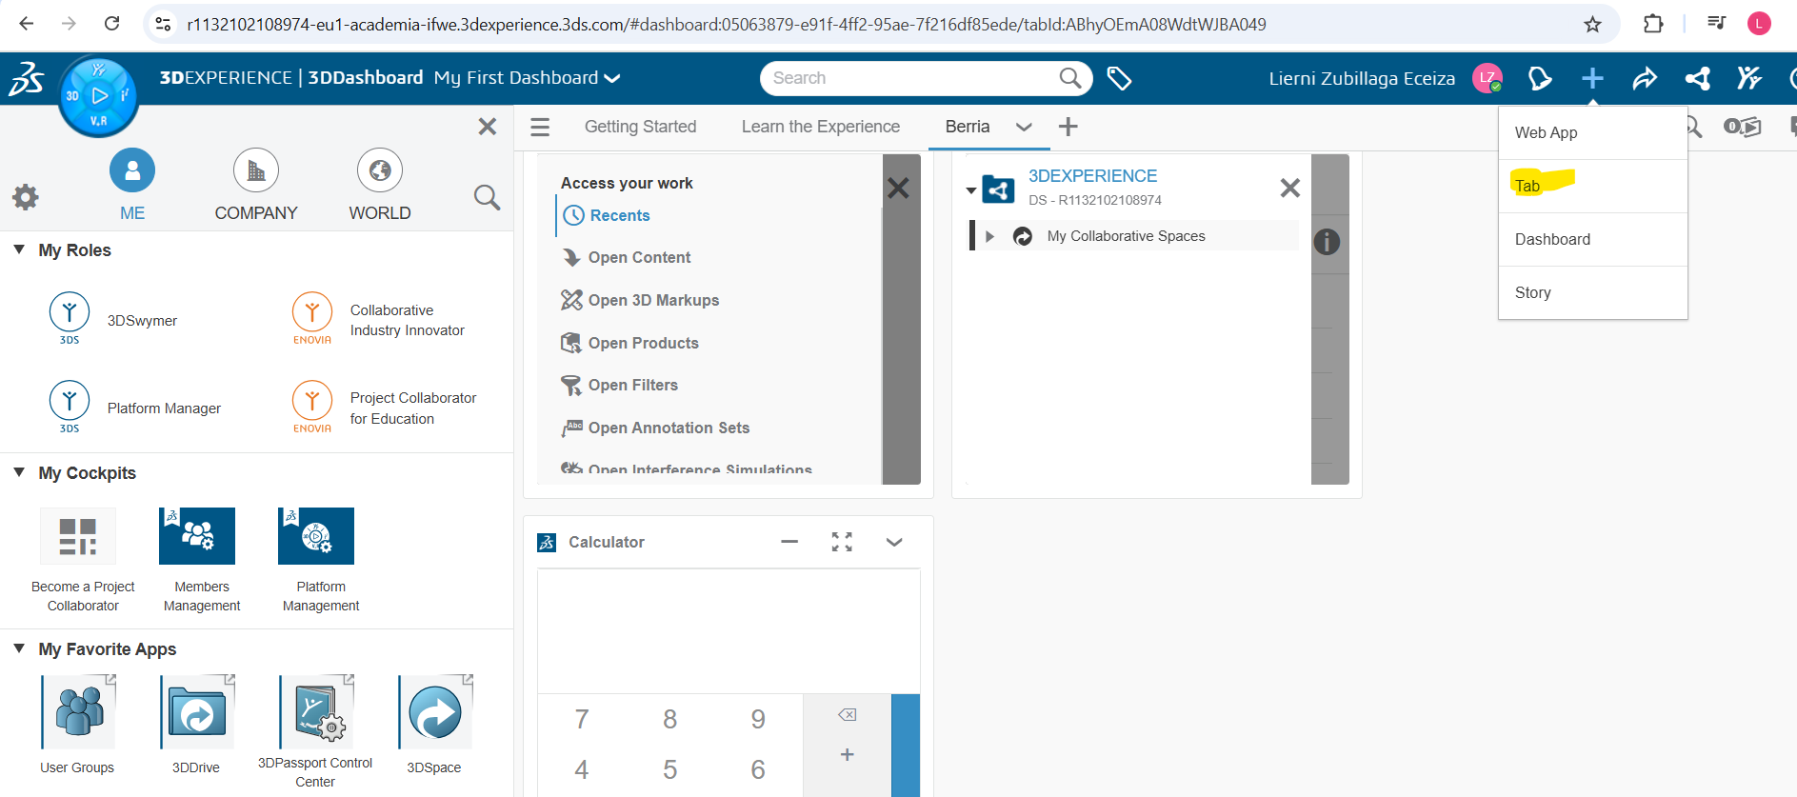
Figure 17 Adding a tab from the general menu on the top.
Then a menu a new tab would be added with the option to rename directly to the upper menu
Figure 18 Example of different tabs of a dashboard

How to add apps to a dashboard or tab of a dashboard
Starting in the dashboard menu: Click first on the compass.
Then a menu in the left side would be displayed and different roles of the user would be shown.
By clicking on every role different apps would be displayed in the bottom of the left hand many.
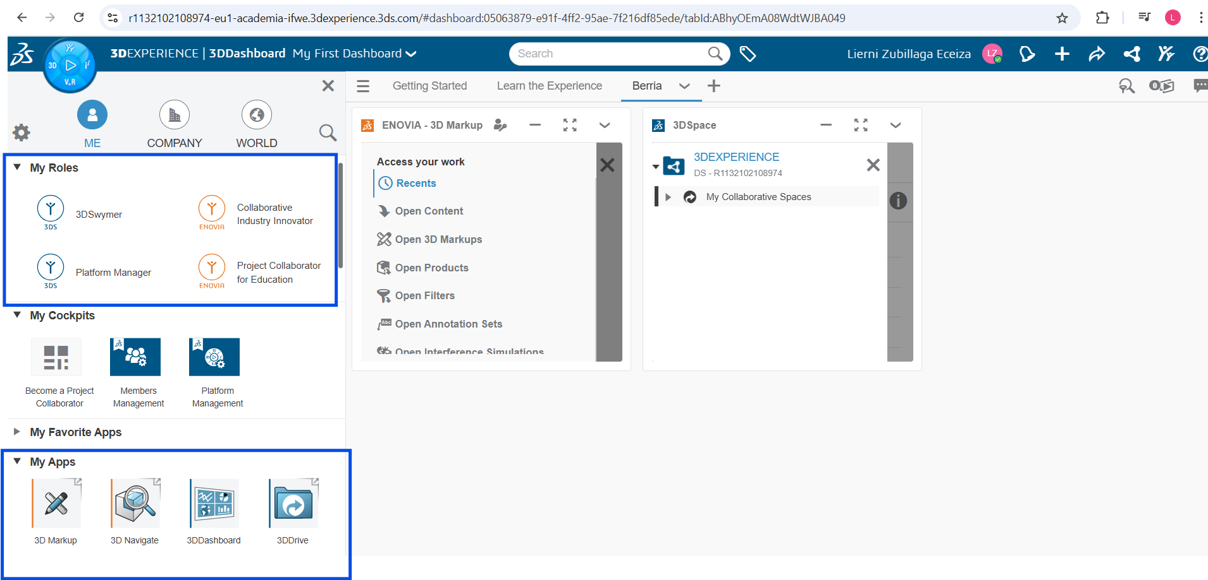
Figure 19 The menu displayed after clicking the compass on the left side. Marking the position of the roles of the user and the corresponding apps.
Once the app has been selected click on it and drag the app to the right side of the screen where the tabs of the dashboard are shown.

Practical apps

3D Drive
It is the app to manage the cloud storage: by default the user would have a little space available in 3D Experience.
But this app enables to use other cloud storage providers like: Box, Dropbox, Google drive or One drive.
It is necessary to install in the desktop the app and the link with the cloud method desired. It is not compulsory to install the desktop adding.
The installation is offered in the 3D Experience location.
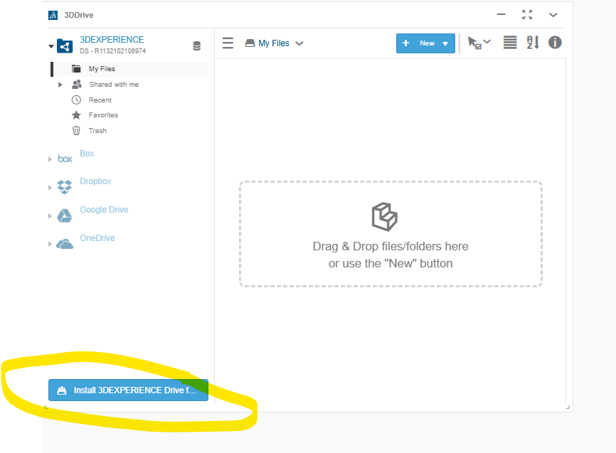
Figure 20 Installation link
Finally, documents can be added either using the menu or by drag and drop on the area defined area.
It is very practical for sharing documents without using the PLM part.
The app is accessible from 3 places the app menu, the dashboard or the shortcut of the upper menu.
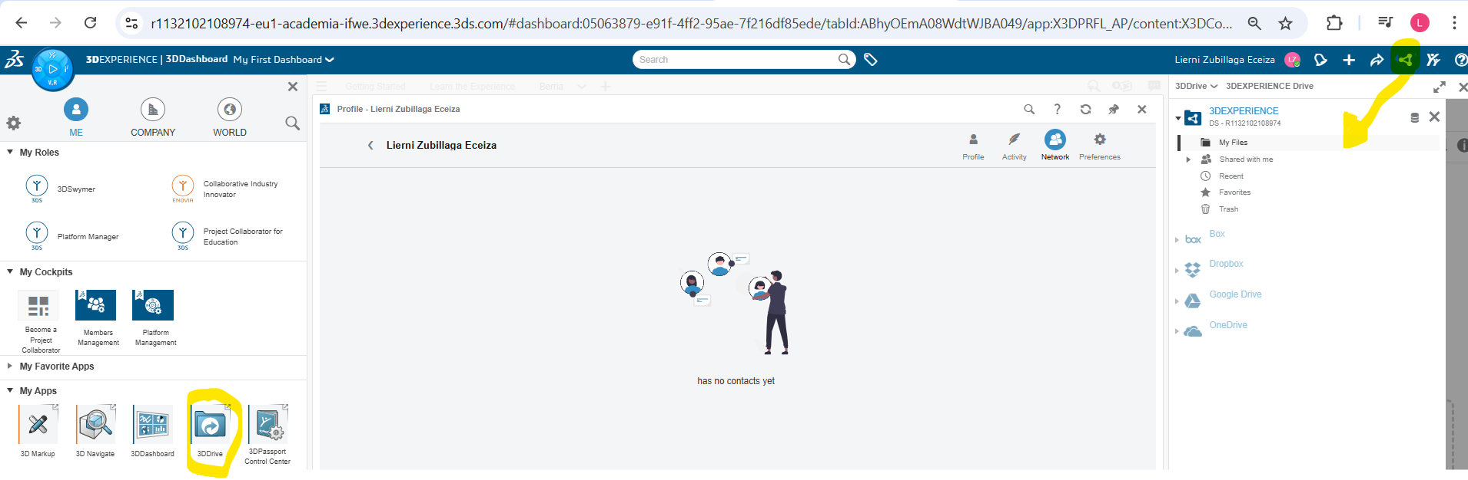
Figure 21 Access to the 3D drive app

3D Swym
It is the communication application: that enables, call, video calls, chats… additionally the management of communities is done by this interface.
Communities are groups of users that are linked by a topic (a project, a product…). A standard user can only be invited to a community. They can propose a new community. But only the administrator would have the capability to accept the proposal and open a new community.
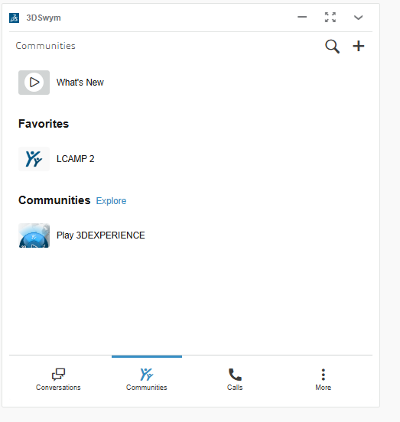
Figure 22 User interface of the 3D Swyn app.
It is also available from the upper menu as shown in the next picture.
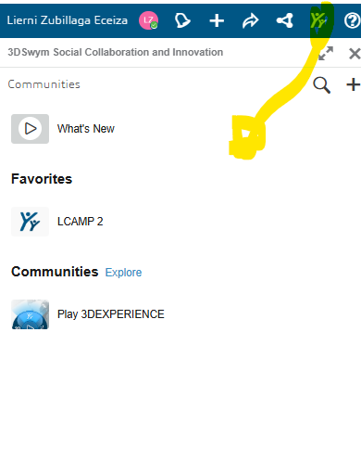
Figure 23 Shortcut icon on upper menu for 3D Swym

3D Play:
It is a app for the visualization of the parts. Models can be seen or displayed 3D visualization, additionally is possible to make annotation on the part.
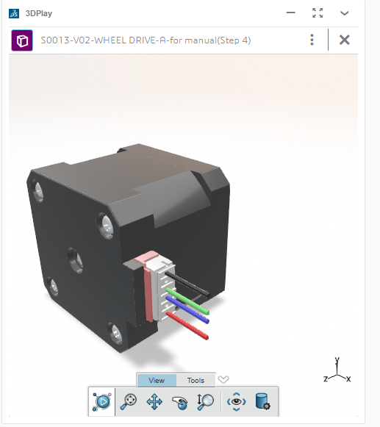
Figure 24 3D Play interface example

3D Space
It contains the collaborative space that the user has access.
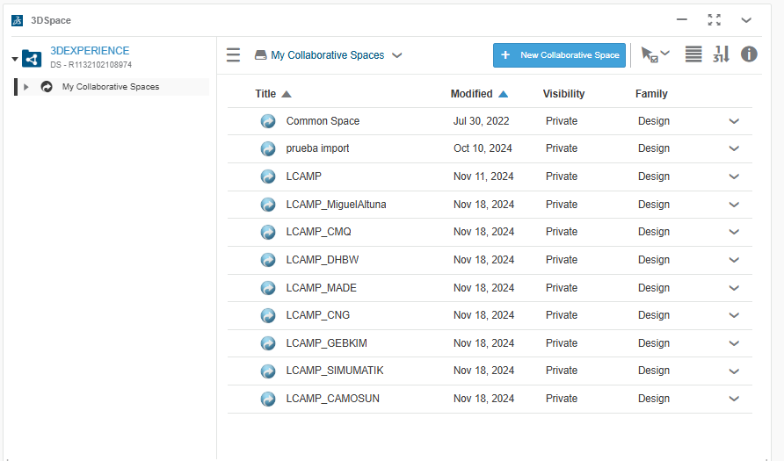
Figure 25 3D Space interface example
Finally, other apps that can be useful are: 3D sketch, Newsfeeds, calculator…
Remember that each app window can be maximized minimized and have properties to adjust.

Solidworks and 3DExperience
It is necessary to have Solidworks program in the computer to run the combination with 3D Experience. In case the computer has not the program, 3D Experience would check if there is enough space for installation. In case the computer is capable the would have the chance to install Solidworks program.
In the app menu there is available a link with the following image.
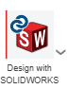
Figure 26 Solidworks connector icon in 3D Experience
The Solidworks + 3D Experience interface would look as shown in the next image.
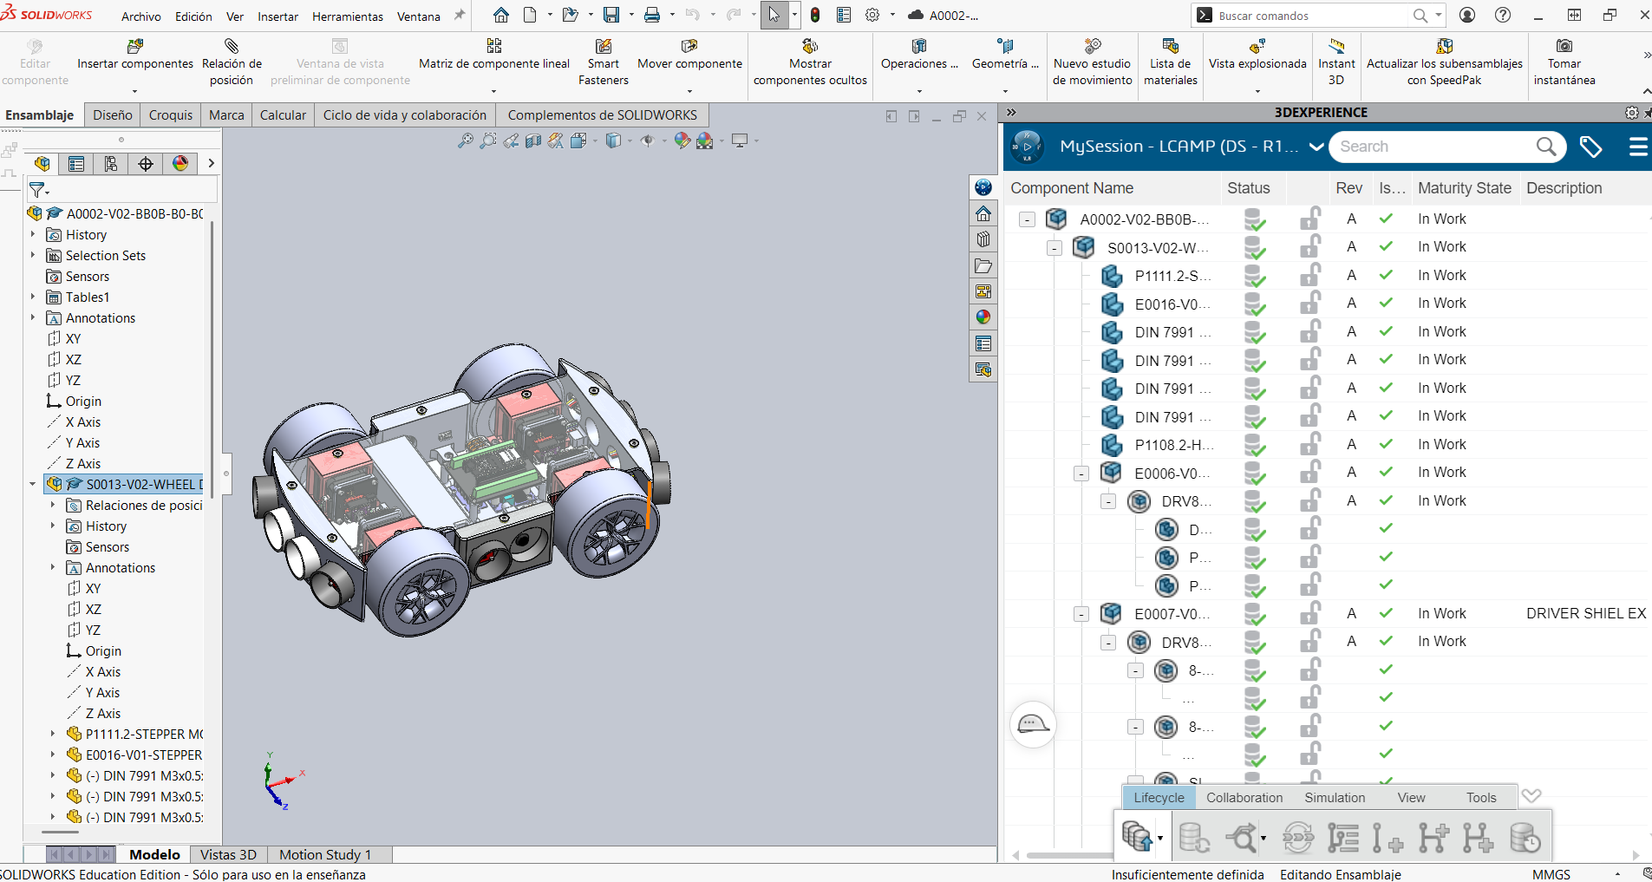
Figure 27 Solidworks + 3D Experience interface
The drawing can be done normally in Solidworks in case the want to be saved in the PLM of 3D Experience. 2 options are possible.
The first one is from the general menu or short cut Ctrl + Alt+ S.
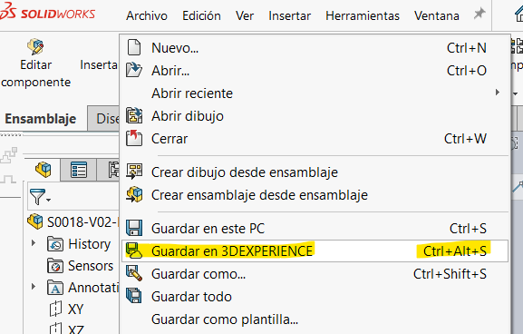
Figure 28 General menu saving mode in 3D Experience.
Or from the icon menu.
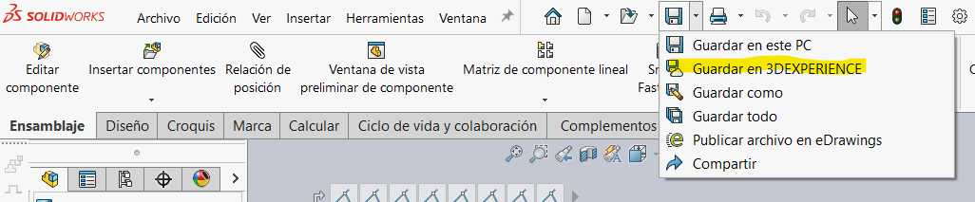
Figure 29 Icon menu saving mode for 3D Experience.
Then the collaborative space should be chosen and also the bookmark, in order to have a good tracking.
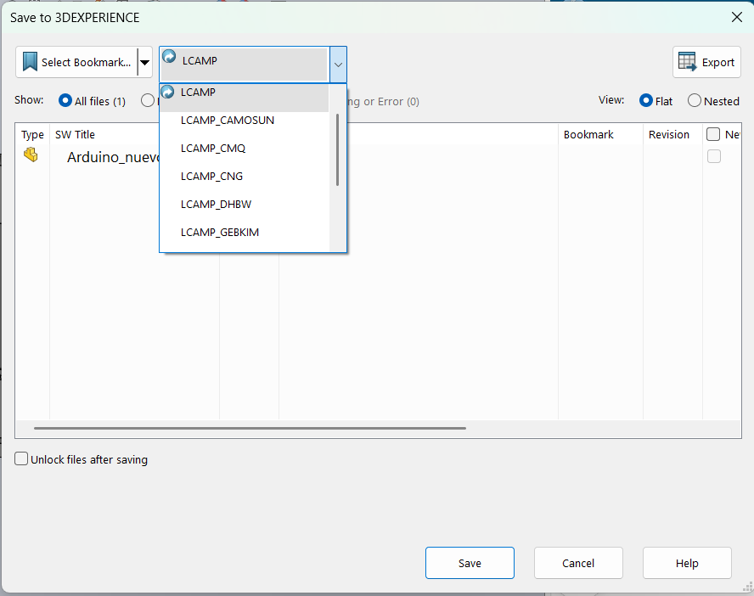
Figure 30 Selection of collaborative space
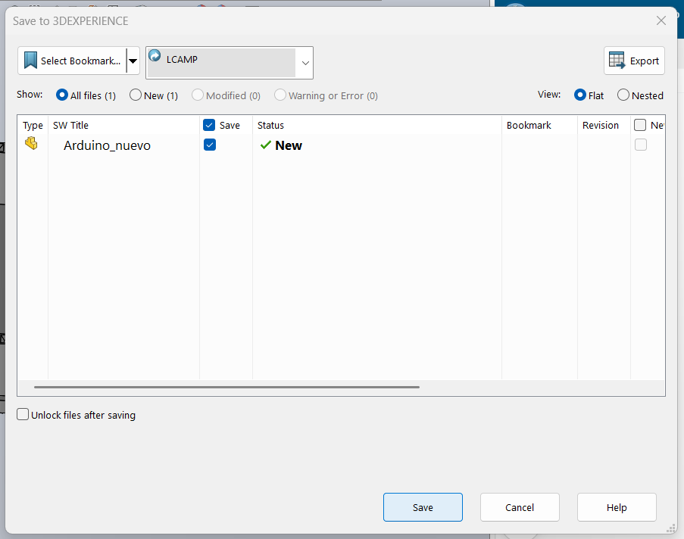
Figure 31 Selection of bookmark
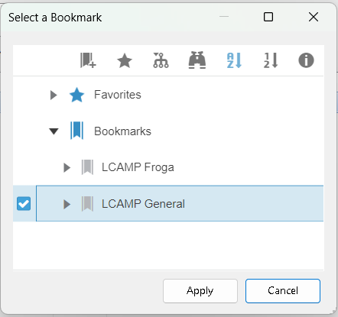
Figure 32 Selection menu of the bookmark
Figure 33 How to save the part.
Then after saving the visualization in 3D experience of the part would be 3D experience bookmark visualization. It can take few minutes to save the file, depending on the size of the file and network.
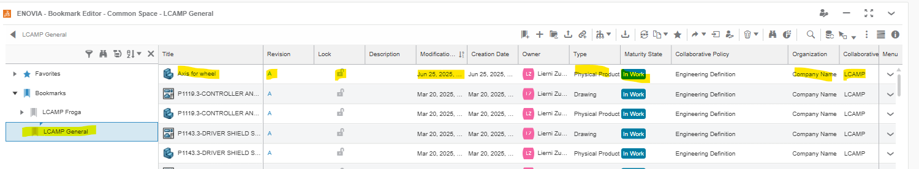
Figure 34 Visualization of the ENOVIA Bookmark viewer in 3D Experience
The save part visualization in Solidworks and 3D Experience view.
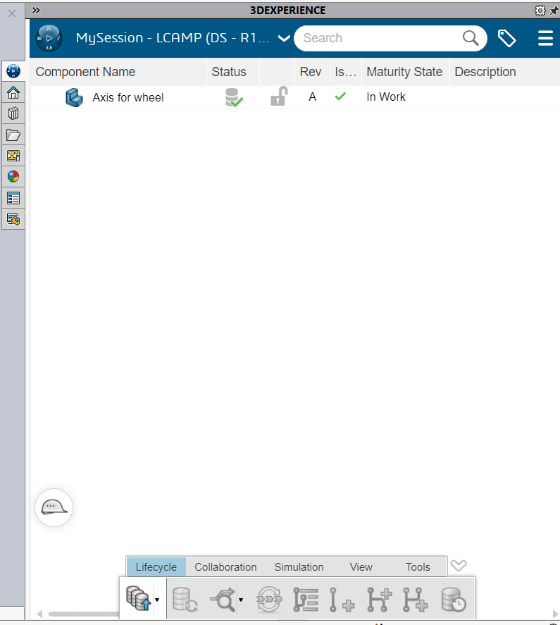
Figure 35 3D Experience view in Solidworks.

3D Experience PLM
The program and app family of the PLM is known as ENOVIA. The collaborative spaces are active by invitations and different roles are available.
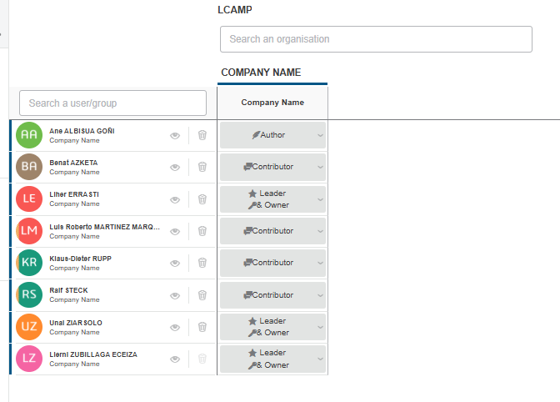
Figure 36 Example of coworkers in a collaborative space.
Depending in the roll type we have been assigned capability for doing different things would be given.
  - Leader and owner: see, edit and give other rolls and add user.
  - Author: create and publish new docs and read them.
  - Collaborator: see and work on the existing documents.
The information is save like in a “huge warehouse”. Because of that it is very useful to use bookmarks to classify data in virtual folders (drawings) and the document management app.
It is hardly recommended to prepare a dashboard for PLM. The minimum needed apps would be: 3D Space, Document management and bookmarks.
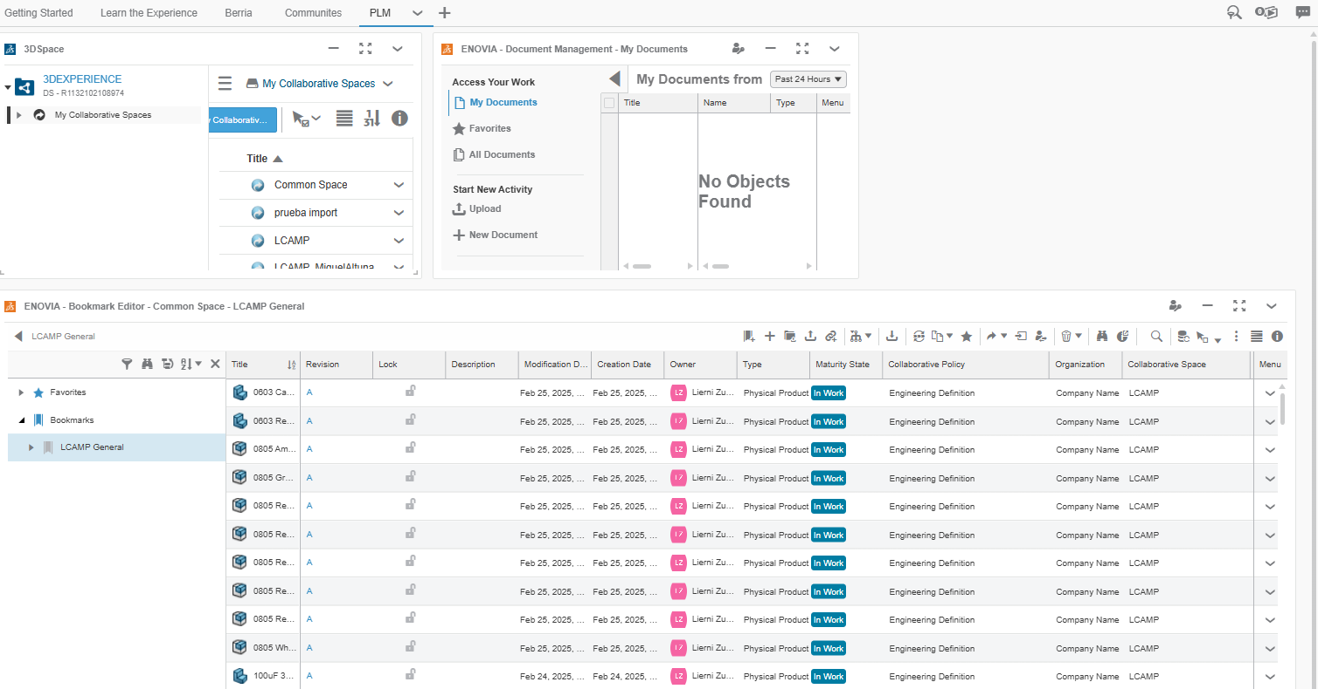
Figure 37 Example of PLM recommended dashboard.
Document management is used for:
  - Download
  - Visualised
  - Updated
  - Edited
  - Added to the library
The type of documents manage can be Excel files, word files, pdf…
Drawing and other types of documents can be in different stages.
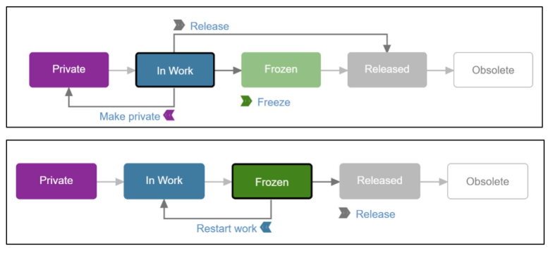
Figure 38 Product cycle process in 3D Experience PLM
  - Part in work process: we can edited without blocking.
  - Edited: Must be blocked to be edited and to create a new revision when saved.
  - Once released the part cannot be edited.
  - In case it is necessary a new revision would be created.
Additionally, note that each configuration of a physical product would form a CAD Family.

How to find efficiently
As far as the PLM is a “huge warehouse” apart from saving parts and documents in corresponding Collaborative Spaces and Bookmarks. The system offers a searching engine that has a good capability.
In the upper menu there is a white box that in which Search is written. All type of documents in 3D Experience containing the keyword would be displayed. Additionally a filtering is offered by clicking on the “ticket” button clicking .
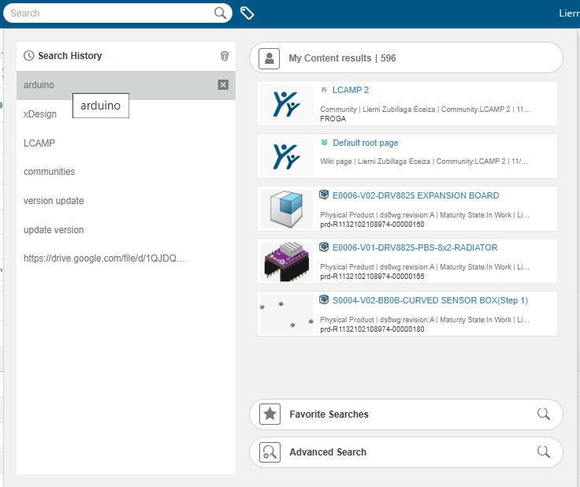
Figure 39 General search example
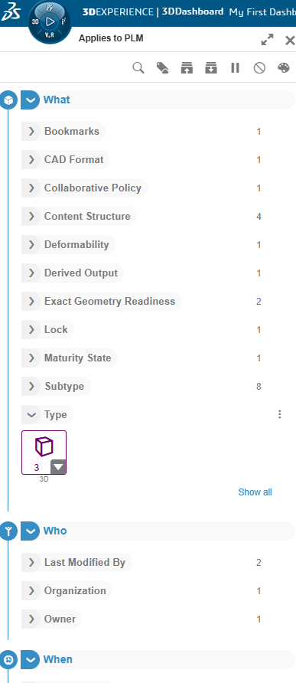
Figure 40 Filtering menu display

Additional educational resources
In the homepage of the platform default options of online education are available. the links and videos are shown in two tabs. On both tabs of dashboard in Getting started and learn the experience could be found those links.
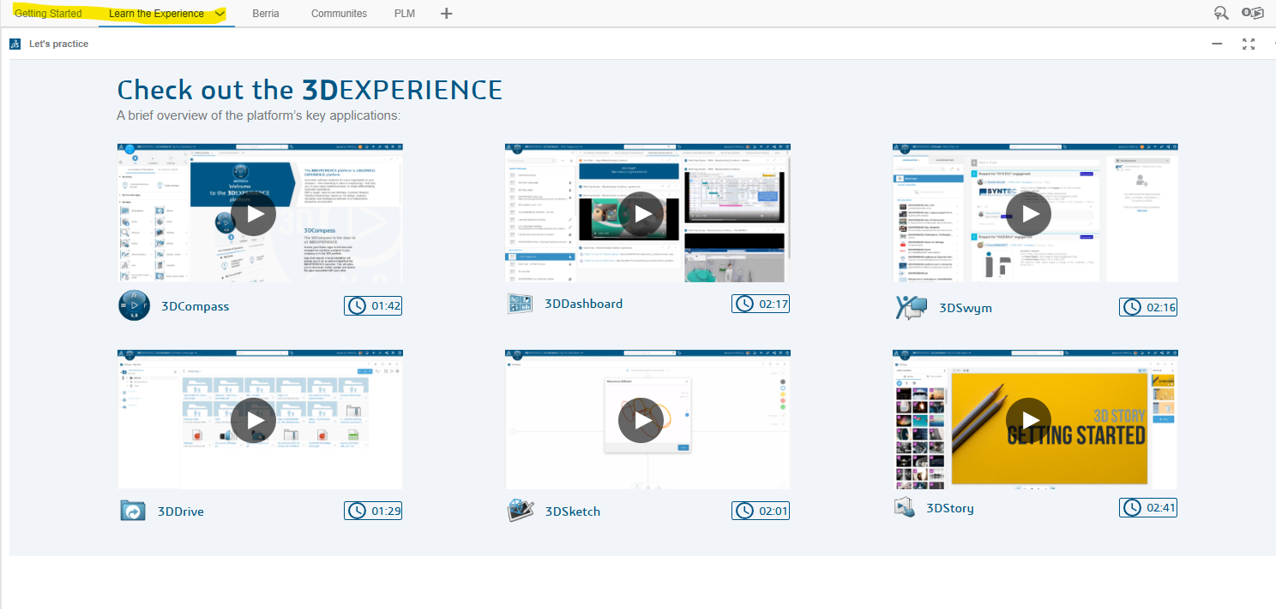
Figure 41 Dashboard tabs of the educational videos.
Finally a deeper educational web application is available for the 3D Experience users offered by Dassault. It is necessary to sign up and formations shown would only consider the applications available for the enroled user.
https://eduspace.3ds.com/CompanionManager/public/#/
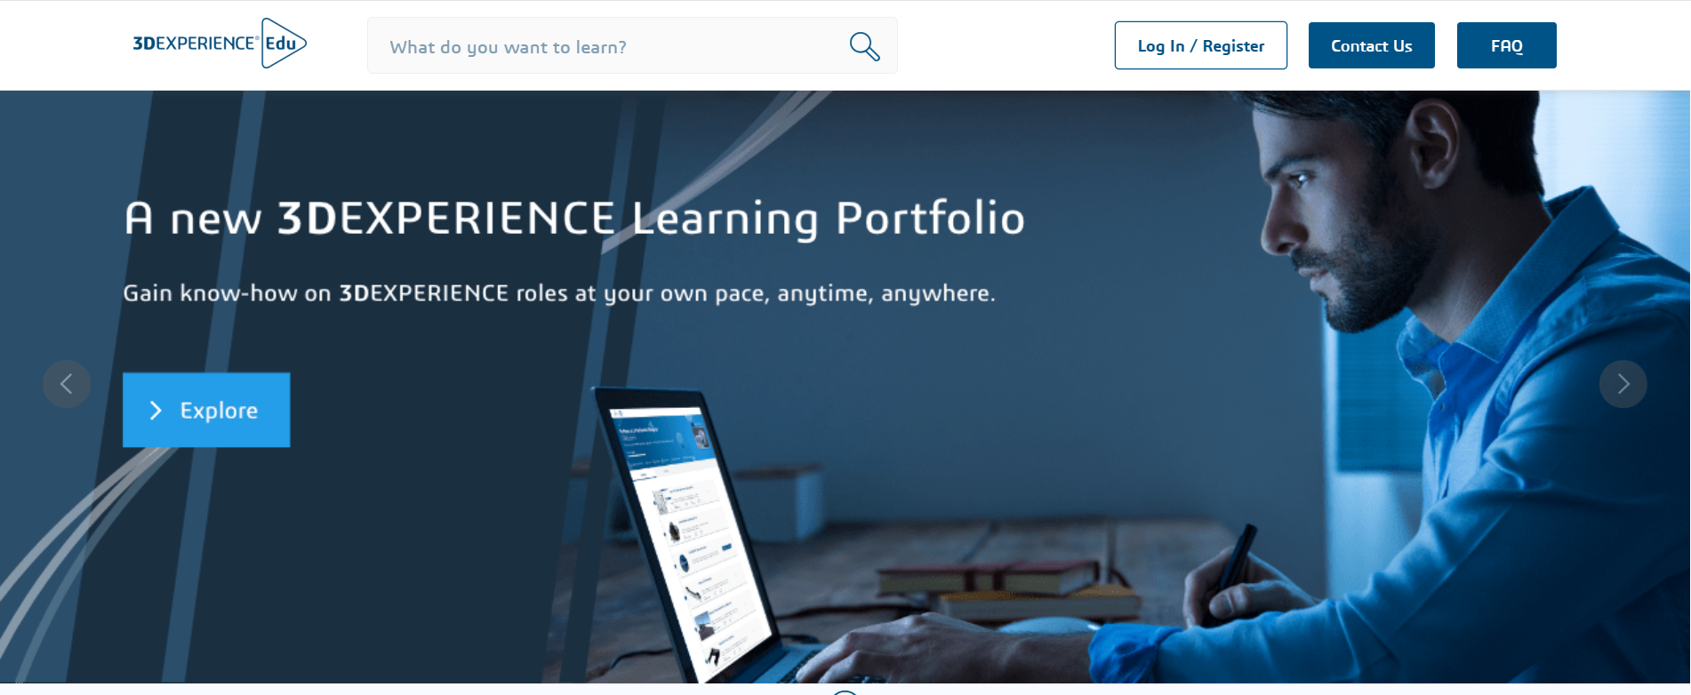
Figure 42 Dassault educational platform homepage.

Index of Images
Figure 1Example of invitation email 5
Figure 23DExperience registration webpage 6
Figure 3 Initial view of the platform. 6
Figure 4Profile main page 7
Figure 5Basic settings of the user 7
Figure 6Preferences menu selection botton 7
Figure 7Different preferences that can be set up. 8
Figure 8How to edit the name of the dashboard 10
Figure 9Dashboard edition window view. 10
Figure 10 Image containing in yellow the option to share a dashboard. 11
Figure 11 Access to the dashboards. 11
Figure 12 Dashboards menu 12
Figure 13 By clicking on the + sign a new dashboard can be added. 12
Figure 14 Adding a dashboard from the general menu on the top. 12
Figure 15 Dashboard creation menu. 13
Figure 16 By clicking on the + sign a new tab can be added. 14
Figure 17 Adding a tab from the general menu on the top. 14
Figure 18 Example of different tabs of a dashboard 14
Figure 19 The menu displayed after clicking the compass on the left side. Marking the position of the roles of the user and the corresponding apps. 15
Figure 20 Installation link 16
Figure 21 Access to the 3D drive app 17
Figure 22 User interface of the 3D Swyn app. 17
Figure 23 Shortcut icon on upper menu for 3D Swym 18
Figure 24 3D Play interface example 19
Figure 25 3D Space interface example 19
Figure 26 Solidworks connector icon in 3D Experience 20
Figure 27 Solidworks + 3D Experience interface 20
Figure 28 General menu saving mode in 3D Experience. 21
Figure 29 Icon menu saving mode for 3D Experience. 21
Figure 30 Selection of collaborative space 21
Figure 31 Selection of bookmark 22
Figure 32 Selection menu of the bookmark 22
Figure 33 How to save the part. 22
Figure 34 Visualization of the ENOVIA Bookmark viewer in 3D Experience 23
Figure 35 3D Experience view in Solidworks. 23
Figure 36 Example of coworkers in a collaborative space. 24
Figure 37 Example of PLM recommended dashboard. 25
Figure 38 Product cycle process in 3D Experience PLM 25
Figure 39 General search example 27
Figure 40 Filtering menu display 28
Figure 41 Dashboard tabs of the educational videos. 29
Figure 42 Dassault educational platform homepage. 29

.

