
CLF-CAM-01-SV-CNG-Siemens NX
WP6 COLLABORATIVE LEARNING FACTORY




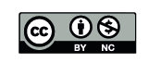

Funded by the European Union. Views and opinions expressed are however those of the author(s) only and do not necessarily reflect those of the European Union or the European Education and Culture Executive Agency (EACEA). Neither the European Union nor EACEA can be held responsible for them.
This work is licensed by the LCAMP Partnership under a Creative Commons Attribution-NonCommercial 4.0 International License.
LCAMP partners:
TKNIKA – Basque VET Applied Research Centre, CIFP Miguel Altuna LHII, DHBW Heilbronn – Duale Hochschule, Baden-Württemberg, Curt Nicolin High School, AFM – Spanish Association of Machine Tool Industries, EARLALL – European Association of Regional & Local Authorities for Lifelong Learning, FORCAM, CMQE: Association campus des métiers et des qualifications industrie du future, MV: Mecanic Vallée, KIC: Knowledge Innovation Centre, MADE Competence Centre Industria 4.0; AFIL: Associazione Fabbrica Intelligente Lombardia, SIMUMATIK AB; Association HVC Association of Slovene Higher Vocational Colleges; TSCMB:Tehniški šolski center Maribor, KPDoNE: Kocaeli Directorate Of National Education; GEBKİM OIZ and CAMOSUN college.

CONTENT TABLE

1. Introduktion 4
2. Komma igång. 5
3. Kontrollera delarna 6
4. Lägg till råämne och Part 7
5. Placera ditt råämne och Part 8
6. Placera ut koordinatsystemet 10
7. Definiera vad som är part och ämne 12
8. Gå in i 2D 13
9. Sätt begränsningar 14
10. Bildregister 15

Introduction
This micro-course covers how to get started with CAM in Siemens NX and how to create a setup for turning. The course is designed to provide a basic understanding of the tools and techniques needed to use CAM in Siemens NX effectively. By following this course, you will learn how to create a setup for turning, which is an important part of the manufacturing process. The course is suitable for both beginners and those looking to refresh their knowledge in the field.

getting started
Start by opening the Manufacturing mode with reference to the part you want to create a CAM for.
Open a part in NX that you want to create a CAM for, then select File > New > Manufacturing. Next, choose the machine you wish to use for your CAM setup.
At the bottom of the window, you can see if the setup is referencing a part—this should be the part you intend to generate a CAM for.
If the correct part is not selected, or if there is no part in the box, click the small icon to the right of the box and choose the part you want to use.
Click OK
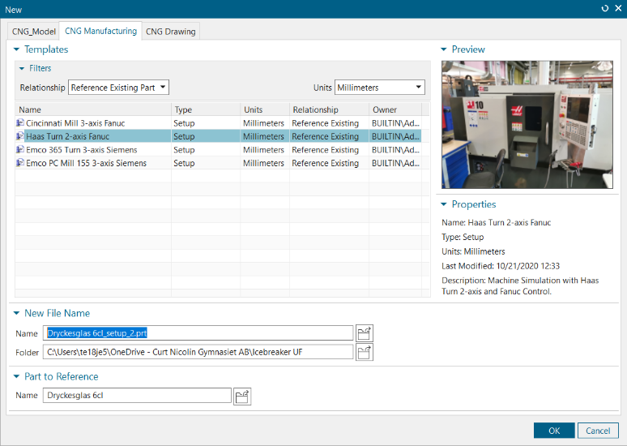
Figure 1 Create a file

control the parts
Check if there is already a part and stock added to the setup.
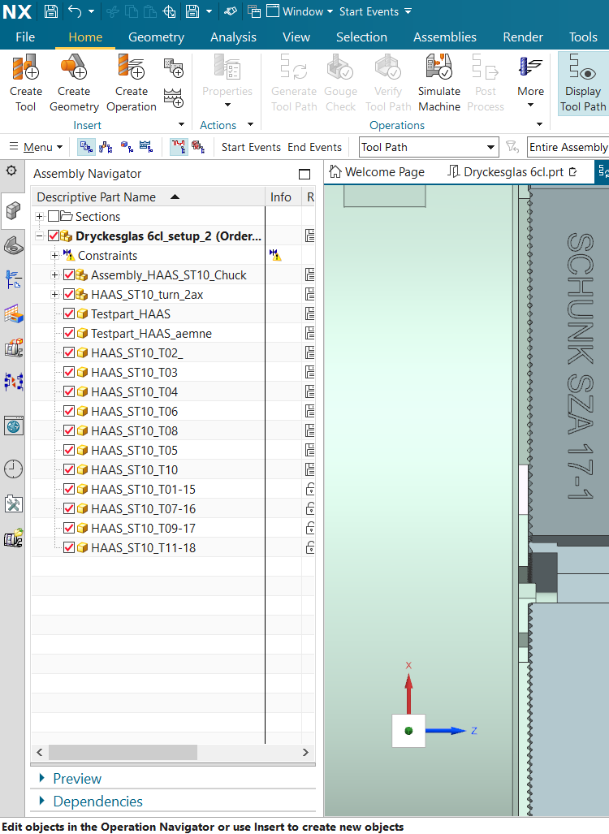
Open the Assembly Navigator check whether a part and a stock material have already been added to the setup.
Red arrow = Assembly Navigator
Blue arrow = Testpart
Green arrow = stock material
Figure 2 Control the parts

Add stock material and Part
If the setup already contains a stock and a part, replace them as follows:
Right-click on the test part that is already added click Replace Component Select the Part you wish to create a CAM for (your reference part) Click OK.
Right-click on the stock that is already added Click Replace Component Select the stock you have created for your part Click OK.
Click the small plus sign to the left of Constraints to display all existing constraints If there are any existing constraints, select them and delete them.
If the setup does not already contain any stock or part
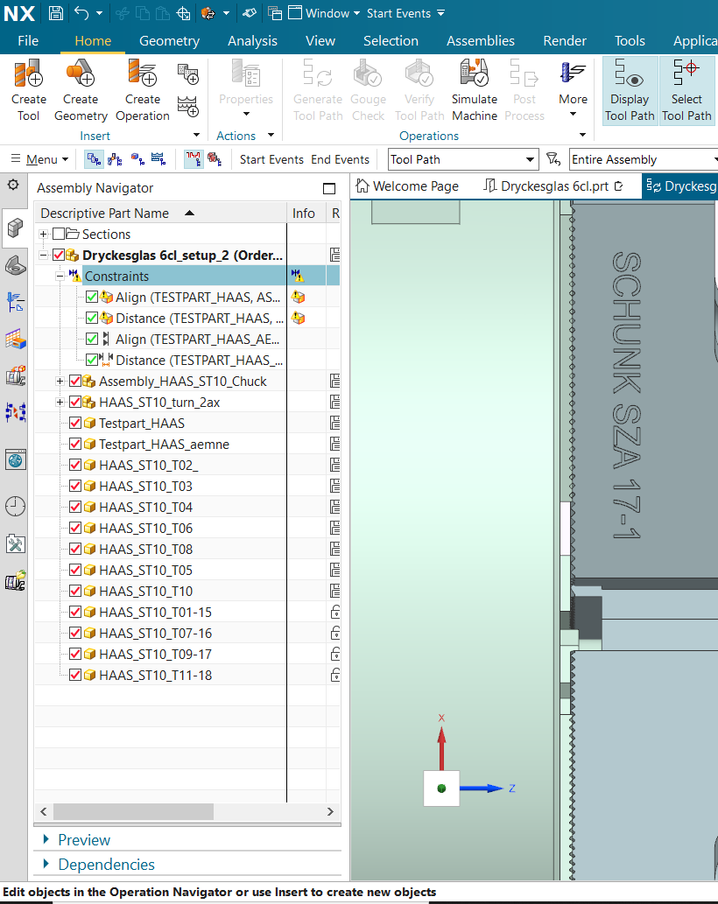
Go to Geometry and select Add Component to add your part and your stock material.
Figure 3 Constraints

Place your stock material and part
To position your stock material and part correctly in the machine:
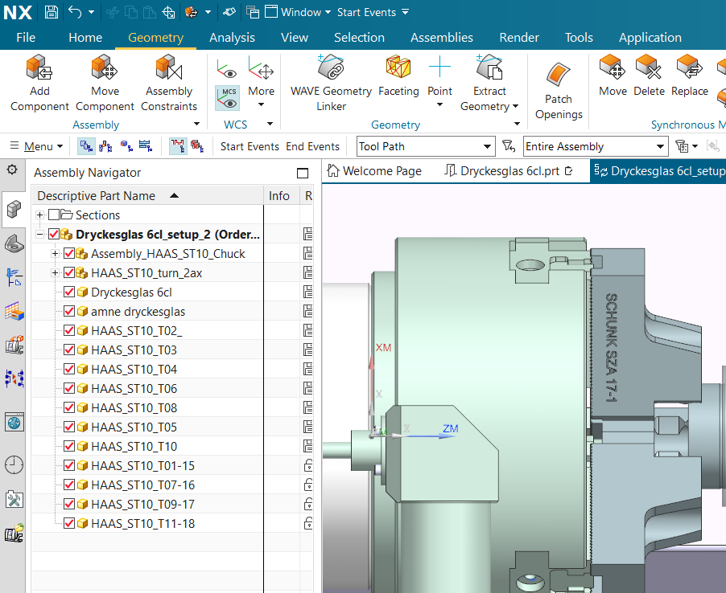
Click on Geometry Select Assembly Constraints choose the constraint type touch align first select the center axis of the workpiece, then the center axis of the chuck.
Red arrow = Geometry
Green arrow = Assembly constraints
Orange arrow = Touch align
Black arrow = Center axis
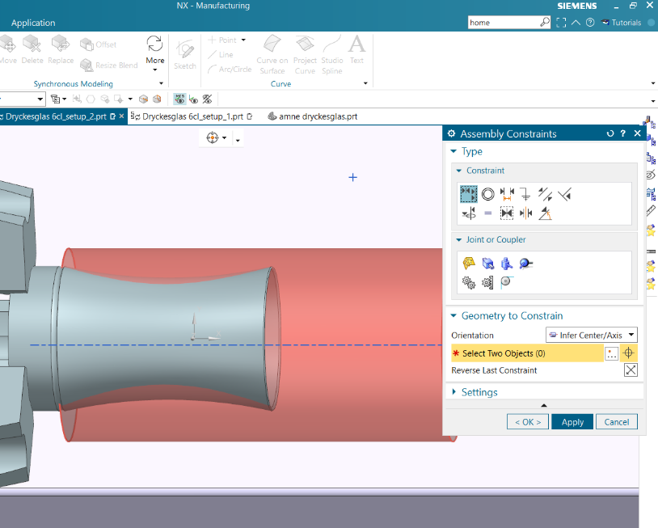
Figure 4 Assembly Constraints
Figure 5 Types of Constraints

When you have clicked on both center axes, press Apply select Touch Align again First, select the bottom/short side of the stock, then select the jaws press OK.
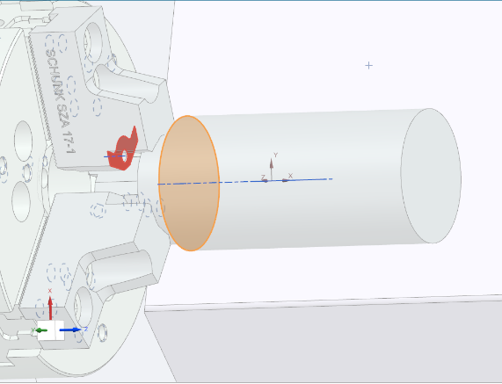
Orange surface = Underside of stock
Red surface = Surface of the jaws to mark
Red ring = The Jaws

Figure 6 Constraints to attach the stock to the jaws

Once the constraints for the stock are set, it's time to apply the constraints to the part.
Start by marking the center axes of the part in the same way as you did with the stock, using Touch Align (remember to select the part’s centerline first since the first item selected will be the one that moves) once both are marked, press Apply choose the Distance constraint type first select the top of the part, then the top of the stock set the distance so the part sits 1 mm inside the stock press OK
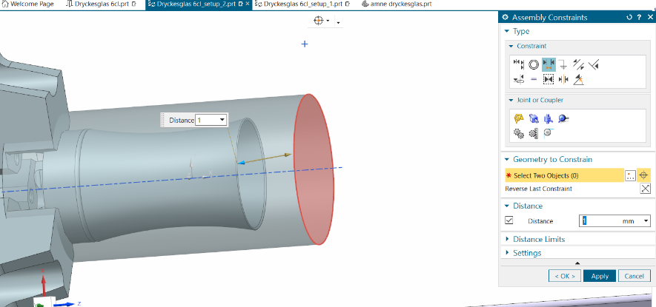
Black arrow = Distance
Green arrow = the top of the part
Red sruface = the top of the stock
Blue arrow = where you set the distance
Figure 7 Constraints between part and stock

set the coordinate system
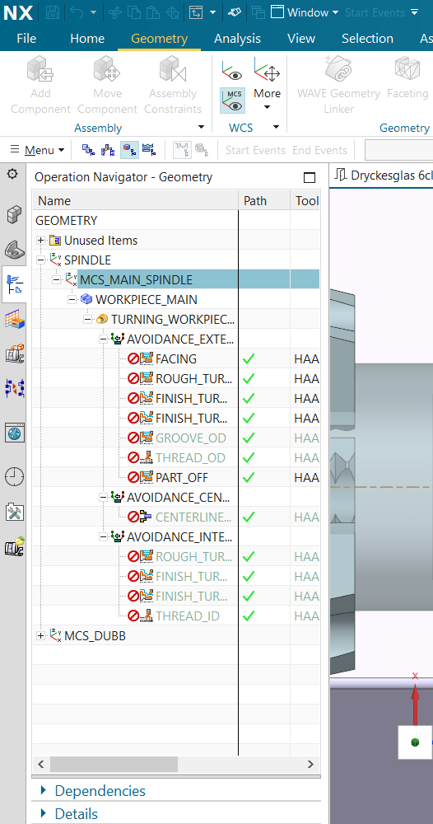
Click on Operation Navigator choose Geometry View choose MCS Main Spindle
Red arrow = Operation Navigator
Orange arrow = Geometry View
Black arrow = MCS Main Spindle
Figure 8 Navigate the coordinate system

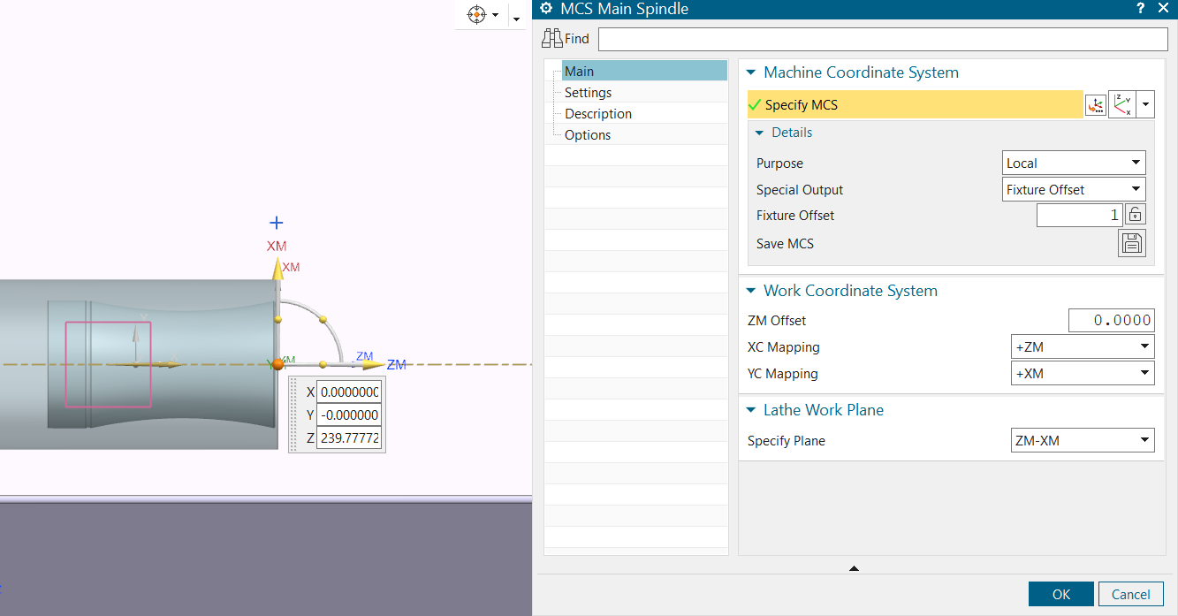
After you opened MCS Main Spindle make sure the window down the right Specify MCS is chosen as Dynamic grab the ZM – Axis and drag it to the surface of your part Click OK
Red arrow = Main
Green arrow = Dynamic
Black arrow = ZM-Axis
Figure 9 Move the coordinate system

Define what’s the part and the stock
Now we need to tell NX what our Part is and what is our Raw Material/ stock.
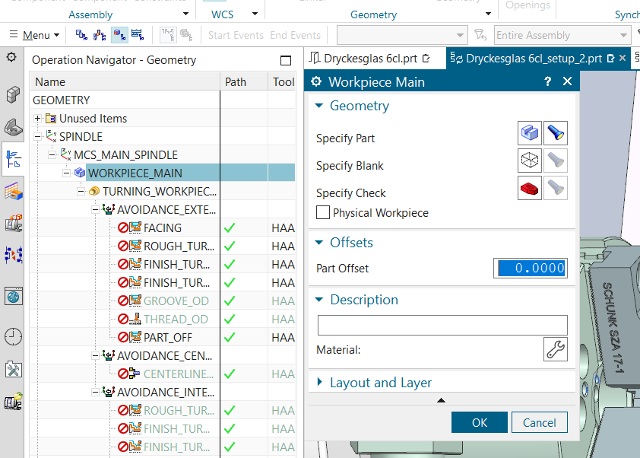
Double click on Workpiece Main Click on the windows and to define.
Red arrow = Part choosen
Green arrow = Part not choosen
Once the part is selected, you can click on the flashlight and the selected part will be highlighted in the assembly.
Specify Part/ Black arrow = Your part (easiest to select by hovering the mouse over and selecting from the list)
Specify Blank/ Orange arrow = Your stock
Specify Check/ Blue arrow = The Jaws (make sure to choose all the jaws)

Figure 10 Define part and stock
Press OK

Entering 2D
You are now in Workpiece Main Open Turning Workpiece Main by doubleclicking Press OK
Go back to Assembly Navigator uncheck the small windows to the left of the stock and the part which should make these visible in 2D with a clip section view.
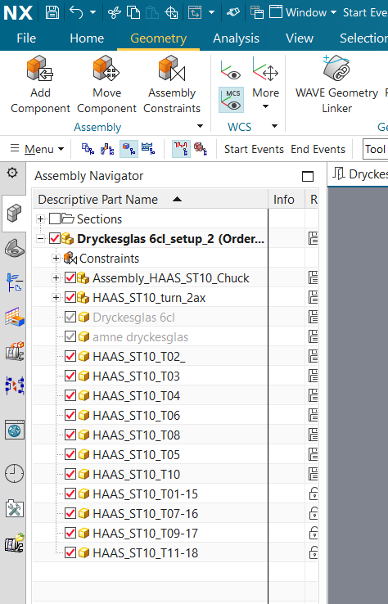
Red arrow = Un checked part
Orange arrow = Un checked stock
Figure 11 Unview the part and the stock

set limitations
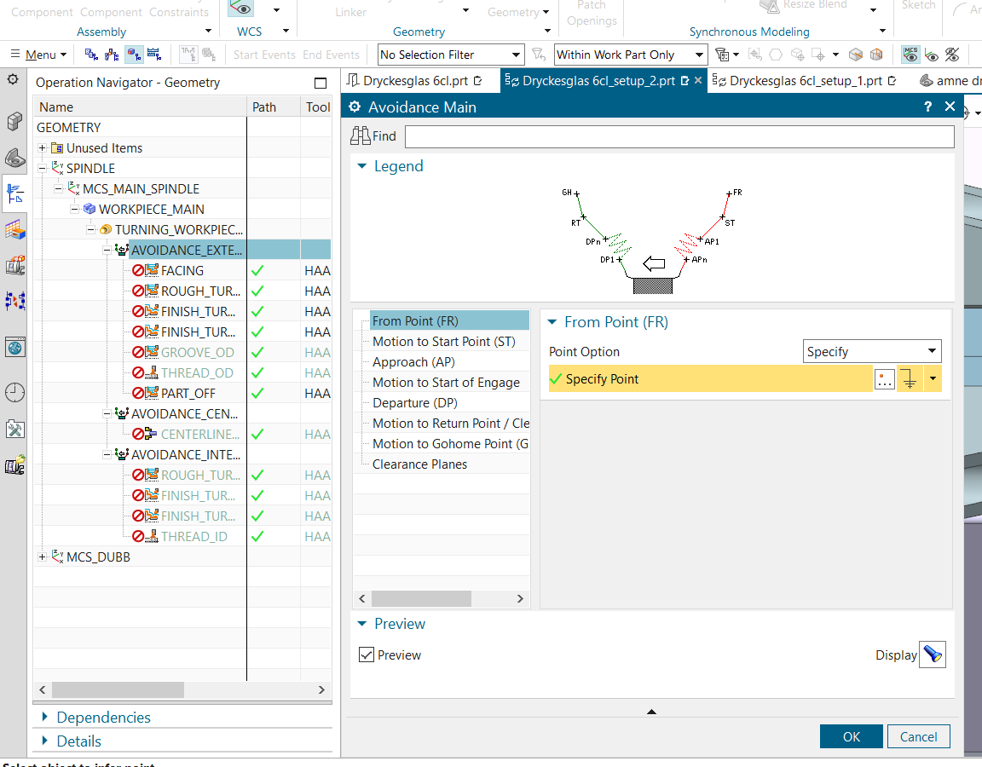
Go back to Operation Navigator choose Geometry View again click on Avoidance external go to the tab From Point (FR) Move and set the placements for the points that comes up with the part and the stock.
Red arrow = Avoidance External
Black arrow = The tab From Point (FR)
Figure 12 Set limitations
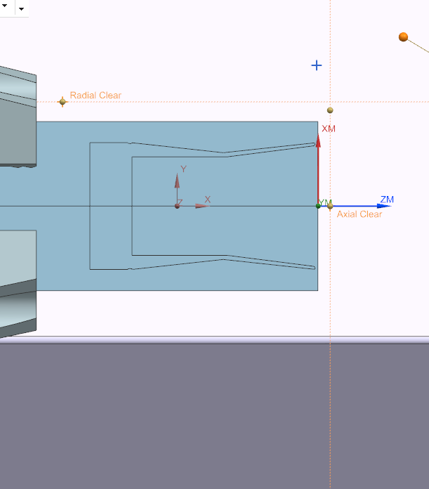
Arrow 1 = From Point, placed a little diagonally above the right edge of the subject
Arrow 2 = Start Point, placed a little bit diagonally above the right edge of the subject
Arrow 3 = Radial clear, is placed a little above the workpiece and a little to the right of the chuck
Arrow 4 = Axial Clear, placed along the center axis and a little to the right of the right edge of the blank
3
2
4
11

Figure 13 set the dots for limitations
Now you are ready to start creating Operations.

Index of images
Figure 1 Create a file 5
Figure 2 Control the parts………………………………….……………………………………………………...6
Figure 3 Constraints……..…………………………………………………………………………………………7
Figure 4 Assembly Constraints………………….………………………………………………………………..8
Figure 5 Types of Constraints………….………………………………………………………………………….8
Figure 6 Constraints to attach the stock to the jaws………………..……………………………………………9
Figure 7 Constraints between part and stock……………………….…………………………………………...9
Figure 8 Navigate the coordinate system……………………………………………………………………….10
Figure 9 Move the coordinate system…………………………………………………………………………...11
Figure 10 Define part and stock….………………...……………………………………………………………12
Figure 11 Unview the part and the stock………………………………………………………..………………13
Figure 12 Set limitations…………………………………………………………………………..…….………..14
Figure 13 Set the dots for limitations…………………………………………………………………..………..14

