
Process Automation with PLC,
HMI and electro pneumatic systems
WP6 COLLABORATIVE LEARNING FACTORY






Funded by the European Union. Views and opinions expressed are however those of the author(s) only and do not necessarily reflect those of the European Union or the European Education and Culture Executive Agency (EACEA). Neither the European Union nor EACEA can be held responsible for them.
This work is licensed by the LCAMP Partnership under a Creative Commons Attribution-NonCommercial 4.0 International License.
LCAMP partners:
TKNIKA – Basque VET Applied Research Centre, CIFP Miguel Altuna LHII, DHBW Heilbronn – Duale Hochschule, Baden-Württemberg, Curt Nicolin High School, AFM – Spanish Association of Machine Tool Industries, EARLALL – European Association of Regional & Local Authorities for Lifelong Learning, FORCAM, CMQE: Association campus des métiers et des qualifications industrie du future, MV: Mecanic Vallée, KIC: Knowledge Innovation Centre, MADE Competence Centre Industria 4.0; AFIL: Associazione Fabbrica Intelligente Lombardia, SIMUMATIK AB; Association HVC Association of Slovene Higher Vocational Colleges; TSCMB:Tehniški šolski center Maribor, KPDoNE: Kocaeli Directorate Of National Education; GEBKİM OIZ and CAMOSUN college.

CONTENT TABLE

1. Introduction 5
2. module plan 6
3. module documentation 9
4 COMMUNICATION. MODULE VIDEO DIARY 11
5 MODULE CONTENTS 11
5.1 PLC INPUTS AND OUTPUTS CONNECTIONS 11
5.2 SEQUENTIAL SYSTEMS. GRAFCET 13
5.3 SEQUENTIAL SYSTEMS. PROGRAMMING WITH KOP LANGUAGE 22
5.4 EXERCICES 29
5.5 FESTO STATIONS CHALLENGE 32
6 teachers timetable 38
7 challenge 38

Introduction
This training module introduces students to process automation using programmable logic controllers (PLCs), human-machine interfaces (HMIs), and electro-pneumatic systems. Through hands-on activities, learners will connect and program digital inputs and outputs, develop sequential logic using GRAFCET, and implement ladder logic (KOP) in TIA Portal. The module includes simulation, troubleshooting, and real-world challenges using FESTO workstations, where students collaborate in international teams to automate industrial stations. The training culminates in a technical report, video diary, and oral presentation, fostering both technical and transversal skills aligned with LCAMP learning outcomes.

module plan
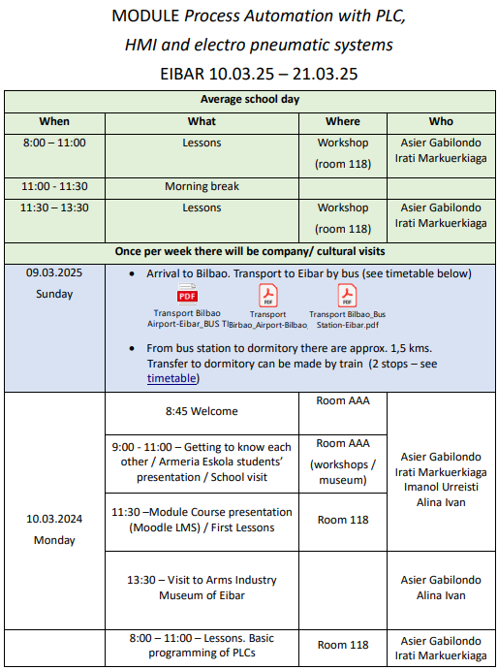.
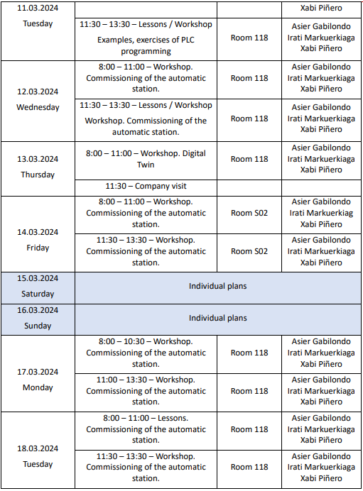
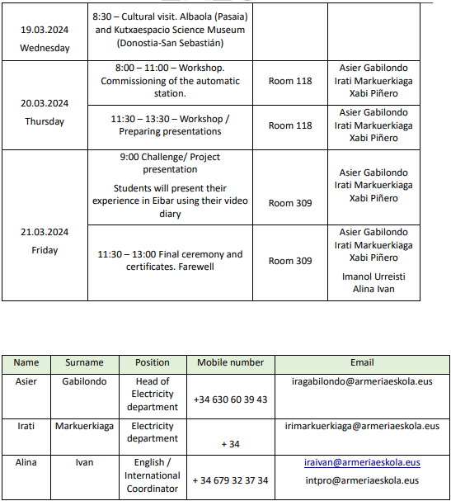

module documentation
Process Automation with PLC,
HMI and electro pneumatic systems
10.03. – 21.03.2025 Armeria Eskola VET College
STUDY MODULE GUIDE
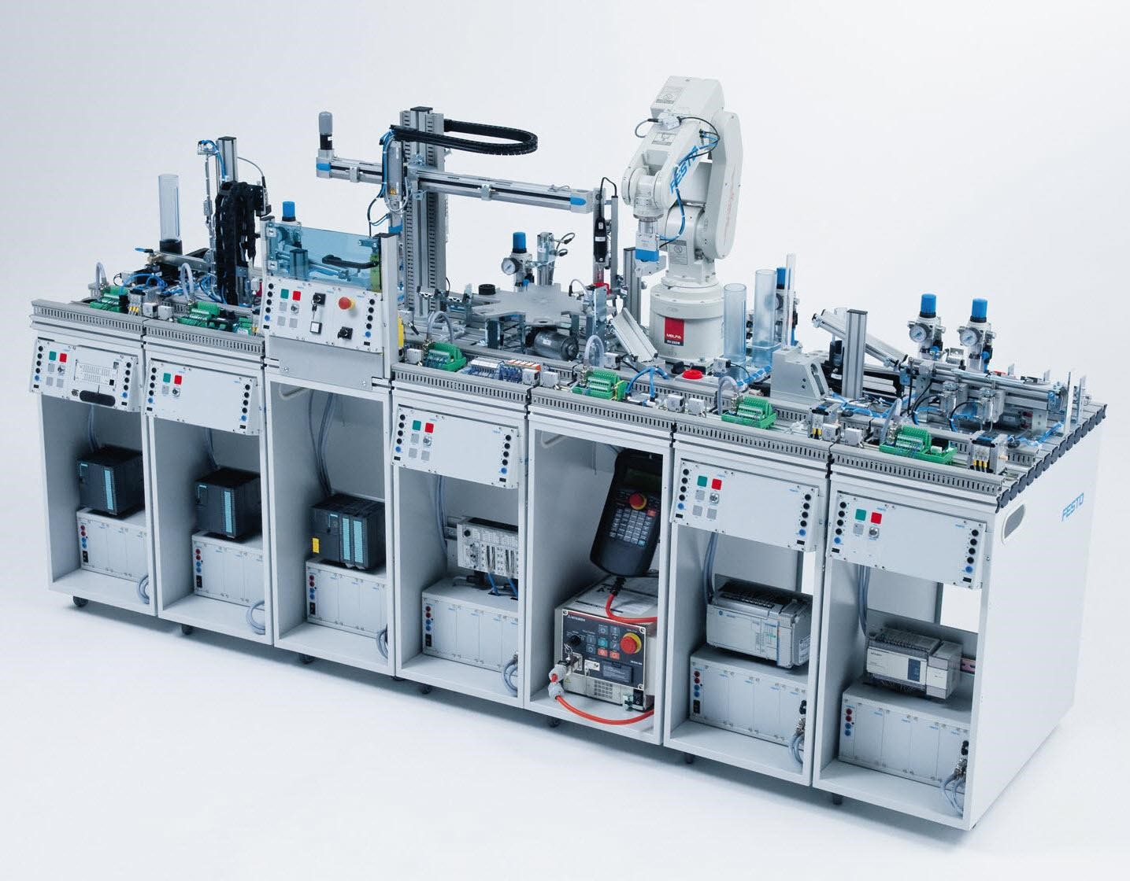

Assessment rubric:
COMPETENCES | EXCELLENT (4 points) | GOOD (3 points) | SATISFACTORY (2 points) | TO BE DEVELOPED (1 point)
Schematic representation of the automated system using  Grafcet and the GEMMA guide. | The Grafcet and the  GEMMA guide have been drawn using a  specific software, fully  match the PLC program and have a very high level of concreteness. | The Grafcet and the GEMMA guide have been drawn using a specific software,  mostly match the PLC  program and have an adequate level of concreteness. | The Grafcet and the  GEMMA guide have been drawn using a specific  software, but has quite a  few differences from the PLC program or lacks concreteness. | The Grafcet and the GEMMA guide have not been drawn with software and/or do not coincide  with the PLC program and/or are not specific enough.
Development of the PLC program and commissioning of the automated system. | It correctly fulfills all the points of operation of the program and the structure of the program is divided into FCs, and there are comments in all networks to better understand the program. Besides, all the points of the Checklist are well accomplished at first. | It fulfills all the points of operation of the program, except the indicators and the program structure is divided into FCs, but there are not many comments in the networks. Besides, it correctly accomplishes all the points of the Checklist, but it was not the first time. | It fulfills only the main  (critical) points of operation of the program and the program structure is divided into FCs. Besides, it correctly accomplishes all the points of the Checklist, but the correction has been made more than twice. | It does not adequately fulfill most of the program's operating points and the structure of the program is not divided into FCs. Besides, it does not accomplish all the points of the Checklist.
General communication  skills | The student shows complete knowledge of the subject, he/she does not make mistakes, he/she does not hesitate, he/she keeps attention easily, clear and fluid communication, appropriate sentences. | The student shows good knowledge of the subject. Fluid exposition. Very few errors, he/she manages to keep the attention for the most part, in general uses easily understandable sentences. | Although the student has some knowledge of the subject, he/she shows himself/herself to be hesitant, he/she tries hard to attract attention, but without success, some parts are difficult to understand. | The student does not demonstrate knowledge of the subject, there is no interest in attracting attention, most of the sentences are not understood.

4 COMMUNICATION. MODULE VIDEO DIARY


Record your experience through the module in a VIDEO DIARY. Include images and sequences from your daily activities and reactions and thoughts, spoken right to the camera. Maximum length: 2 minutes.
Easy-to-use useful tool for video edition: https://www.canva.com

MODULE CONTENTS

5.1 PLC INPUTS AND OUTPUTS CONNECTIONS

5.1.1 DC Inputs
PLC power supply: 24v DC:
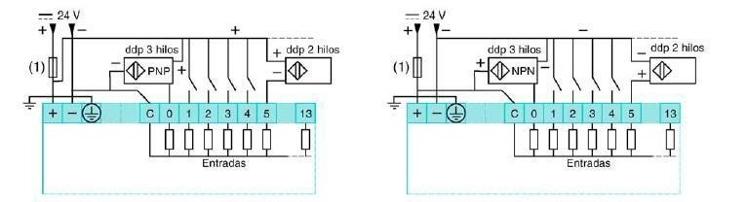
Positive logic – Sinking inputs Negative logic – Sourcing inputs (PNP sensors) (NPN sensors)

PLC power supply: 230v AC:
Positive logic – Sinking inputs (PNP sensors)
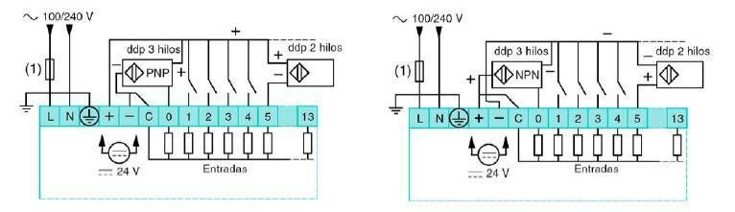

Negative logic – Sourcing inputs (NPN sensors)

7.1.2 AC Inputs

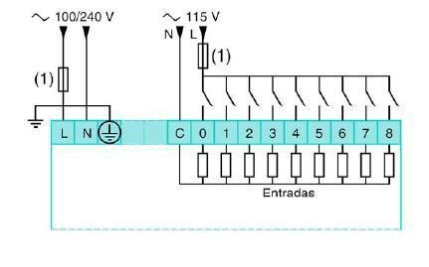
5.1.3 PLC Output connections

Positive logic – Sourcing outputs (PNP)
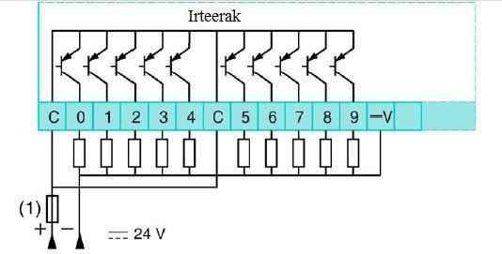

Negative logic – Sinking outputs (NPN)

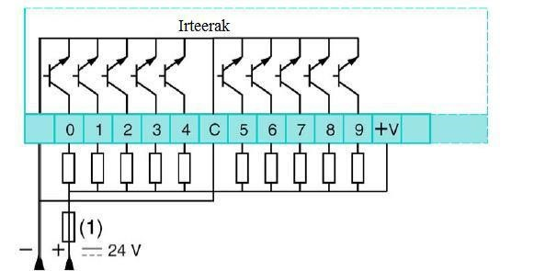

RELAY OUTPUTS
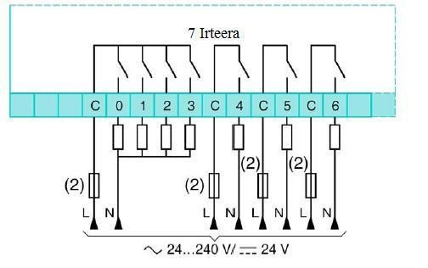

5.2 SEQUENTIAL SYSTEMS. GRAFCET

5.2.1 Basic elements and general rules
This first examples are designed to provide an overview of Grafcet before getting down to details. Grafcet has four basic kinds of elements:
- Steps, shown graphically as numbered boxes.
- Links, shown as horizontal or vertical lines.
- Transitions, shown as short numbered horizontal lines.
- Statements, text instructions describing control actions and conditions.
There are also three main indicators to describe the state of the actions and conditions:
- N: Set to 1 as long as the step is active.
- S: Set to 1
- R: Set to 0
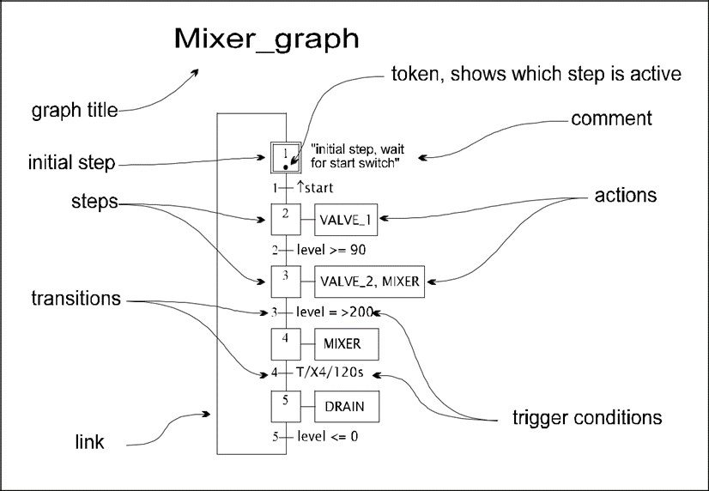
Rule 1: Initial State
State evolution requires active Steps at the beginning of operation (at least one).

Rule 2: Transposition of a Transition
A Transition is active or enabled only if all the Steps at its input are active (if not it is inactive).
A Transition can only be transposed if it is active and is true the associated condition (receptivity function).

Rule 3: Evolution of active Steps
The transposition of a Transition leads to the deactivation of all the Steps on its inputs and the activation of all Steps on its outputs.

Rule 4: Simultaneous transposition of Transitions
All active Transitions are transposed simultaneously.

Example 1:
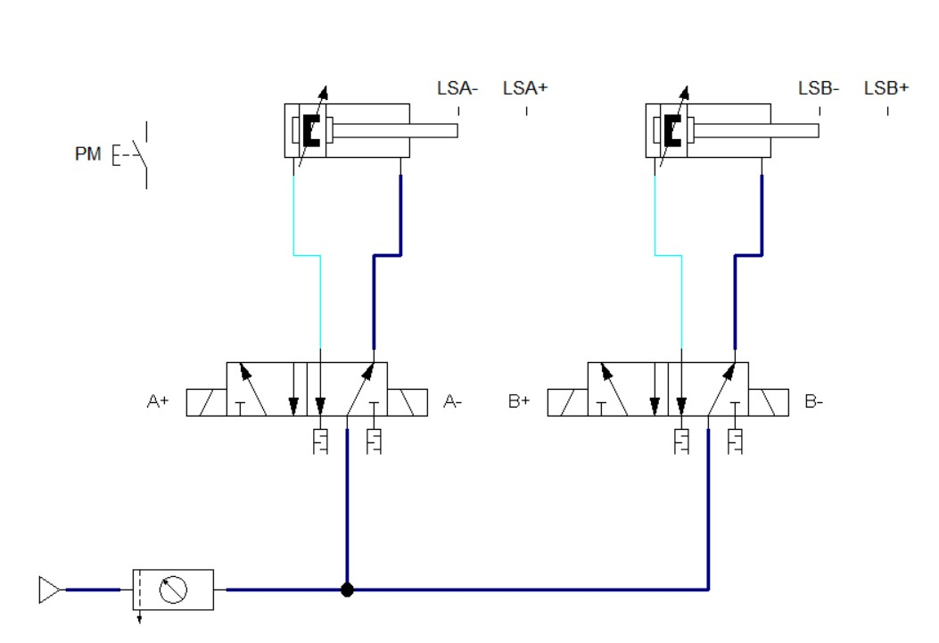

Sequence: When the PM pushbutton is pressed, the following sequence takes place:
A+B+B-A-
Grafcet:
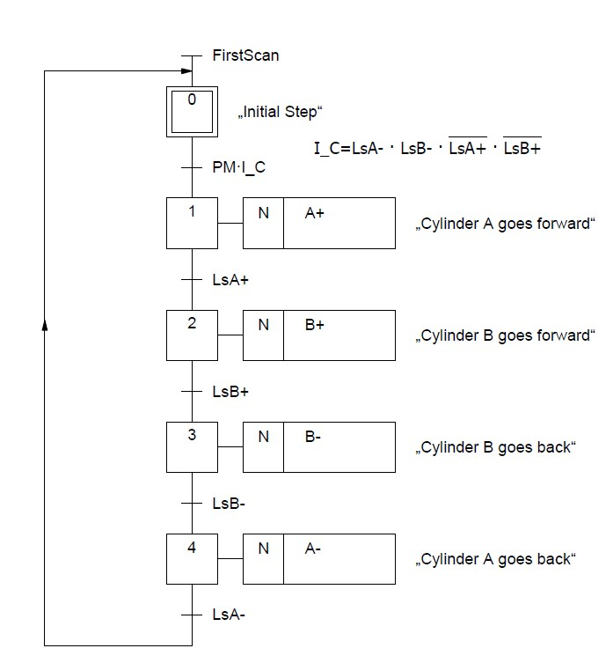
Example 2:
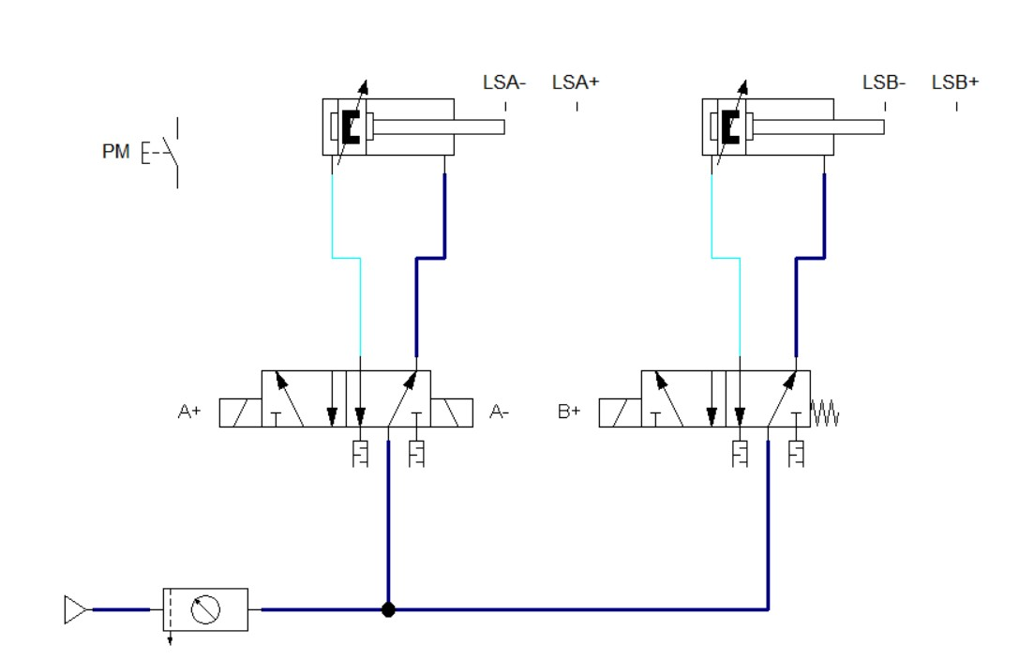
Sequence: When the PM pushbutton is pressed, the following sequence takes place:
B+A+A-B-

Grafcet:
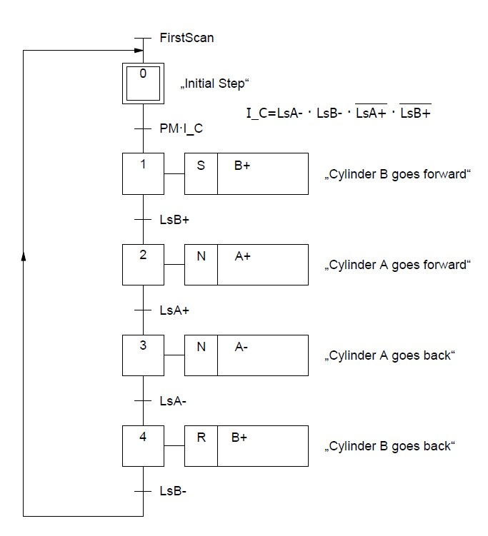
5.2.2 OR Divergences and convergences OR Divergences:
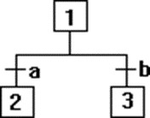
If Step 1 active and a TRUE then deactivate Step 1 and activate Step 2. If Step 1 active and b TRUE then deactivate Step 1 and activate Step 3.
Note: a and b can not be active at the same time OR Convergences:
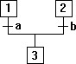
If Step 1 active and a TRUE, then deactivate Step 1
and activate Step 3 (state of Step 2 remains unchanged). The same happens for Step 2 and b.

Example 3:
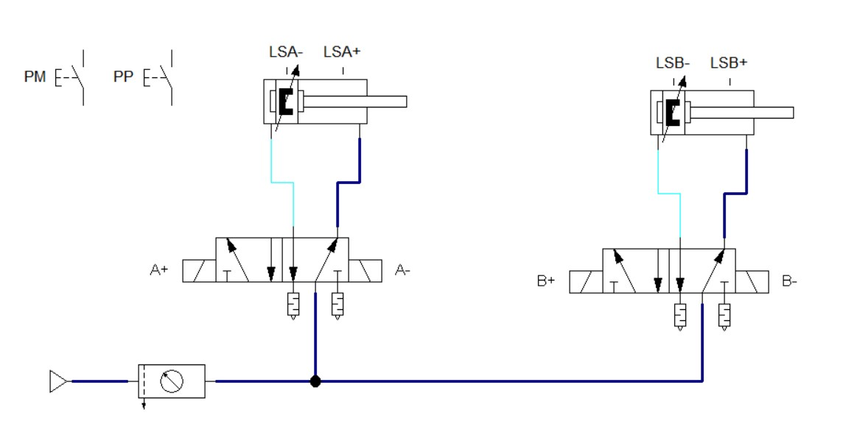

Sequence: When the PM pushbutton is pressed, the following sequence takes place:
A+B+B-A-
If the cylinders are not in their initial position (both cylinders retracted), after pressing the PP pushbutton the cylinders will go to their original position.
Grafcet:
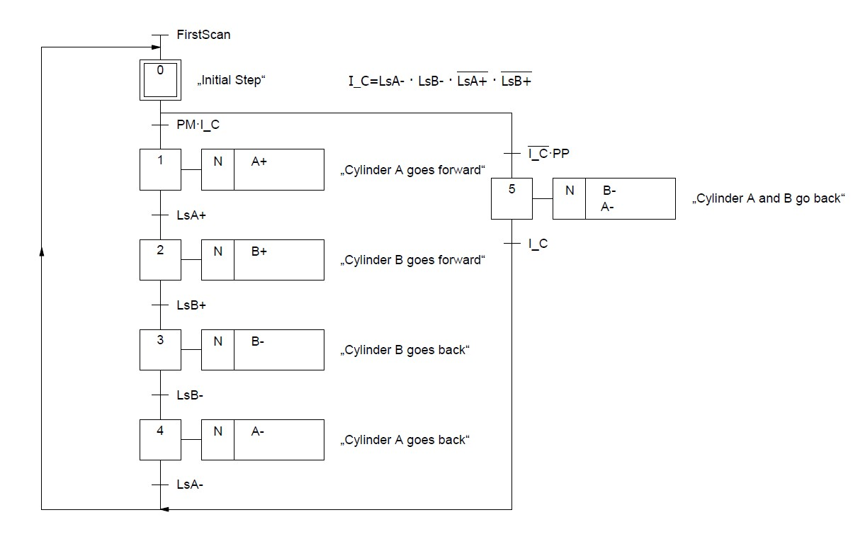
5.2.3 AND Divergences and convergences AND Divergences:
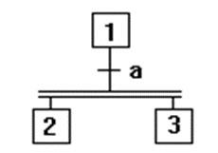
If Step 1 active and a TRUE, then deactivate Step 1 and activate Steps 2 and 3.

AND Convergences:
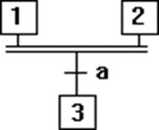
If Steps 1 and 2 active and a TRUE then deactivate Steps 1 and 2 and activate Step 3.

Example 3:
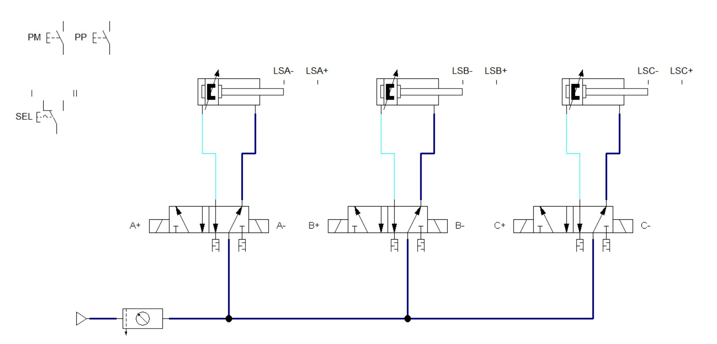
Sequence: With the selector SEL in position (I), when the PM button is pressed, the following sequence takes place:
A+  A-
C+  C-
B+  B-

When the cylinder C is retracted, the cycle will end in case the selector SEL is in position (I) (single cycle). If the selector SEL is in position (II), the cycle will start again automatically (continuous cycle).
If the cylinders are not in their initial position (both cylinders retracted), after pressing the PP pushbutton the cylinders will go to their original position.

Grafcet:
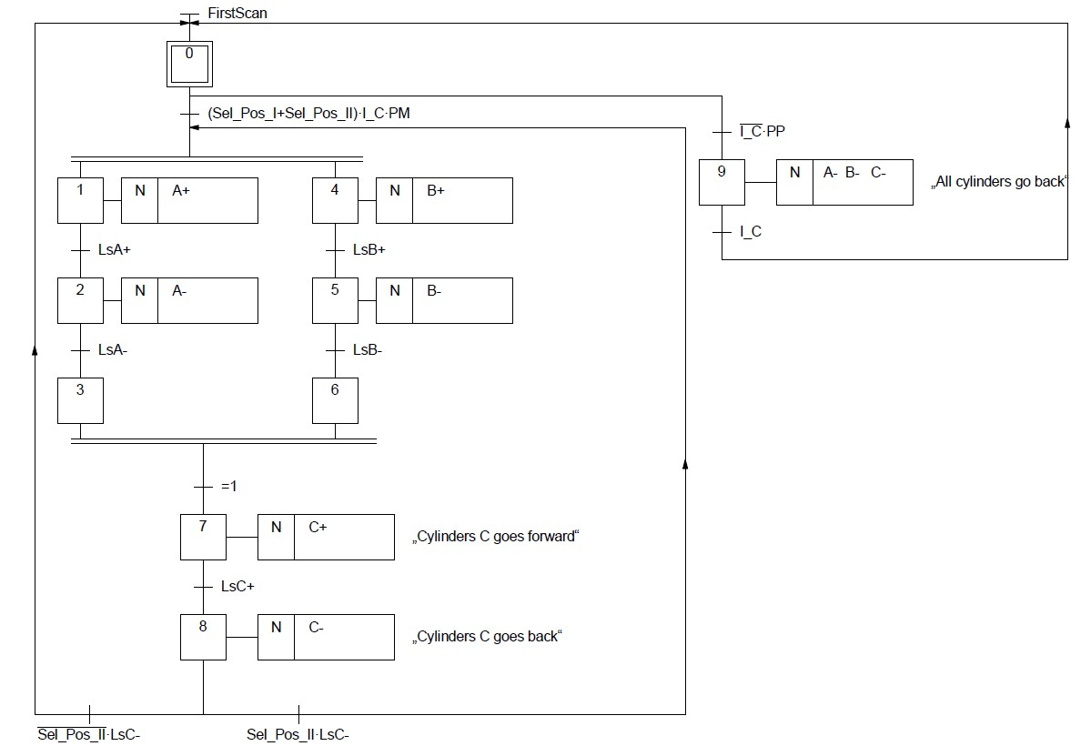

5.2.4 Emergency and reset Grafcet Example 4:
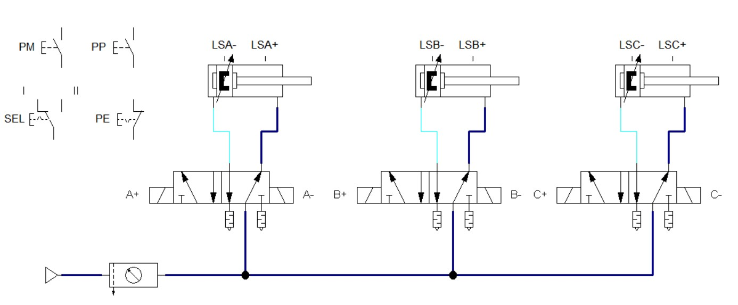
The cycle can be stopped at any time with the emergency stop button. To reset the cycle and return the elements to their origin, use the step-by-step button. Once the system is in origin, it can proceed to another cycle.
Grafcet:
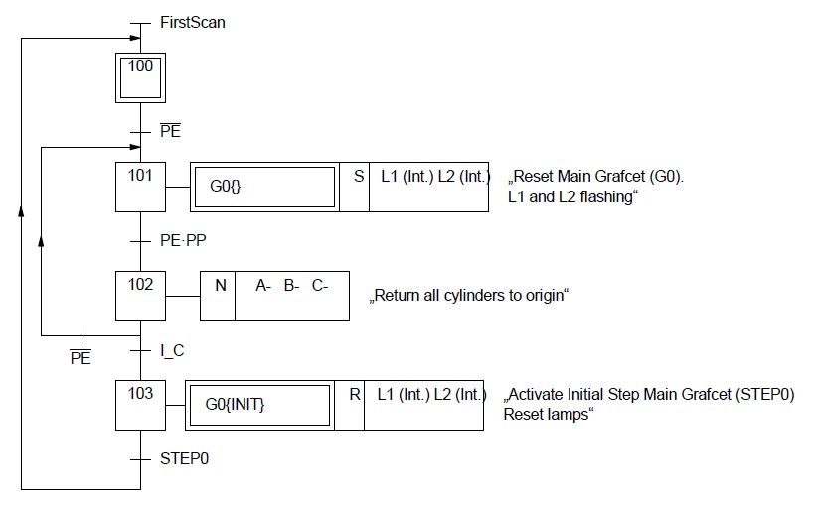
There are two specific actions to take into account:
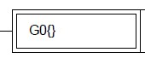
This special action is used to represent the reset of all the steps in the main grafcet (G0).

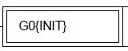
This special action is used to represent the activation of the initial step (STEP0) of the main grafcet (G0).

5.3 SEQUENTIAL SYSTEMS. PROGRAMMING WITH KOP LANGUAGE

5.3.1 Program organization
The organization of the program in a PLC will be as shown in the next image.
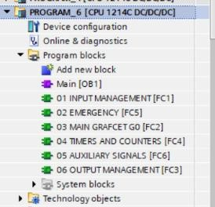
- INPUT MANAGEMENT: In this Function (FC) we will treat the inputs and define de Initial Conditions of the machine.
- EMERGENCY: In this Function (FC) we will program the emergency and reset sequence.
- MAIN GRAFCET G0: In this Function (FC) we will program the main sequence of the machine.
- TIMERS AND COUNTERS: In this Function (FC) we will define and program the timers and counters used in the sequence.
- AUXILIARY SIGNALS: In this Function (FC) we will define and program other auxiliary signals used in the sequence.
- OUTPUT MANAGEMENT: In this Function (FC) we will program the outputs of the machine.

5.3.2 Programming the input management function
In this Function we will treat the inputs and define different situations of the machine related with the value of the inputs (pushbuttons and sensors).
Example: To detect that the cylinder A is at its back position, we will use this statement:
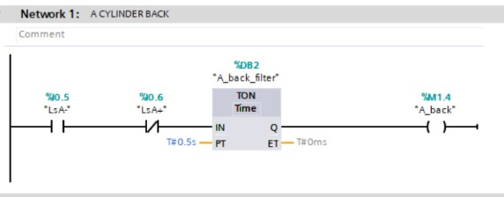
Example: To define de Initial Conditions of the machine, we will use all the previous definitions.
This statement will be the last one of the Input Management block.
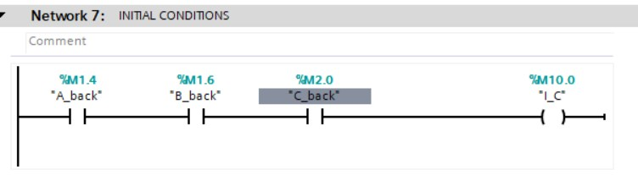

5.3.3 Programming the steps of the Emergency and Main Grafcets
In order to follow all the rules of the Grafcet method, we will program the steps as follows: General steps
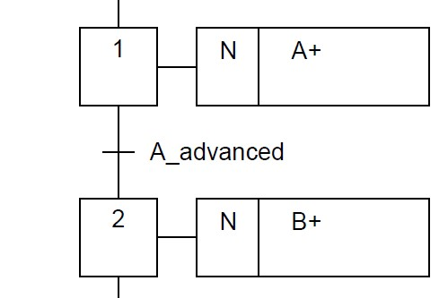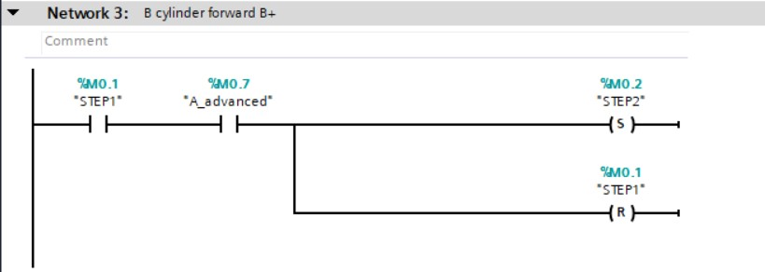

AND divergences

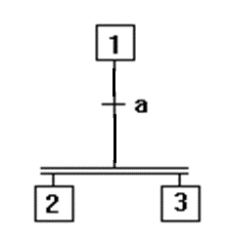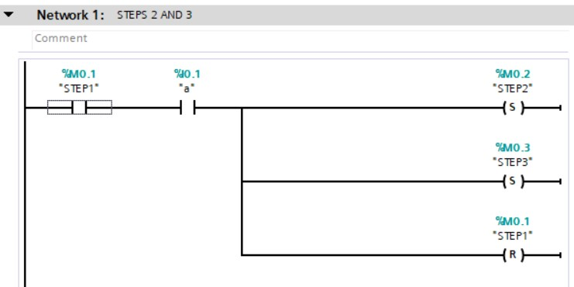

AND convergences
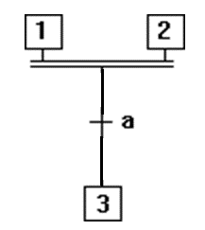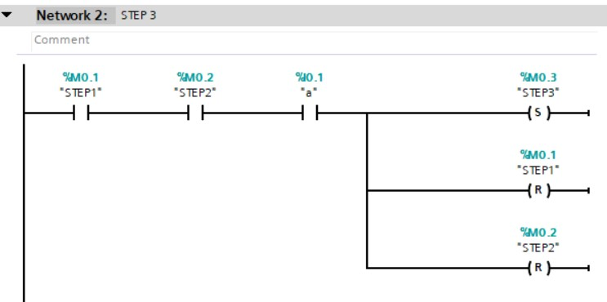

Initial step (STEP0)
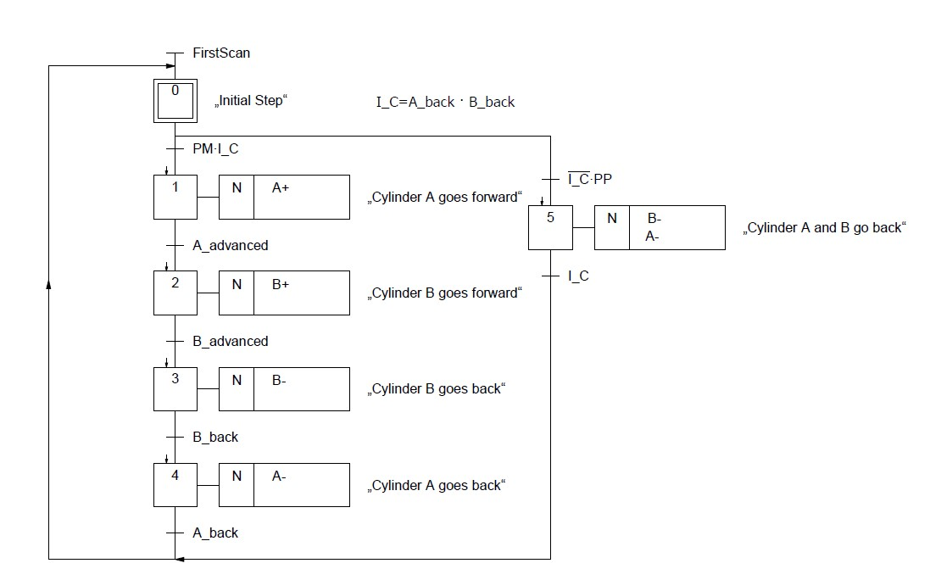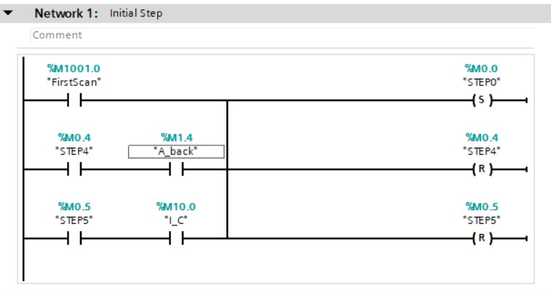

Emergency grafcet – resetting Main Grafcet steps (STEP101)
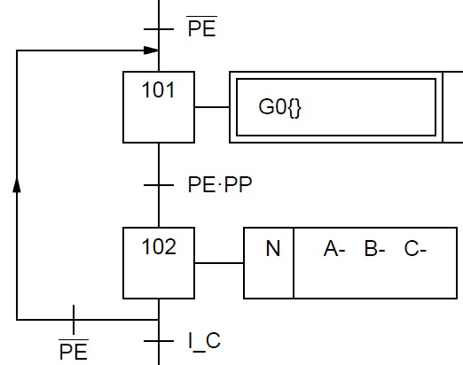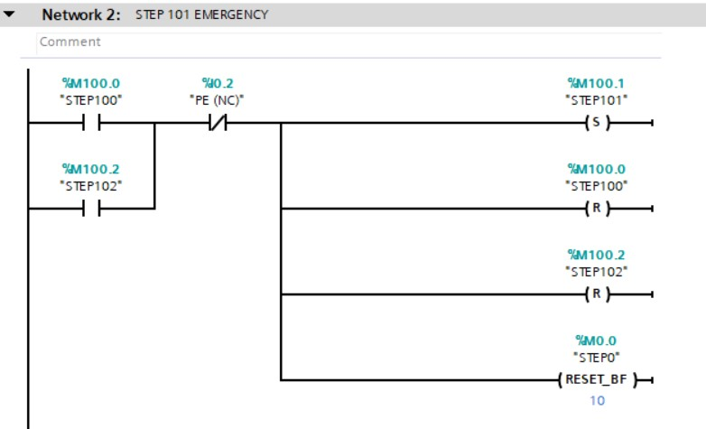

Number of steps in the Main Grafcet G0

Emergency grafcet – initializing Main Grafcet
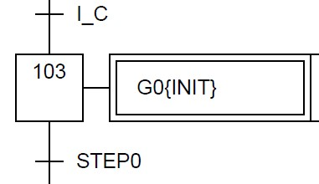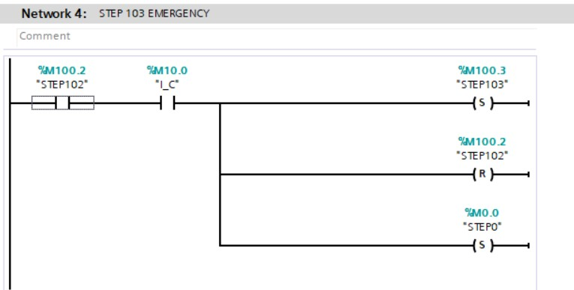

5.3.4 Programming timers and counters
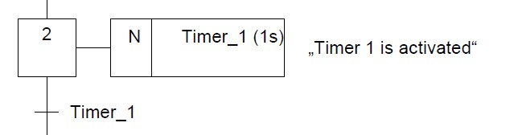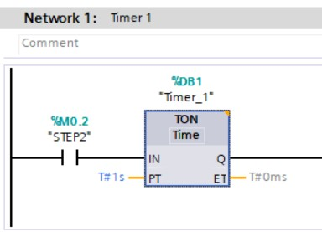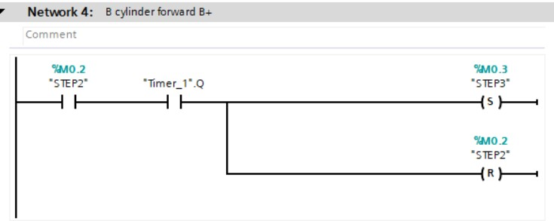
TON Timer activated as an action in a step

CTU (Count Up) counter increment and reset as an action in a step
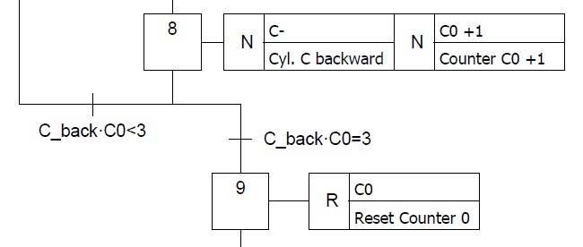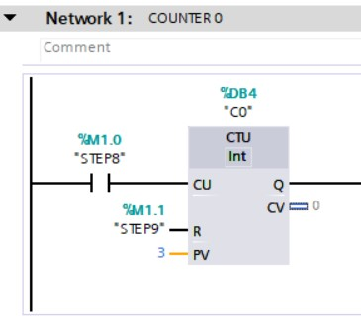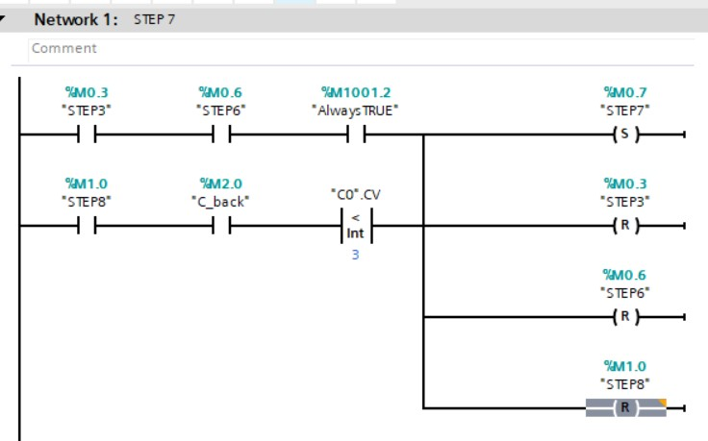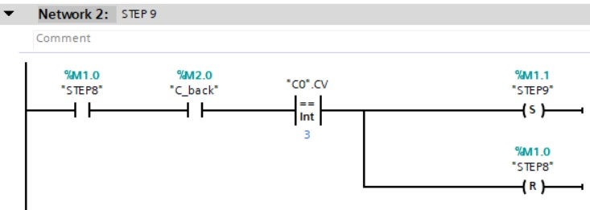

5.3.5 Programming the auxiliary signals and outputs
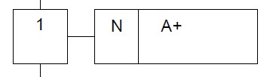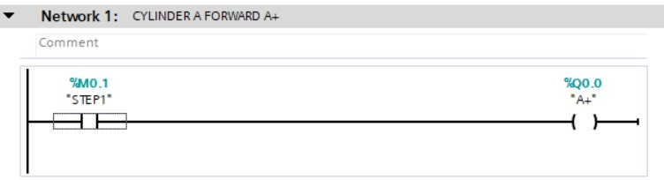
Activation of the output A+ in Example 1

Activation and deactivation of output B+ in Example 2
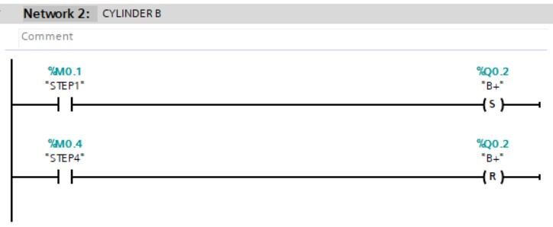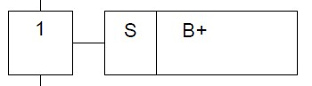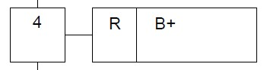

Activation of auxiliary signals as an action in a step
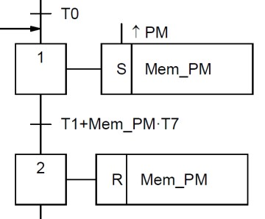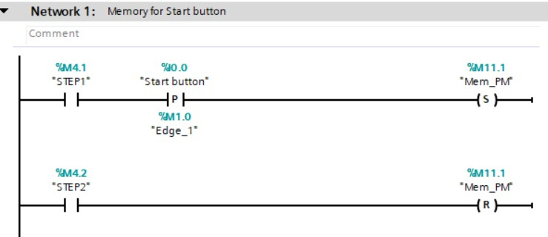

5.4 EXERCICES
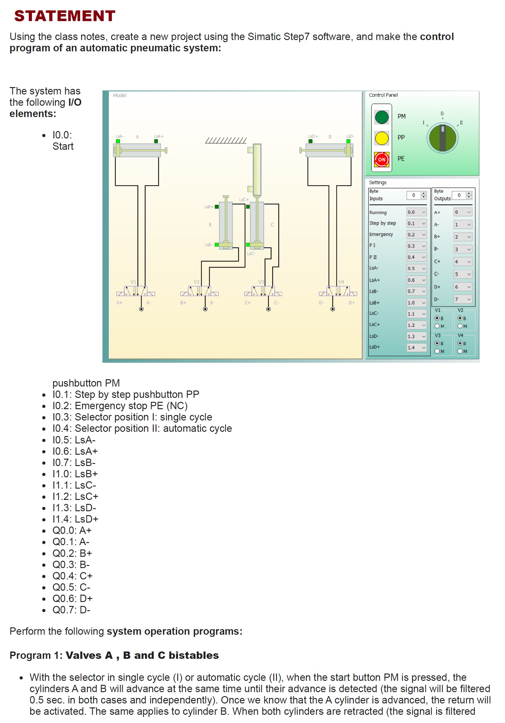
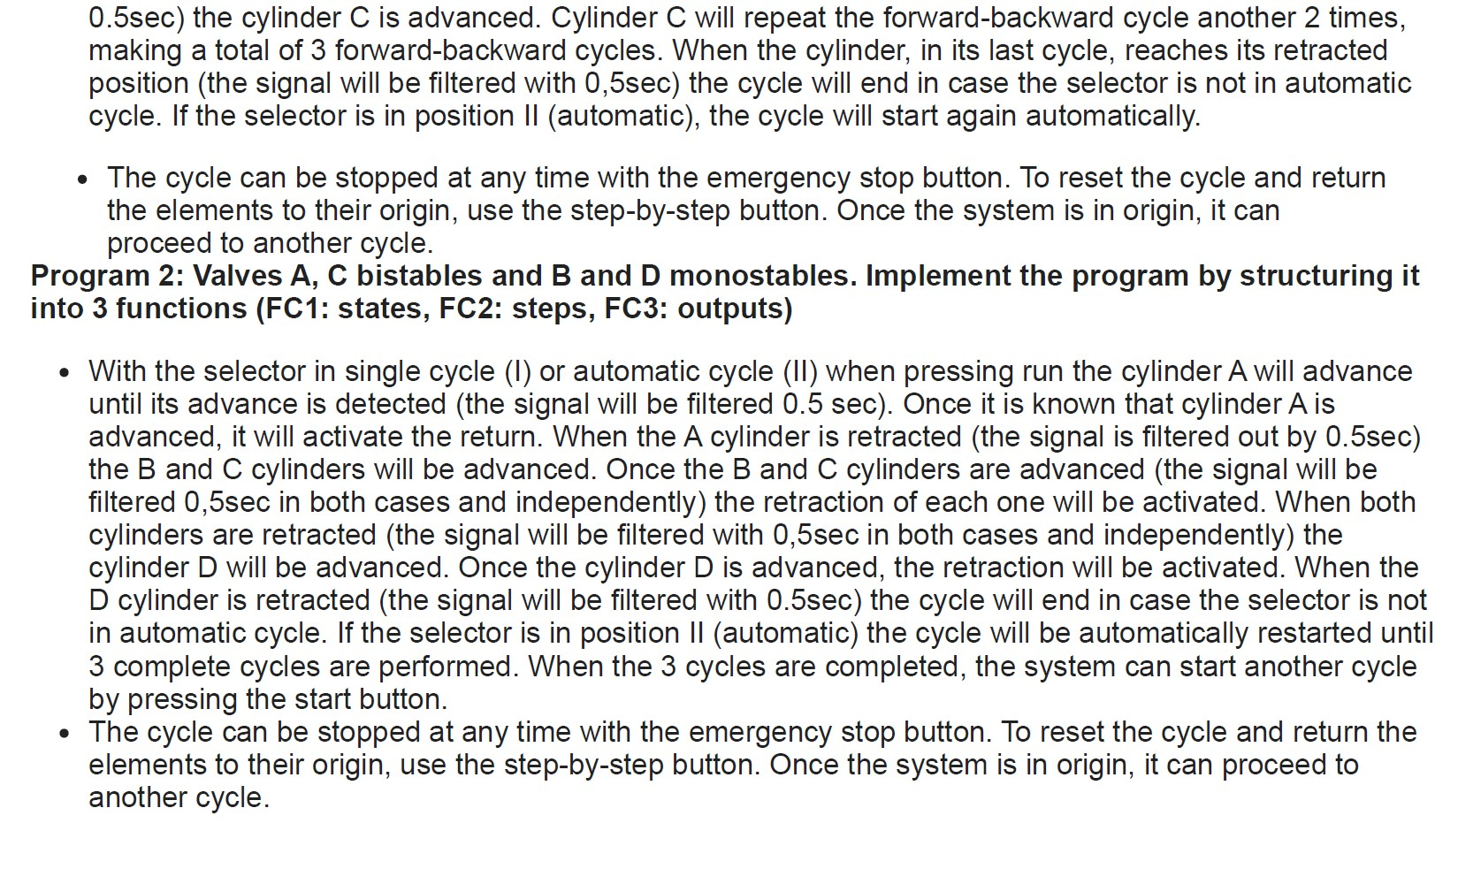

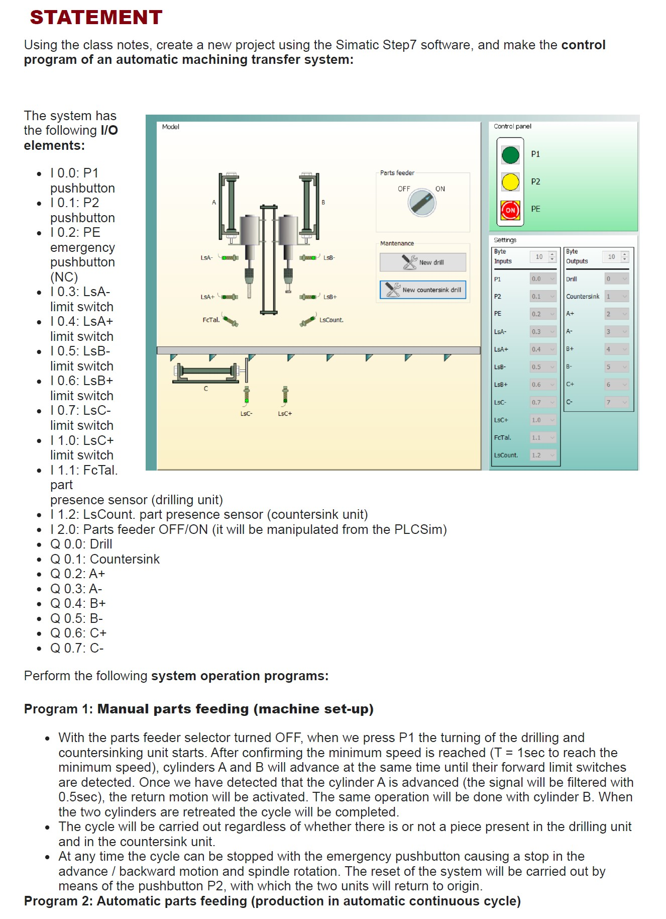
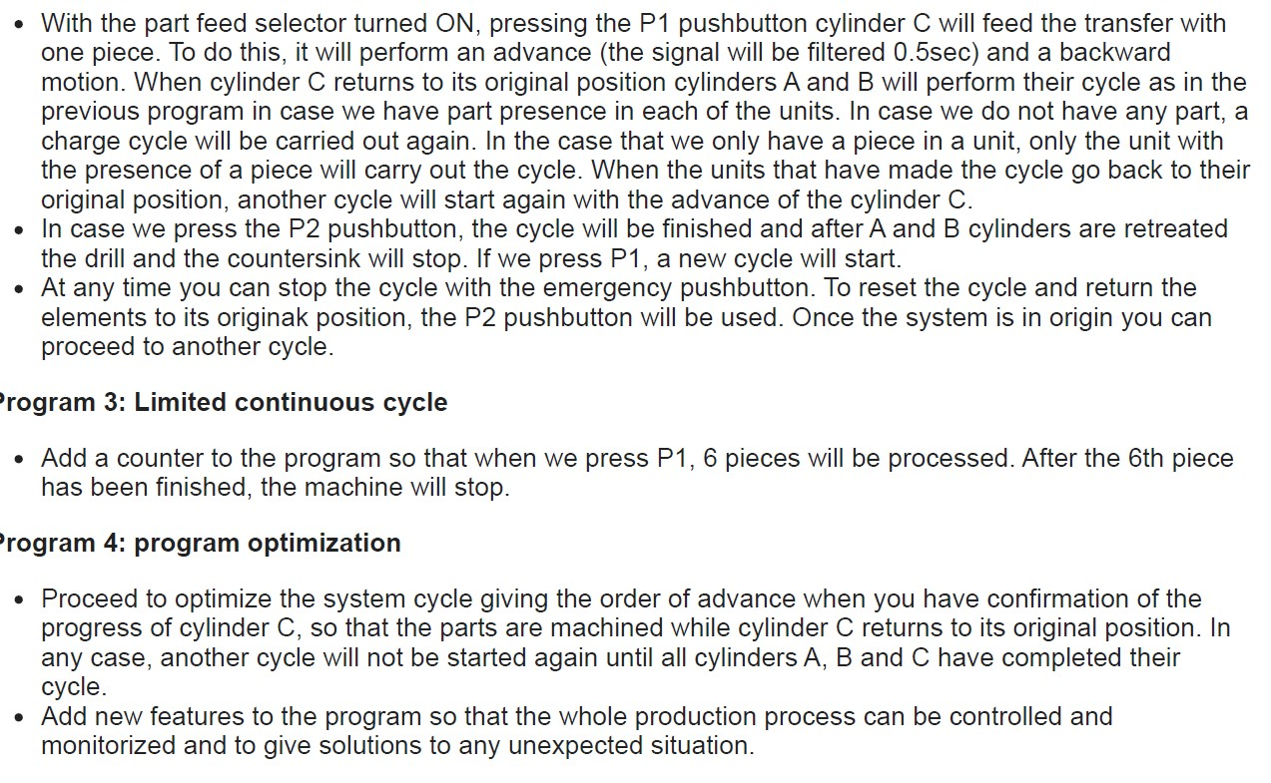

5.5 FESTO STATIONS CHALLENGE

5.5.1 GENERAL OVERVIEW
You have started working in DUAL format in a company that manufactures automatic machines. In this company they design, assemble and program automatic production machines for customers from various sectors. The machines use electric and electropneumatic actuators to perform sequential production and handling operations of different parts. These sequential operations are controlled by a programmable logic controller (PLC).
In this company you have initially received the necessary training to program programmable controllers (first part of the challenge, training) and now it is your turn to program the automatic machine that will be sent to the customer. The customer, on the day of delivery of the machine, will go through a checklist to verify the conformity of what was requested with what was done and the consequent fulfilment of the agreed contract.

5.5.2 GROUPS AND WORKSTATIONS
Each group will be formed by a student from the Berufsschule für Fertigungstechnik school and one or two students from Armeria Eskola. In the following table you can see the groups and the work stations:
GROUP | STUDENT | SCHOOL | FESTO WORK STATION
1 | Aaron Noponen | Gradia | Pick&Place Station
1 | Daniel Lucas | Armeria Eskola | Pick&Place Station
2 | Paul Dobe | MDM | Measuring Station
2 | Urko Zengotitabengoa | Armeria Eskola | Measuring Station
3 | Max Anderson | MDM | Separating Station
3 | Jon Ajuriagoikoa | Armeria Eskola | Separating Station
4 | Tony Rau | MDM | Handling Station
4 | Paul Suarez | Armeria Eskola | Handling Station
5 | Lauri Lapinoja | Gradia | Sorting Station
5 | Unai Fernandez | Armeria Eskola | Sorting Station

5.5.3 TECHNOLOGICAL DESCRIPTION
In this challenge, you will have to use a FESTO workstation. Each workstation has different features so, to carry out the challenge, you must analyse and study each of them in detail.
In the installation, each workstation has a Siemens S7 300 PLC or a Siemens 1200 PLC. In each of these PLCs, you will have to make the program for the proper operation of the workstation.
Each workstation has a control panel. Depending on the assignment of the evaluation team, the. The aim of the control panel is to give orders to the installation and receive information about its operation.

GROUP 1 PICK&PLACE STATION
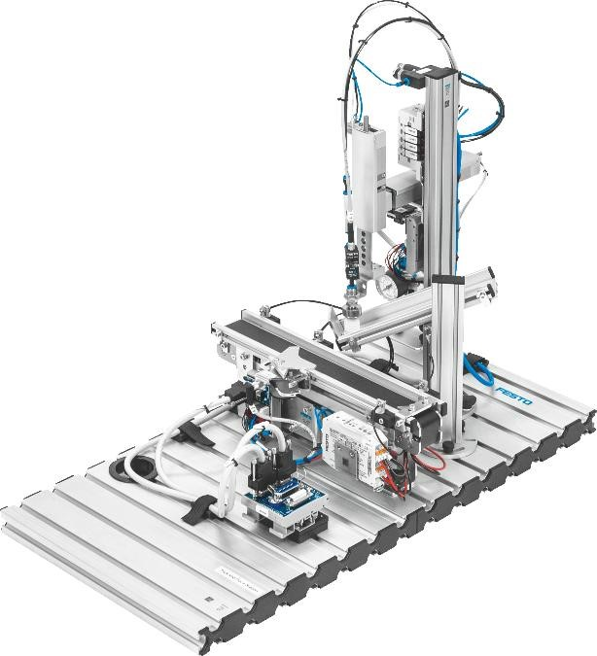

GROUP 2 – MEASURING STATION
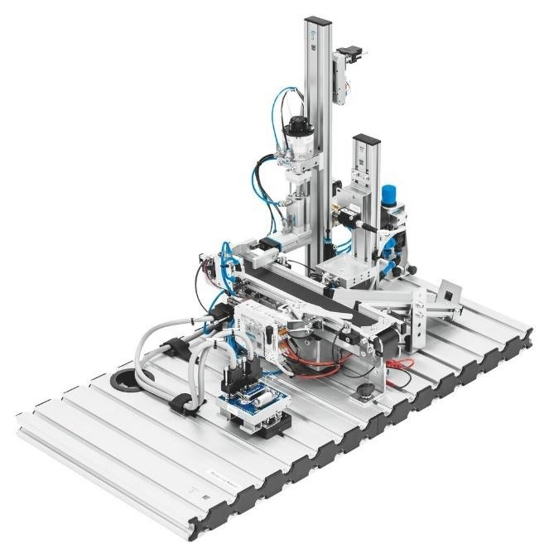

GROUP 3 SEPARATING STATION
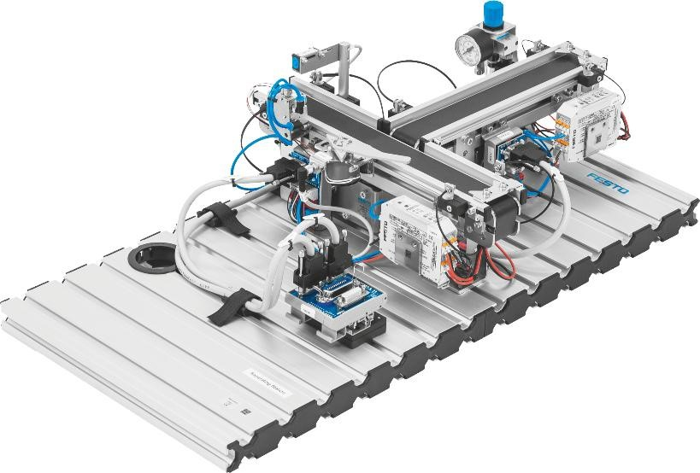

GROUP 4 – HANDLING STATION
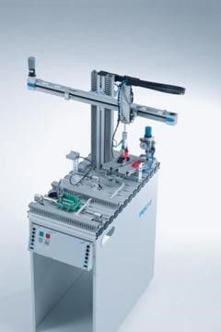

GROUP 5 SORTING STATION
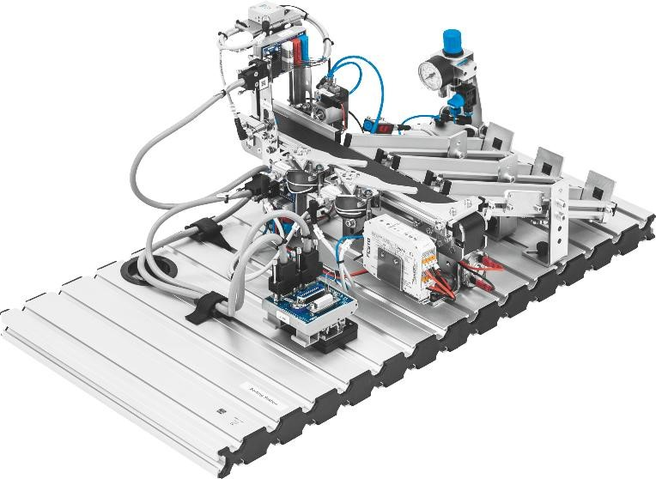

5.5.4 WORK TO BE DONE
Before taking other steps, you have to check the state in which each station is. Complete the assembly of the machine if necessary, and if any component is missing, you will have to inform the teacher.
After analysing the FESTO workstation, each group will have to define the automatic sequence to be done, with the help of the teacher. You will have to make the I/O tables of each station and the Grafcet of its operation. Finally, you will have to program and test the individual operation of each station. All the technical information about the station will be provided.

5.5.5 CHECKLIST
Each group will have a checklist to complete. This checklist will be agreed and defined by both the students group and the evaluation team (teachers

5.5.6 ORAL PRESENTATION
All groups will make a presentation of the challenge. The presentation will last between 10-15 minutes and it must explain all the relevant aspects of the challenge.

5.5.7 TECHNICAL INFORMATION
You will find the technical information you need and more information in the following link: EMEU PLC Automation Module Login:
Username: | inter05@armeriaeskola.eus
 | inter06@armeriaeskola.eus
 | inter07@armeriaeskola.eus
 | inter08@armeriaeskola.eus
 | inter09@armeriaeskola.eus

Password: 123456
Team:

● Asier Gabilondo - teacher leader (+34630603943)
- Irati Markuerkiaga – teacher (+34)
- Alina Ivan – international coordinator (+34679323734)

teachers timetable
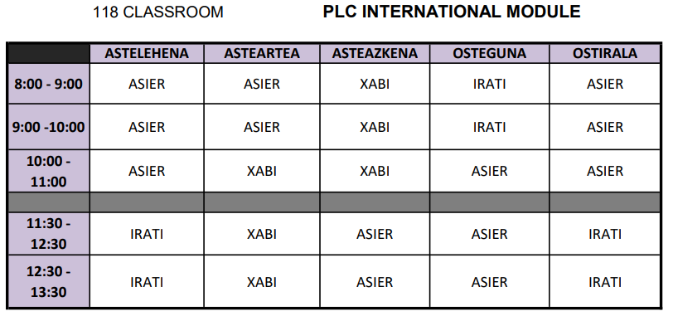

challenge
You have started working in DUAL format in a company that manufactures automatic machines. In this company they design, assemble and program automatic production machines for customers from various sectors. The machines use electric and electropneumatic actuators to perform sequential production and handling operations of different parts. These sequential operations are controlled by a programmable logic controller (PLC).
In this company you have initially received the necessary training to program programmable controllers (first part of the challenge, training) and now it is your turn to program the automatic machine that will be sent to the customer. The customer, on the day of delivery of the machine, will go through a checklist to verify the conformity of what was requested with what was done and the consequent fulfilment of the agreed contract.
The stations you will have to program will be the following FESTO stations:
- Pick&Place: Manual, Circuit Diagrams Pick&Place, Datasheet Stack Magazine, Circuit Diagrams Stack Magazine
- Separating: Manual, Electrical Diagrams, Pneumatic Diagrams
- Measuring: Manual, Circuit Diagrams
- Handling: Manual, Electrical Diagrams, Pneumatic Diagrams, Basic TIA Portal Project
- Sorting: Manual, Electrical Diagrams, Pneumatic Diagrams
You can find more information in the FESTO Data Portal and Control Panel and Control Board diagrams.
The work you will have to do is organized in the following phases:
- Automatic station analysis and working proposal. To do this you must analyze all the sensors and actuators that the work station. You will look for the analyzed elements in the technical information, and you will make a proposal. For help, you will have this document.
- Programming of the automatic station. You must elaborate the I/O table, the Grafcet and the program so that the machine works as agreed with the customer. An operation checklist will be defined and verified by the customer before delivering the program. The modes of operation of the station will be the following:
  - Manual mode (Single cycle): it will perform a single complete sequence by means of the Start button whenever there is a part.
  - Automatic mode (Continuous cycle): it will perform complete sequences one after the other whenever there is a part.
  - Stop end of cycle: the stop button is used to request a stop at the end of the cycle. In stations with several workstations, it will be used to empty the parts.
  - Emergency and reset: The system can be stopped at any time by pressing the emergency button. If necessary, any parts left in progress will be removed and the system will be reset by means of the Reset button, which will return the system to its initial conditions. If the part can be recovered, an auxiliary cycle will be carried out.
  - Treatment of the LEDs:
    - Initial position: Start light flashing
    - Stop at the end of cycle: Q1 light flashing
    - Automatic mode: Q1 light on
    - Manual mode: Q1 light flashing.
    - Emergency stop: Q1 and Q2 lights flashing alternately. With emergency stop button unlocked Reset light flashing
    - Reset system: Q1 and Q2 lights flashing, Reset light on
- Preparation of documentation. You will write a report containing the following structure:
  - Presentation and objectives of the project
  - Station
    - Description of parts and components
    - Station control panel
    - Operation modes of the workstation
    - Work sequence. Grafcet
  - PLC program
    - I/O Tables
    - Program Structure
    - Programming the station
  - Areas for improvement
  - Conclusions
  - Annexes
- Presentation of the work done. You will present and defend the work done.
Assessment criteria
- Station Checklists:
  - Pick&Place station
  - Separating station
  - Sorting station
  - Fluidic muscle press station
  - Handling station
Recomendations
After finishing the challenge, deliver the report in PDF format, and the program, compressing it with the archiving utility of the TIA Portal.



