Exercises

TCP configuration
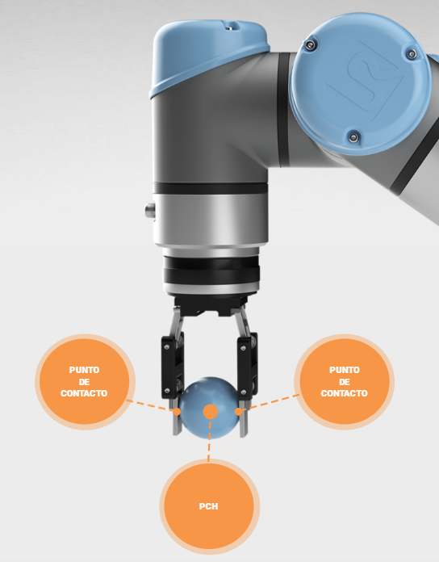
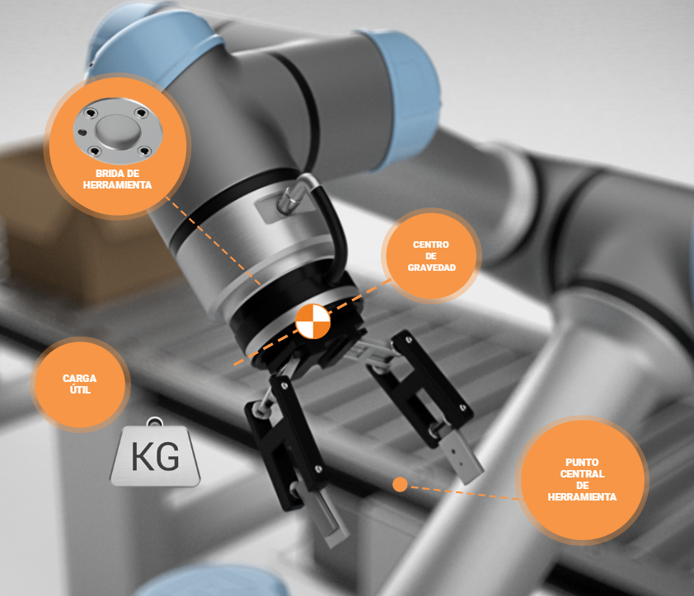

1.Exercise: TCP
- Find in the following images where the TCP of the scraper is located.
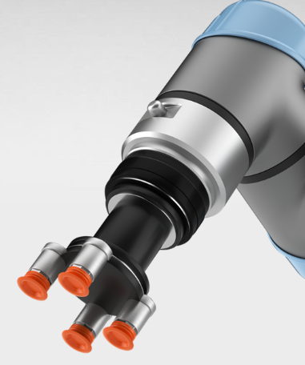
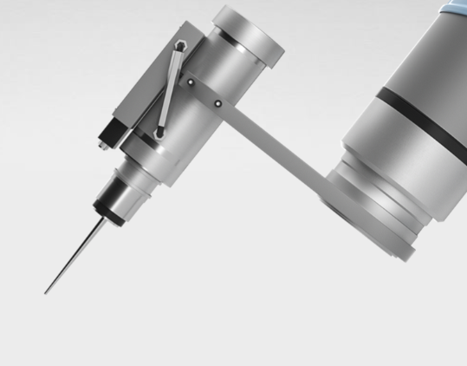
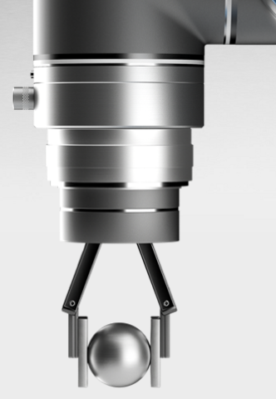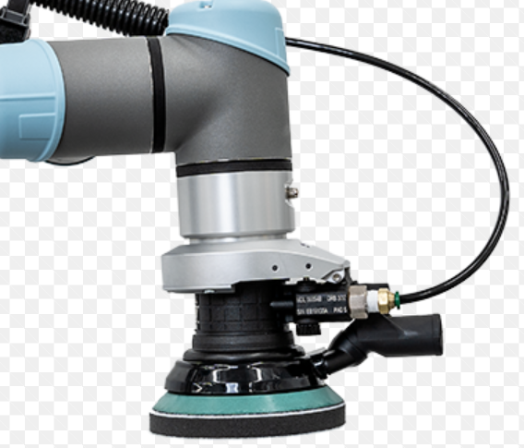

2. Exercise: TCP – I/O - Variables (To do it behind the 2. module)
- An installation file must be created.
- There, 2 different TCP will be configured.
- Digital inputs and outputs must also be configured and named:

Three different lights (LEDs) and tape on the output, push buttons and sensors on the inputs.
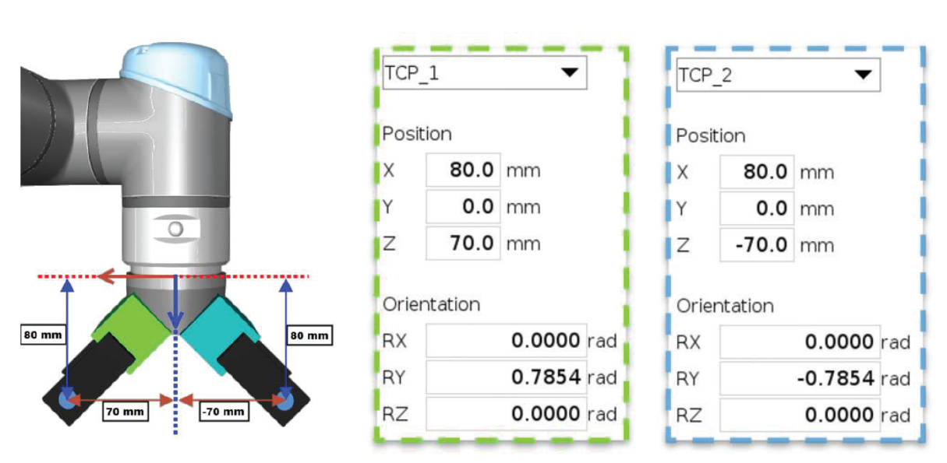

DIFFERENT TYPES OF MOVEMENT.
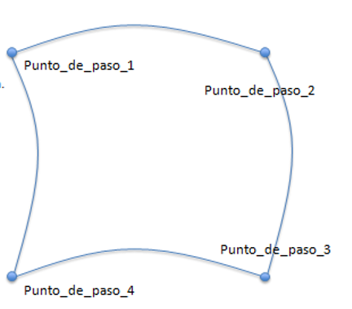
Exercise 3: MoveJ (To do it behind the third module)
What needs to be done:
•Set up 4 different points using MoveJ.
•They are the fastest movements.
•It is ideal for swirling movements.

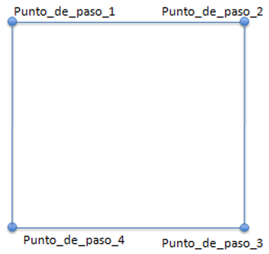
Exercise 4: MoveL
What needs to be done:

- Set up 4 different points using MoveL.
- The TCP movement is correct.
- Suitable for approaching and moving away from objects.

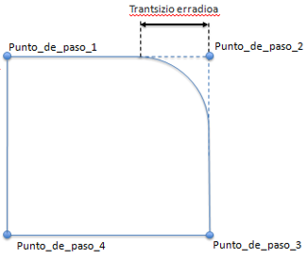
Exercise 5: MoveL and transitions.
What needs to be done:

- Using MoveL, set up 4 different points and set transition radii to at least 2 points.
- We will use R=25.
- It is an uninterrupted movement.
- The robot does not stop at step points.
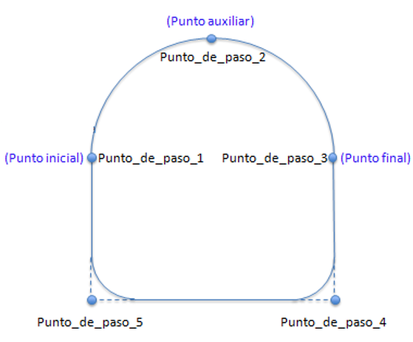

Exercise 6: MoveC and circulas Movement.
What needs to be done:

- Using MoveP and MoveC, do a 5 point image.
- Three points are required for circular movement:
  - Initial point
  - Auxiliar point
  - Final point
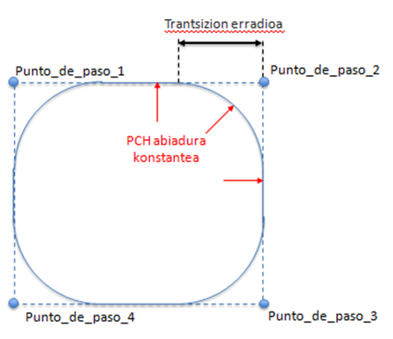

Exercise 7: MoveP and Circular Movement.
What needs to be done:

- MoveP
- Used in process applications.
- Perform linear movement.
- TCP moves at speed counter
- Interleaved transition radius.
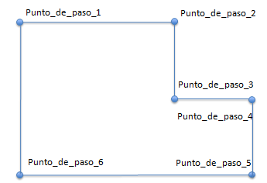
Exercise 8
What needs to be done:
- Using MoveL, run the following route with 6 points.

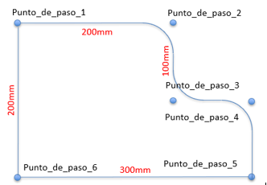
Exercise 9
What needs to be done:
- Using MoveL, run a program similar to the previous exercise but now using transition radios.
- Set the 2, 3, 4 points to a radius of 50mm.

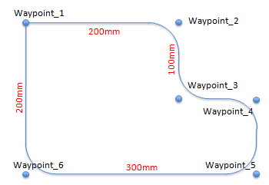
Exercise 10.:
What needs to be done:
- A program similar to the exercise before running with MoveP instead of MoveL..

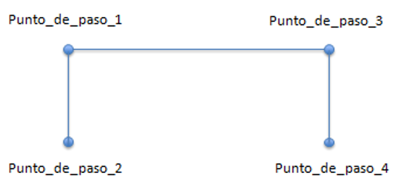
Exercise 11:
What needs to be done:
- Using MoveL, run the following route with 4 points.
- Create a simple pick and place program.
- Simulate the movements you would make to take a piece.

Exercise 12:
What needs to be done:
- Using MoveL, run the following route with 6 points.
- 2.puntuan turn 180° to one side of the flange and 4.puntuan turn 180° to the other.
- Simulate the movements you would make to attach or detach a piece. Point 5 Point 6

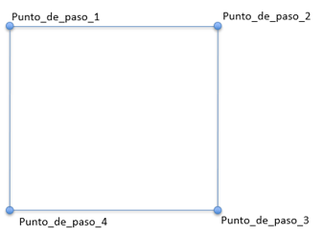
Exercise 13.: Relative position
What needs to be done:
- Using MoveL and placing 3 relative positions, perform the following route.

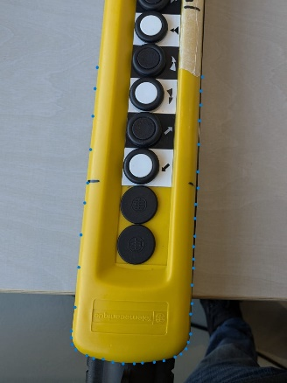
Exercise 14: The movement of embrodery mugimendua
What needs to be done:
- Using the movements learned above, pass the edge of the yellow boot close to the flame of the robot. As if it were a gluing process..

Exercise 15: Guitar´s edges
What needs to be done:
- Using the movements learned above, pass the edge of the guitar close to the flame of the robot. As if it were a gluing process. The guitar plane is out.

Exercise 16: Creating and moving a plan

What needs to be done:
- Using Functions we will have to create a plane, the same clipboard that we have. Once we have created that plane, we will move in that plane and we will make the cut of that piece next to us by touching it..

DIFFERENT TYPES OF ORDERS.

Exercise 17:
What needs to be done:
- Designate 0. Digital output as “GRIPPER.
- Using MoveL, run the following route with 4 points.
- In the second point the digital 0 output will be activated and wait 2 seconds to confirm that the piece has been received correctly.
- When it arrives to point 4 the digital 0 output will be deactivated and wait for 2 seconds to confirm that the piece has been deposited correctly.

Exercise 18: Wait and adjust
What needs to be done:
- Designate 4. Digital output as “Lamp” and 5. Digital input as “Pushbutton”.
- Make Connections in the Control Box.
- Make a small program so that the program waits for the pushbutton to be pressed and the light stays on for 5 seconds when it is pressed.
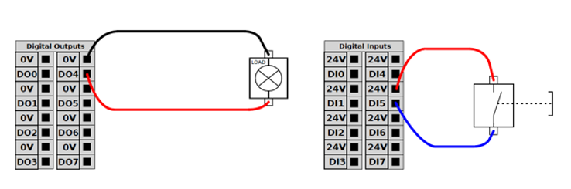

Exercise 19: Warning
What needs to be done:
- Designate 4. Digital output as “Lamp” and 5. Digital input as “Pushbutton”.
- Make Connections in the Control Box.
- When you press the button, a warning will appear saying “the light is going to turn on”.
- It will be on for 2 seconds, another 2 will be off, and another 2 will be on.
- 2 seconds after the last power up, we will receive a new warning that the program has finished.

Exercise 20: Functions
What needs to be done:
- Create 2 plane functions.
- Draw a triangle on each new plane.
- Draw the triangle in the foreground and then apply it in the background.

Exercise 21: Loop
What needs to be done:
- Designate 4. Digital output as “Lamp” and 5. Digital input as “Pushbutton”.
- Make Connections in the Control Box.
- When you press the button, a warning will appear saying “the light is going to turn on”. (Wait).
- The light will turn on and the robot will make a path of any 3 points 5 times. The light will then turn off and travel the same route as mentioned above for another 3 times.
- At the end you will see a message informing you that the entire cycle has been completed.
- Use folders to collect parts of the program and make the program more understandable.
Exercise 22: Loop
What needs to be done:
- Designate 4. Digital output “Lamp” and 5th and 6th digital inputs “Pushbutton 1” and “Pushbutton 2”.
- Run a program similar to the previous one, but instead of writing the number of loops, a condition will be set. In this case, “pushbutton 2” while being depressed” should be set as the condition.
- If it is not depressed, the program will continue, but if it is not depressed, it will continue to follow the commands within the loop.

Exercise 23: If, else, elseif
What needs to be done:
- Designate 1. digital output “Lamp” and 1th and 2nd digital inputs “Pushbutton 1” and “Pushbutton 2”.
- We will ask if the Pushbutton1 or Pushbutton2 is pressed and turn on the Lamp if it is negative. When the pushbutton 1 is depressed, the lamp is turned off and the robot will follow a path of 4 points.
- f the pushbutton 2 is depressed, the lamp will turn off and follow a 3-point path.

Exercise 24: If and asignation
What needs to be done:
- Create a program using installation variables to count execution cycles.
- Create an installation variable called a counter with a value of 0.
- Create a simple program that moves between Point 1 and Point 2.
- Increase the counter variable after each move.
- When the counter reaches 10 cycles, move to the tool cleaning (point_step_3).
- When the counter reaches 20 cycles, display the message "Change tray on the feeder".
Exercise 25: If, else, elseif, asignatión,
What needs to be done:
- Designate 4th digital output “Lamp” and 0 and 1 digital inputs “Pushbutton 1” and “Pushbutton 2””.
- Until the Pushbutton 1 is pressed, the Lamp will be intermittently for 1 second.
- Pressing 1 button will make a triangle 3 times, using variables and if instead of loops. In Embodiment 3, the program returns to the beginning and the variable is zeroed.
Exercise 26: Switch. If and asignation
What needs to be done:
- Designate 0, 1, 2 and 3. Digital inputs “Pushbutton 1, Pushbutton 2, Pushbutton 3 and Pushbutton 4”.
- There will be 4 different options via switch commands. Depending on the pulser that is pressed, a geometric figure will be drawn 1, 2, 3 or 4 times. A counter will be used for this purpose and this amount will be checked with the if command. When it is finished, the counter will be reset to 0.

Exercise 27: Subprogram
What needs to be done:
- Designate 0, 1 and 2. Digital inputs “Pushbutton 1, Pushbutton 2, and Pushbutton 3”.
- Create 3 subprograms: one to make a triangle, the other to make a square, and the last to make a rectangle.
- Using a switch, choose which subprogram to invent.

Exercise 28: Timmer
What needs to be done:
- Make a program that will be performing a 2-point vertical movement for two minutes and then performing a 2-point horizontal movement for three minutes at the end.
- Timing production and display time when finished.
Exercise 29: Subprograma, switch, temporizador, if and asignation.
What needs to be done:
- Develop a program that draws squares, triangles, or circles based on the data entered by the employee.
- First, the program will ask the employee if they want to repeat the last process entered. If the answer is "no", you will ask what process you want (1 squares, 2 triangles, 3 circles) and then how many times you want to do it.
- Create a subprogram for each type of production.
- Timing production and display time when finished.

